Unit 5: Computational Intelligence and NLP

Topic 1: Introduction to Computational Intelligence in NLP

1. Definition / Introduction
Computational Intelligence (CI) refers to a subfield of artificial intelligence that relies on nature-inspired, heuristic, and probabilistic methodologies to solve complex, non-linear, and computationally hard real-world problems. Unlike classical Artificial Intelligence, which fundamentally depends on hard-coded rules, explicit symbolic logic, and structured knowledge representations, Computational Intelligence builds robust models capable of learning, evolving, adapting, and abstracting patterns from noisy, unstructured data.
In the domain of Natural Language Processing (NLP), Computational Intelligence bridges the gap between raw, highly ambiguous human communication and digital processing systems. Human language is inherently contextual, polysemous, and structurally complex. CI techniques—comprising artificial neural networks, deep learning architectures, evolutionary computation, and fuzzy logic systems—enable computers to parse semantic meaning, track long-range contextual dependencies, generalize across vocabulary variants, and translate information across language barriers without requiring manual feature engineering.

2. Detailed Explanation
The integration of Computational Intelligence into NLP represents an evolution from rule-based parsers to deeply integrated mathematical vector spaces. Human language poses severe analytical challenges: sparsity, high-dimensionality, sequential dependencies, and contextual variability. CI solves these problems by transforming discrete textual structures (such as characters, words, and sentences) into dense continuous vector spaces and processing them using multi-layered structural representations.

Core Structural Paradigm Shifts in CI-driven NLP:
- From Discrete Tokens to Dense Continuous Vector Spaces: Traditional NLP relied on distinct categorical representations where words were isolated entities (e.g., One-Hot Encoding). This approach created sparse matrices of enormous dimensions and failed to capture structural relationships. Computational Intelligence relies on distribution-driven neural frameworks to map human vocabulary into dense, lower-dimensional vector spaces. Within these continuous spaces, mathematical distance matches conceptual and semantic similarity.
- Handling Sequential Temporal Dependencies: Human language is inherently sequential, where the meaning of a given word depends heavily on preceding and succeeding terms. Early neural models struggled with temporal ordering. Advanced computational models handle sequential text by updating internal mathematical states step-by-step or by mapping mathematical attention across an entire text sequence concurrently to resolve complex contextual relations.
- Hierarchical Abstraction and Feature Learning: Instead of manually designing linguistic rules or constructing human-engineered syntactic features, deep multi-layered computational architectures automatically extract hierarchical features. Lower layers capture surface-level patterns like morphological boundaries and character sequences, middle layers track syntactic alignments like part-of-speech groupings, and deeper layers infer rich contextual semantics, sentiment structures, and abstract relational ideas.

3. Key Points
- Continuous Semantic Representation: Words and sentences are projected onto a continuous coordinate plane where contextual connections are captured using mathematical properties like cosine similarity.
- Data-Driven Feature Engineering: Eliminates the need for hand-crafted grammatical rules by discovering underlying linguistic structures directly from large corpora of text.
- High Resilience to Noise: Heuristic and neural architectures are naturally robust against typographical errors, slang, grammatically incomplete inputs, and unexpected vocabulary variations.
- Scalability Across Languages: Because CI architectures rely heavily on statistical pattern learning and deep structural abstractions rather than rigid language-specific dictionaries, the underlying frameworks adapt efficiently across different human languages.
- Core Pillars of CI in modern NLP: Driven primarily by Deep Artificial Neural Networks (RNNs, LSTMs, Transformers), Evolutionary Optimization (used for hyperparameter tuning and text-generation optimization), and Probabilistic Graph Models.

4. Diagram / Example

Architectural Component Relationships

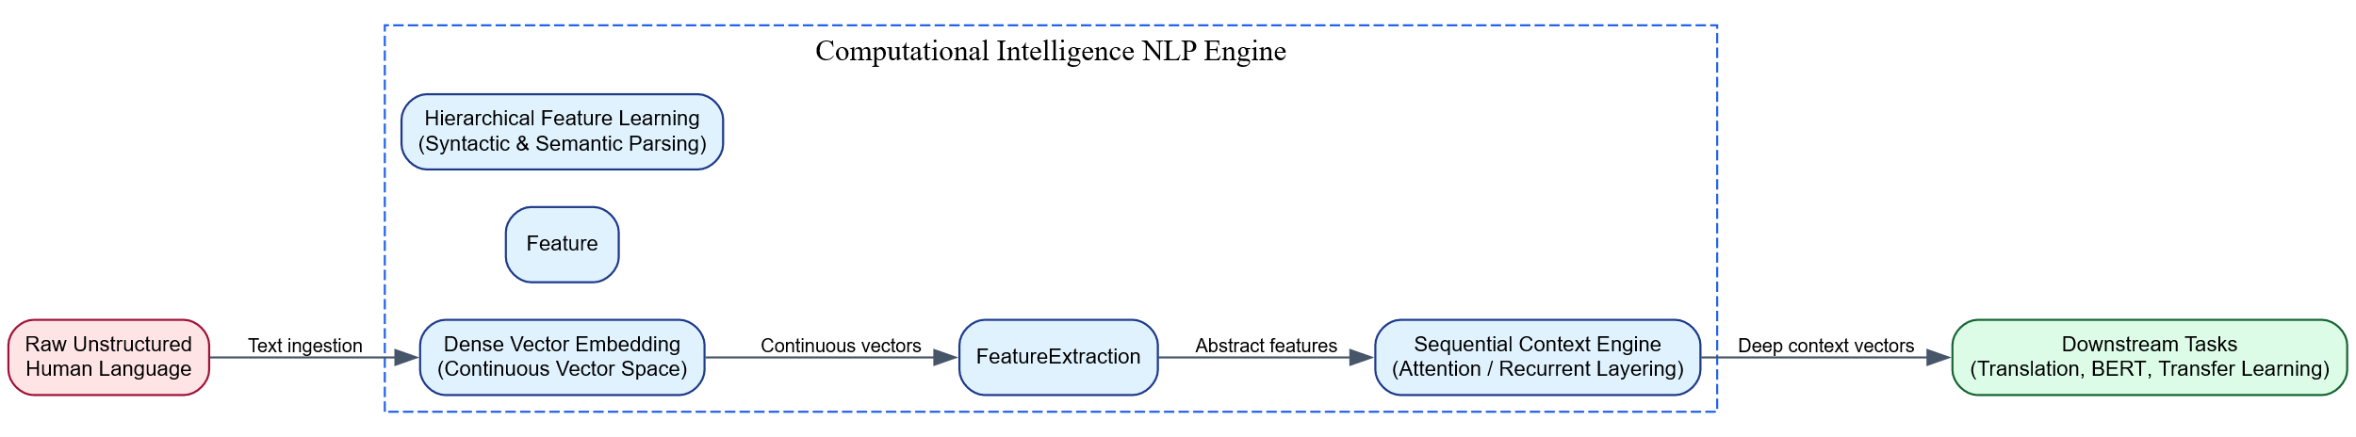Descriptive Conceptual Example
Consider the sentence: “The bank of the river was muddy, so I walked to a financial bank to withdraw money.” A classical rule-based system struggle significantly here because the token “bank” appears twice with entirely different meanings. A Computational Intelligence framework handles this sequence efficiently:
- It ingests the continuous string and converts the tokens into vector sequences.
- The sequence engine processes the contextual terms surrounding the first occurrence (“river”, “muddy”).
- The engine shifts internal vector parameters, aligning the first instance of “bank” closer to geographical vectors.
- When it encounters the second instance, it scans the neighboring context (“financial”, “withdraw”, “money”) and projects this vector representation into a completely separate area of the semantic space dedicated to economic institutions.

5. Conclusion / Summary
Computational Intelligence serves as the mathematical foundation for modern Natural Language Processing by trading fragile rule-based structures for robust, self-learning architectures. By mapping linguistic patterns into dense continuous spaces, learning hierarchical representations automatically, and adapting to sequential context, CI systems process language with human-like contextual awareness. This foundational paradigm underpins every advanced development in modern language technologies—from fundamental vector embeddings (Word2Vec, GloVe) to sophisticated translation systems (Seq2Seq, NMT) and massive pre-trained transformer architectures (BERT).

Word Embedding Techniques — Bag of Words (BoW)

1. Definition / Introduction
The Bag of Words (BoW) model is a fundamental, non-neural text representation technique in Natural Language Processing that converts unstructured text documents into fixed-length numeric feature vectors. It is a vocabulary-based representation strategy that strips away grammar, sentence structure, and token ordering, focusing exclusively on the frequency or presence of words within a document.
The term “Bag of Words” is an analogy: a document is treated like a literal pouch or “bag” filled with isolated words. The model keeps track of how many times each word appears in the bag but discards all structural context regarding where or how those words were originally positioned.

2. Detailed Explanation
The generation of a Bag of Words matrix involves a structured text processing pipeline:

Step 1: Tokenization and Vocabulary Generation (The Dictionary)
The algorithm scans all text documents across an entire dataset (called the corpus). It isolates every unique word, normalizes them (typically converting them to lowercase), and compiles a unique master list of vocabulary words ($V$).

Step 2: Vector Initialization
Each individual document is assigned a feature vector of length $\left|V\right|$, where $\left|V\right|$ represents the total number of unique words in the master vocabulary. Every index in this vector maps to a specific word in the dictionary.

Step 3: Count Aggregation (Frequency Mapping)
The algorithm iterates through a document. For every word encountered that exists in the master vocabulary, it increments the numeric value at that word’s corresponding vector index. Words not present in the document receive a count value of 0.

Two Structural Variations of BoW:
- Binary BoW: Instead of raw frequencies, it marks indices using Boolean logic: 1 if the word is present in the document, and 0 if it is absent. This is highly effective for binary classification tasks like spam detection.
- Frequency BoW: Records the exact integer count of each word within the document, capturing structural emphasis based on repetition.

Structural Limitations of the BoW Paradigm:
- The Sparsity Problem: In real-world corpuses, vocabulary sizes can exceed hundreds of thousands of words ($\left|V\right|>100,000$). However, an individual sentence might contain only five or six unique tokens. This leaves the remaining tens of thousands of indices filled with 0, creating highly sparse matrices that waste immense computer memory.
- Loss of Sequential Context (Word Order): Because it collapses sentences into counts, phrases with completely opposite meanings but identical word counts end up with identical vector representations.
- The Out-of-Vocabulary (OOV) Barrier: If a model encounters a brand new word during production testing that was not part of the initial training corpus, it has no way to expand its feature space and must completely ignore the token.
- No Semantic Similarity Matching: Every word is treated as an orthogonal entity. The model cannot mathematically infer that the word “awesome” is conceptually close to the word “fantastic.”

3. Key Points
- Frequency-Driven Vectorization: Converts text fields into numeric vectors based strictly on token presence or repetition.
- Fixed-Dimension Constraints: The final dimensionality of every document vector is strictly bound to the total size of the corpus vocabulary ($\left|V\right|$).
- Order Independent: Discards all grammatical sequences, syntax layouts, and spatial positioning of individual tokens.
- Extreme Matrix Sparsity: Results in vectors populated predominantly by zeros, requiring specialized sparse matrix storage formatting during implementation.
- High Semantic Blindness: Fails to recognize word relationships, synonyms, or contextual variations.

4. Diagram / Example

Architectural Vector Conversion Pipeline

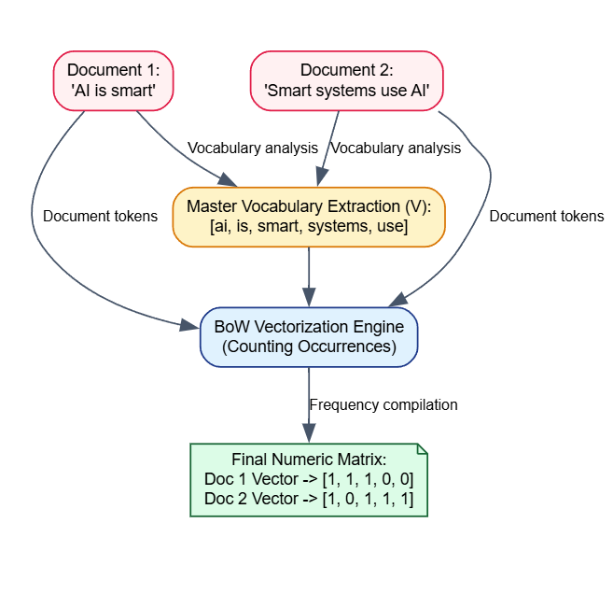Analytical Numerical Example
Let us trace an explicit mathematical evaluation with a small corpus containing two distinct textual records:
- Document 1: “Cats chase mice”
- Document 2: “Mice evade cats”

Step 1: Construct the Master Vocabulary Vector
$$\text{Vocabulary }\left(V\right)=\left[ \text{"cats"}, \text{"chase"}, \text{"evade"}, \text{"mice"} \right]$$
$$\text{Vocabulary Size }\left(\left|V\right|\right)=4$$

Step 2: Compute Frequency Alignments
- For Document 1 (“Cats chase mice”):
  - “cats” occurs 1 time
  - “chase” occurs 1 time
  - “evade” occurs 0 times
  - “mice” occurs 1 time
$${\vec{D}}_{1}=\left[1,1,0,1\right]$$
- For Document 2 (“Mice evade cats”):
  - “cats” occurs 1 time
  - “chase” occurs 0 times
  - “evade” occurs 1 time
  - “mice” occurs 1 time
$${\vec{D}}_{2}=\left[1,0,1,1\right]$$

5. Conclusion / Summary
The Bag of Words model serves as a straightforward, interpretable entry point for numeric feature extraction in Natural Language Processing. While it is highly efficient for basic baseline systems—such as classifying linear sentiments or filtering basic spam signatures—its systemic vulnerability to matrix sparsity and absolute disregard for semantic syntax limits its utility in modern, complex, context-heavy AI tasks. It establishes the design baseline that more advanced embedding schemes (such as TF-IDF and neural embeddings) attempt to optimize.

Term Frequency-Inverse Document Frequency (TF-IDF)

1. Definition / Introduction
Term Frequency-Inverse Document Frequency (TF-IDF) is a statistical, frequency-based weighting framework designed to reflect how important a specific word is to a target document within a collection or corpus.
Unlike the basic Bag of Words model, which tracks raw counts, TF-IDF scales down vectors for universally common words (like “the”, “is”, “and”) while scaling up vectors for descriptive, information-dense tokens that appear only within specific documents. It transforms text strings into a continuous, non-neural vector space where highly informative keywords receive prominent mathematical weights.

2. Detailed Explanation
The TF-IDF framework calculates its weights by multiplying two separate statistical metrics: Term Frequency (TF) and Inverse Document Frequency (IDF).

Mathematical Breakdown:

1. Term Frequency ($TF$)
Measures how frequently a term $t$ appears inside a specific document $d$. The basic assumption is that if a word occurs many times in a text, it is central to that text’s topic.
$$TF\left(t,d\right)=\frac{\text{Number of times term }t\text{ appears in document }d}{\text{Total number of terms in document }d}$$

2. Inverse Document Frequency ($IDF$)
Measures how common or rare a term $t$ is across the entire corpus collection $D$. If a word appears in almost every document, its descriptive power drops to zero. A logarithmic scale manages this distribution.
$$IDF\left(t,D\right)=log\left(\frac{\text{Total number of documents }\left|D\right|}{\text{Number of documents containing term }t+1}\right)$$
(Note: A $+1$ is standard in the denominator to prevent division-by-zero errors if a term is not found in the training corpus).

3. Combined TF-IDF Score
The final weight is the product of these two values:
$$\text{TF-IDF}\left(t,d,D\right)=TF\left(t,d\right)×IDF\left(t,D\right)$$

Significance in Text Representation:
- Stop-Word Suppression: Automatically neutralizes high-frequency functional language particles without requiring a manual, hardcoded stop-word removal list.
- Keyword Extraction Extraction: Surface-level indicators of localized topical trends naturally receive higher values, making it highly effective for document search and index ranking systems.
- Limitations: Like Bag of Words, it remains an orthogonal discrete representation scheme. It cannot handle out-of-vocabulary terms, discards grammar and word order, and fails to map semantic similarities (e.g., “car” and “automobile” remain distinct, unrelated dimensions).

3. Key Points
- Balance of Local vs. Global Frequencies: Evaluates localized token repetitions against global corpus visibility.
- Dynamic Information Scaling: Assigns higher numeric weights to rare, highly specific terms and penalizes common words.
- Orthogonal Matrix Layout: Results in a sparse vector format where vocabulary dimensions match the total number of unique terms across the corpus ($\left|V\right|$).
- Grammar-Blind Processing: Discards structural sequencing, word placement, and sentence syntax.

4. Diagram / Example

Analytical Numerical Example
Consider a tiny corpus containing $\left|D\right|=2$ documents:
- Document 1 ($d_{1}$): “quantum physics computing”
- Document 2 ($d_{2}$): “computing basics”
Let us compute the exact $\text{TF-IDF}$ weight for the specific word “quantum” inside Document 1 ($d_{1}$):
- Calculate $TF\left(\text{"quantum"},d_{1}\right)$:
  - “quantum” occurs $1$ time in $d_{1}$. Total tokens in $d_{1}=3$.
$$TF=\frac{1}{3}≈0.333$$
- Calculate $IDF\left(\text{"quantum"},D\right)$:
  - Total documents $\left|D\right|=2$. Documents containing “quantum” = 1 ($d_{1}$).
$$IDF=log\left(\frac{2}{1}\right)≈0.301$$
- Compute Final $\text{TF-IDF}$ Weight:
$$\text{TF-IDF}=0.333×0.301≈0.100$$
Conversely, for a universally shared word like “computing”:
- It appears in both documents, so its $IDF=log\left(2/2\right)=log\left(1\right)=0$.
- Consequently, its final $\text{TF-IDF}$ score drops to $0$ in both documents, correctly identifying it as uninformative for distinguishing between the two texts.

5. Conclusion / Summary
TF-IDF updates simple count models by adjusting raw frequencies based on how rare a word is across an entire dataset. While it provides an efficient, statistical baseline for search engines and basic text classification, its structural sparsity and inability to capture word meaning mean that advanced, context-heavy AI pipelines typically rely on dense neural embeddings.

Word2Vec Word Embeddings

1. Definition / Introduction
Word2Vec is a foundational, neural-network-based predictive framework designed to learn distributed, dense, low-dimensional vector representations of words from massive, unstructured textual datasets. Developed by Tomas Mikolov et al. at Google, it operates on the Distributional Hypothesis, which states that words appearing in similar contextual environments share similar semantic meanings.
Unlike sparse, high-dimensional models like Bag of Words and TF-IDF, Word2Vec compresses vocabulary spaces into compact continuous feature spaces (typically ranging from 100 to 300 dimensions). Within this space, geometric proximity matches semantic similarity, allowing models to perform vector arithmetic like:
$${\vec{v}}_{\text{King}}-{\vec{v}}_{\text{Man}}+{\vec{v}}_{\text{Woman}}≈{\vec{v}}_{\text{Queen}}$$

2. Detailed Explanation
Word2Vec builds its dense vector spaces using two-layer neural architectures that learn weights by predicting words within local sliding window frames. Rather than attempting to compute absolute global matrices, it optimizes linear prediction tracks using two distinct structural training frameworks:

1. Continuous Bag of Words (CBOW) Architecture
The CBOW architecture predicts a single target center word ($w_{t}$) based on a surrounding window of context words ($w_{t-c},…,w_{t+c}$).
- Mechanism: The vector representations of the surrounding context words are fed into an input layer, combined via an average/sum pooling operation in a shared projection hidden layer, and then used to predict the target center word via a Softmax classification step.
- Operational Characteristics: CBOW smooths out much of the distributional context by averaging the input vectors. As a result, it trains significantly faster and demonstrates superior statistical accuracy when processing high-frequency words.

2. Continuous Skip-gram Architecture
The Skip-gram architecture inverts the CBOW objective: it takes a single center word ($w_{t}$) as input and attempts to predict the surrounding context words within its current window frame.
- Mechanism: The target word vector is passed through the projection layer to generate multiple independent output distributions, each attempting to predict a word at a specific offset position within the context window.
- Operational Characteristics: Because it forces the model to learn distinct target-to-context relationships for every encounter, Skip-gram handles rare words and specialized phrases exceptionally well, though it requires more computation time.

Optimization Mechanics (Making Training Viable)
Computing a full Softmax over a massive vocabulary space ($\left|V\right|$) at the output layer is computationally expensive. Word2Vec addresses this using two optimization strategies:
- Hierarchical Softmax: Uses a binary Huffman tree structure to reduce the output computation from $O\left(\left|V\right|\right)$ steps down to $O\left(\log_{2}\left|V\right|\right)$.
- Negative Sampling (SGNS): Shifts the objective from multi-class classification to binary logistic regression. For every true target-context pair, the model is trained to distinguish it from a small handful ($k$) of randomly selected “negative” or incorrect noise words, drastically reducing the required weight updates.

3. Key Points
- Dense, Low-Dimensional Representation: Replaces large, sparse matrices with dense vectors of a fixed size (e.g., 300 dimensions).
- Predictive Learning Framework: Uses localized sliding context windows to optimize word vectors via shallow neural network layers.
- Geometric Semantic Space: Positions conceptually related words close together, making relationships measurable via cosine similarity metrics.
- Linear Compositionality: Learns structured relationships that support vector arithmetic, such as mapping countries to their capital cities.
- Context Blindness After Training: Once training concludes, each word is locked into a single fixed vector. This means the model cannot update its representation for polysemous words based on new context (e.g., “apple” as a fruit vs. “Apple” as a technology company).

4. Diagram / Example

The Word2Vec Prediction Topology

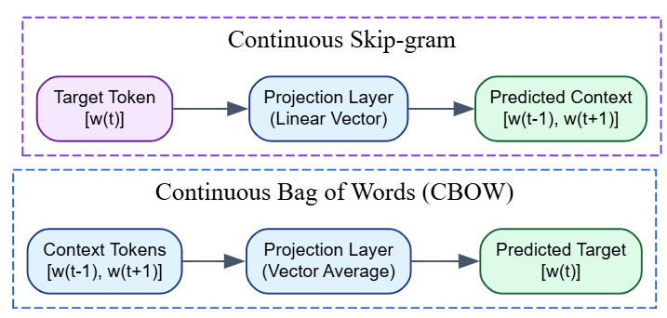Descriptive Application Example
Imagine training a Skip-gram model with a window size of $1$ on the phrase: “Artificial Intelligence transforms industries.”
- When evaluating the center word “Intelligence”, the training loop extracts active prediction target pairs: $\left(\text{"Intelligence"},\text{"Artificial"}\right)$ and $\left(\text{"Intelligence"},\text{"transforms"}\right)$.
- The backpropagation loop updates the embedding weights so that the vector for “Intelligence” is pulled closer to the vectors for “Artificial” and “transforms” in the geometric space. Over millions of iterations across a large corpus, words like “Intelligence”, “Cognition”, and “AI” naturally cluster together because they share similar context words.

5. Conclusion / Summary
Word2Vec transformed modern NLP by replacing high-dimensional, sparse word counts with compact, dense vector spaces learned through neural prediction. While its static design means it cannot adapt to words with multiple meanings in real time, its ability to capture semantic relationships using continuous vector arithmetic served as a foundational step for modern sequence models and deep transformer architectures.

Global Vectors for Word Representation (GloVe)

1. Definition / Introduction
GloVe (Global Vectors for Word Representation) is an unsupervised, log-bilinear neural word embedding model developed by Jeffrey Pennington et al. at Stanford University. It is designed to combine the advantages of two major architectural families: global matrix factorization methods (like Latent Semantic Analysis) and local sliding window-based predictive models (like Word2Vec).
The fundamental concept behind GloVe is that the ratio of word co-occurrence probabilities with a set of probe words contains a clean, mathematical encoding of semantic meaning. Instead of scanning a local window over and over during training, GloVe trains directly on a global, pre-computed word-context co-occurrence matrix, minimizing a specialized weighted least-squares objective function.

2. Detailed Explanation
GloVe addresses a key limitation in how word representations are constructed:
- Matrix Factorization Models (LSA): Efficiently capture global statistical structures but perform poorly on word analogy tasks and capture sub-linear relationships poorly.
- Local Window Predictive Models (Word2Vec): Excel at learning complex semantic analogies but fail to utilize the vast statistical information present in global co-occurrence data, as they stream through isolated local windows.

The Co-occurrence Matrix ($X$)
GloVe begins by parsing the entire text corpus once to construct a global Word-by-Context Co-occurrence Matrix, denoted as $X$.
- An element $X_{ij}$ represents the number of times word $i$ appears within the context window of word $j$.
- Let Xi=k​Xik be the total number of times any word appears in the context of word $i$.
- The probability that word $j$ appears in the context of word $i$ is calculated as:
$$P_{ij}=P\left(j∣i\right)=\frac{X_{ij}}{X_{i}}$$

The Rationale of Co-occurrence Ratios
The core breakthrough of GloVe is that the absolute probabilities themselves are less informative than the ratio of two conditional probabilities evaluated against a third probe word ($k$).
Consider two target words, $i=\text{"ice"}$ and $j=\text{"steam"}$. Let us observe their co-occurrence distributions with various probe words $k$:
- For a probe word $k=\text{"solid"}$ (highly related to ice, unrelated to steam): The probability $P\left(\text{"solid"}∣\text{"ice"}\right)$ will be high, and $P\left(\text{"solid"}∣\text{"steam"}\right)$ will be low. Therefore, the ratio $\frac{P_{ik}}{P_{jk}}$ will be large.
- For a probe word $k=\text{"gas"}$ (unrelated to ice, highly related to steam): The ratio $\frac{P_{ik}}{P_{jk}}$ will be very small.
- For neutral probe words $k=\text{"water"}$ or $k=\text{"fashion"}$: Both probabilities will either be uniformly high or uniformly low, forcing the ratio $\frac{P_{ik}}{P_{jk}}$ close to 1.

The Objective Function
GloVe maps these probability ratios directly into vector dot products using a log-bilinear model:
$$w_{i}^{T}{\tilde{w}}_{j}+b_{i}+{\tilde{b}}_{j}=log\left(X_{ij}\right)$$
Where $w_{i}$ is the target word vector, ${\tilde{w}}_{j}$ is the context word vector, and $b_{i},{\tilde{b}}_{j}$ are scalar bias terms.
To prevent frequent word pairs (like “the”, “is”) from dominating the optimization process, GloVe introduces a specialized weighting function $f\left(X_{ij}\right)$ within a least-squares loss framework:
$$J=\sum_{i,j=1}^{V}{f}\left(X_{ij}\right){\left(w_{i}^{T}{\tilde{w}}_{j}+b_{i}+{\tilde{b}}_{j}-log\left(X_{ij}\right)\right)}^{2}$$
The weighting function is defined as:
$$f\left(x\right)=\left\{\begin{matrix}{\left(\frac{x}{x_{max}}\right)}^{α} & \text{if }x<x_{max} \\ 1 & \text{otherwise}\end{matrix}\right.$$
(Typically, parameters are set to $x_{max}=100$ and $α=0.75$).

3. Key Points
- Global Statistics Optimization: Trains directly on aggregated global corpus statistics rather than streaming local window instances.
- Log-Bilinear Objective: Uses dot products of vectors to match the log-probability of word co-occurrences.
- Bounded Weighting Function: Caps the influence of highly frequent words to prevent stop-words from skewing the vector space.
- Excellent Analytical Performance: Demonstrates strong performance on syntactic and semantic analogy tasks while requiring fewer training epochs than predictive models on large datasets.
- Static Vector Constraint: Like Word2Vec, it yields a single fixed vector per word, meaning it cannot handle polysemy dynamically based on live sentence context.

4. Diagram / Example

Comparison of Architectural Workflows

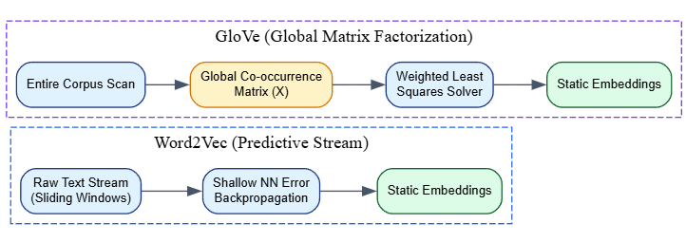Comparison Matrix: Word2Vec vs. GloVe
Characteristic Metric | Word2Vec Predictive Paradigm | GloVe Matrix Factorization Paradigm
Core Learning Objective | Predicts context words given a target word (or vice versa) in a local window. | Minimizes the error between vector dot products and global log co-occurrence counts.
Data Utilization | Processes text sequentially as a continuous stream of local context windows. | Compresses the entire corpus into a global structural matrix before optimization begins.
Computational Footprint | Scales with the size of the text corpus; large datasets require substantial training time. | Scales with vocabulary size $\left|V\right|$; processing time is independent of corpus size once the matrix is built.
Handling Rare Words | Relies on local updates, meaning rare words receive few adjustments and lower vector quality. | Smooths out variations via the global matrix and uses a weighting function to balance rare and common words.

5. Conclusion / Summary
GloVe bridges the gap between count-based global matrix approaches and predictive local window architectures. By optimizing vector dot products to match global log-co-occurrence probabilities, it constructs stable, semantically rich vector spaces efficiently. This method provides an alternative foundational baseline to Word2Vec for downstream language tasks.

Neural Word Embedding

1. Definition / Introduction
Neural Word Embedding is the general term for a class of text representation techniques where words are mapped to high-dimensional, dense, continuous vectors of real numbers using neural network architectures. This paradigm replaces discrete, orthogonal linguistic representations (such as one-hot encoded vectors) with low-dimensional, distributed vector spaces.
The fundamental objective of a neural word embedding is to capture semantic, syntactic, and contextual relationships within dense mathematical vectors. Within this continuous neural space, semantic similarity correlates with geometric proximity, allowing computational architectures to process text using vector operations.

2. Detailed Explanation
The transition to neural word embeddings represents a major shift in how text is represented in NLP. It replaces high-dimensional, sparse representations with dense, continuous vector spaces.

1. Discrete vs. Distributed Representations
- One-Hot Encoding (Discrete): Represents each word as a vector of size $\left|V\right|$, where a single index is set to 1 and all other entries are 0. This configuration assumes all words are mutually independent, meaning the dot product between any two distinct one-hot vectors is always 0. As a result, this representation cannot capture semantic relationships (e.g., ${\vec{v}}_{\text{motocycle}}⋅{\vec{v}}_{\text{scooter}}=0$).
- Distributed Embeddings (Neural): Compacts vocabulary features into a dense vector space of a fixed size ($d≪\left|V\right|$, typically where $d∈\left[50,768\right]$). Every dimension contains a continuous floating-point value. This design distributes semantic attributes across all dimensions of the vector, allowing models to compute relationships using spatial metrics.

2. Mathematical Measurement of Similarity
In a neural embedding space, semantic similarity can be quantified by calculating the spatial distance between vectors. The primary metric used is Cosine Similarity, which measures the cosine of the angle between two non-zero vectors:
$$\text{Cosine Similarity}\left(w_{i},w_{j}\right)=\frac{w_{i}⋅w_{j}}{∥w_{i}∥∥w_{j}∥}=\frac{\sum_{k=1}^{d}{w_{ik}}w_{jk}}{\sqrt{\sum_{k=1}^{d}{w_{ik}^{2}}}\sqrt{\sum_{k=1}^{d}{w_{jk}^{2}}}}$$
- A value close to $1.0$ indicates the vectors point in nearly the same direction, representing high semantic similarity.
- A value of $0.0$ indicates orthogonality, representing no statistical or semantic correlation.

3. Evolution of Neural Word Embeddings
Neural embeddings have evolved through two primary architectural stages:
- Static Neural Embeddings (Context-Independent): Models like Word2Vec, GloVe, and FastText learn a single, fixed vector representation for each word in the vocabulary. While efficient, these static models cannot adapt to polysemous words, assigning the same vector to “bank” whether it refers to a financial institution or the side of a river.
- Dynamic Contextualized Embeddings: Modern transformer-based architectures (such as BERT and GPT) replace static look-up tables with deep encoder-decoder networks. These models compute word representations dynamically based on the surrounding sentence context, generating distinct vectors for the same word depending on how it is used.

3. Key Points
- Dimensionality Reduction: Compresses large, sparse vocabulary vectors into compact, dense continuous spaces.
- Distributed Semantics: Spreads linguistic meaning across continuous dimensions, rather than isolating features at a single index.
- Differentiable Parametrization: Embeddings serve as the weight matrices ($W_{\text{embed}}$) in the first layer of neural networks, allowing them to be optimized via backpropagation.
- Analogical Geometry: Builds structured vector spaces that can capture complex relationships through linear vector arithmetic.
- Foundational Layer Structure: Acts as the entry-level data translation layer for deep learning sequence processors, including RNNs, LSTMs, and Transformers.

4. Diagram / Example

The Embedding Layer Translation Mechanism

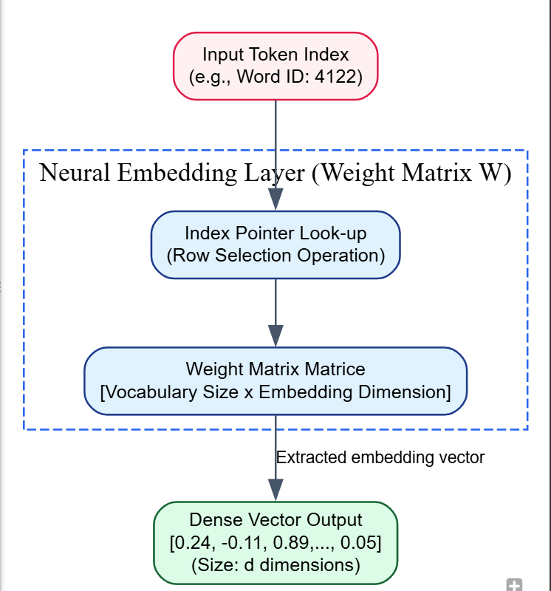Descriptive Conceptual Example
Consider an embedding layer initialized with a dimensionality of $3$. During training, the network projects words into this continuous space. Over time, the dimensions naturally align with abstract semantic concepts:
- Index $0$ might track Animacy (living vs. non-living).
- Index $1$ might track Royalty (regal vs. commoner).
- Index $2$ might track Gender (masculine vs. feminine).
$${\vec{v}}_{\text{"King"}}=\left[0.99, 0.95, 0.88\right]$$
$${\vec{v}}_{\text{"Queen"}}=\left[0.99, 0.96, -0.91\right]$$
$${\vec{v}}_{\text{"Apple"}}=\left[-0.95, -0.92, 0.01\right]$$
Calculating the cosine similarity between ${\vec{v}}_{\text{"King"}}$ and ${\vec{v}}_{\text{"Queen"}}$ yields a score near $1.0$ because they share high values for animacy and royalty, despite their opposite gender assignments. Conversely, computing the similarity between ${\vec{v}}_{\text{"King"}}$ and ${\vec{v}}_{\text{"Apple"}}$ yields a low score, as they share minimal semantic attributes in this space.

5. Conclusion / Summary
Neural word embeddings are a core component of modern Natural Language Processing. By replacing rigid, sparse data structures with dense, continuous vector spaces, they enable neural networks to capture semantic relationships mathematically. This method of representing text forms the foundational input layer for complex language models, including translation networks and large-scale transformer architectures.

PYQ May 2024 (Q5a): Compare and contrast Word2Vec and GloVe in terms of how they generate word embeddings? [9 Marks]

1. Definition / Introduction
Word2Vec and GloVe (Global Vectors for Word Representation) are two foundational, static, neural-network-inspired word embedding paradigms designed to map discrete human vocabularies into dense, continuous, low-dimensional vector spaces. While both frameworks share the ultimate goal of producing dense vector weights where semantic similarity matches geometric proximity, they diverge fundamentally in their mathematical approach to unsupervised pattern extraction.
- Word2Vec (developed by Tomas Mikolov et al. at Google) is a local predictive model. It streams raw text through local, sliding context windows to iteratively adjust embedding parameters via gradient descent optimizations.
- GloVe (developed by Jeffrey Pennington et al. at Stanford University) is a global count-based matrix factorization model. It optimizes vector space coordinates directly against an aggregated, pre-calculated matrix of global word co-occurrence counts across the entire corpus.

2. Detailed Explanation
The structural mechanics of how these two models generate word embeddings reveal fundamentally different mathematical perspectives on representation learning.

Word2Vec Generation Mechanism: Local Predictive Tracking
Word2Vec creates embeddings using shallow, two-layer neural networks that move a sliding context window of size $c$ across an unrolled corpus stream. It uses two primary operational variations:
- Continuous Bag of Words (CBOW): Takes the surrounding context tokens as inputs and passes them through a projection layer (where vectors are averaged) to maximize the log-probability of predicting a single, hidden target center word.
- Continuous Skip-gram: Takes a single center word as input and sets up projection channels to predict the probability distributions of surrounding context words within the window bounds.
The training objective is optimized over sequence steps using a dynamic Softmax function or Negative Sampling (SGNS):
$$logP\left(w_{O}∣w_{I}\right)=logσ\left(v'_{w_{O}}​^{T}v_{w_{I}}\right)+\sum_{i=1}^{k}{E_{w_{i}∼P_{n}\left(w\right)}}\left[logσ\left(-v'_{w_{i}}​^{T}v_{w_{I}}\right)\right]$$
Because updates occur token-by-token within isolated local sliding frames, Word2Vec struggles to capture broader statistical trends across the entire corpus, though it excels at capturing localized syntax and relational analogies.

GloVe Generation Mechanism: Global Co-occurrence Matrix Optimization
GloVe shifts the approach from sequential streaming to a unified batch factorization scheme. The workflow proceeds in two major phases:
- Matrix Construction: It parses the entire text corpus once to build a massive global Word-by-Context Co-occurrence Matrix ($X$). The entry $X_{ij}$ stores the exact calculated count of how many times word $i$ appeared anywhere within the context vicinity of word $j$ across the entire dataset.
- Probability Ratio Modeling: Instead of predicting individual word occurrences, it optimizes vector representations so that the dot product of two word vectors matches the log-probability of their global co-occurrence:
$$w_{i}^{T}{\tilde{w}}_{j}+b_{i}+{\tilde{b}}_{j}=log\left(X_{ij}\right)$$
To prevent common functional stop-words (like “the”, “is”) from dominating the optimization landscape, it solves a weighted least-squares loss function ($J$) that caps maximum frequency influences via an exponent scale $α$:
$$J=\sum_{i,j=1}^{V}{f}\left(X_{ij}\right){\left(w_{i}^{T}{\tilde{w}}_{j}+b_{i}+{\tilde{b}}_{j}-log\left(X_{ij}\right)\right)}^{2} \text{where }f\left(x\right)=min\left(1,{\left(\frac{x}{x_{max}}\right)}^{α}\right)$$

3. Key Points

Contrastive Analytical Metrics:
- Data Processing Style: Word2Vec updates weights token-by-token using an iterative online stream, whereas GloVe optimizes weights using offline batch processing over a single structural matrix.
- Computational Complexity Constraints: Word2Vec’s training runtime scales linearly with the size of the total token count in the corpus ($O\left(\text{Corpus Size}\right)$). GloVe’s vector calculation runtime scales primarily with the vocabulary matrix footprint ($O\left({\left|V\right|}^{2}\right)$), making its training time independent of corpus size once the initial co-occurrence matrix is constructed.
- Statistical Information Leverage: GloVe utilizes global corpus-wide statistical distributions directly. In contrast, Word2Vec relies on localized context windows, adjusting its vectors incrementally through stream-based backpropagation.
- Handling of Rare Vocabulary Entries: Word2Vec struggles with rare words because they generate few local prediction windows, leaving their vector parameters poorly optimized. GloVe handles rare words more robustly by utilizing global co-occurrence contexts smoothed across the matrix via its least-squares weighting function.

4. Diagram / Example

Architectural Comparison Flowchart

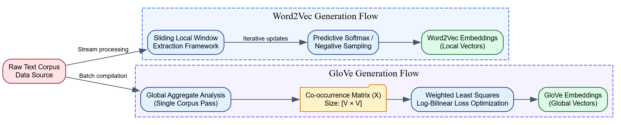Core Differences Matrix for Exam Presentation
Assessment Parameter | Word2Vec Predictive Model | GloVe Co-occurrence Model
Architectural Family | Local Predictive Context Framework. | Global Count-Based Matrix Factorization.
Mathematical Foundation | $P\left(\text{Context}∣\text{Target}\right)$ via Softmax / SGNS. | $w_{i}^{T}{\tilde{w}}_{j}=logP\left(\text{Co-occurrence Ratio}\right)$.
Algorithmic Input | A sequential, localized text token stream. | A pre-computed global co-occurrence matrix.
Primary Strength | Captures fine-grained semantic analogies and nuanced syntax. | Highly efficient training on large scales; robust to rare words.
Primary Failure State | Misses global statistical context outside the local window. | Scalability drops significantly if vocabulary size $\left|V\right|$ spikes dramatically.

5. Conclusion / Summary
Word2Vec and GloVe highlight the two primary strategies for generating static neural word embeddings. Word2Vec uses a local, streaming approach that relies on predictive, window-based neural updates to capture fine-grained relational analogies. GloVe takes a global approach, using batch optimization over a pre-computed co-occurrence matrix to leverage corpus-wide statistical distributions efficiently. While modern NLP applications often rely on dynamic, transformer-based representations, both Word2Vec and GloVe remain vital foundation models for dense text vectorization.

PYQ May 2024 (Q6b): Describe the TF-IDF (Term Frequency-Inverse Document Frequency) weighting scheme and its significance in text representation? [9 Marks]

1. Definition / Introduction
Term Frequency-Inverse Document Frequency (TF-IDF) is a statistical, frequency-based weighting framework used in Natural Language Processing to convert unstructured text documents into structured numeric feature vectors. It is designed to reflect how important or informative a specific word is to a target document within a larger collection or corpus.
Unlike primitive vectorization schemes like the Bag of Words model—which rely purely on raw counts—TF-IDF balances local term repetition against global corpus-wide visibility. It downweights universally ubiquitous, non-informative terms (e.g., “the”, “is”, “and”) while scaling up rare, highly descriptive topical keywords that occur within specific documents, mapping text into a continuous, non-neural vector space.

2. Detailed Explanation
The TF-IDF mathematical framework evaluates text by multiplying two distinct statistical metrics: Term Frequency (TF) and Inverse Document Frequency (IDF).

1. Mathematical Components

A. Term Frequency ($TF$)
Term Frequency measures how frequently a term $t$ appears inside a specific target document $d$. The underlying principle is that if a word is repeated multiple times within a text, it is likely central to that document’s specific subject matter.
$$TF\left(t,d\right)=\frac{\text{Count of term }t\text{ in document }d}{\text{Total number of all terms in document }d}$$

B. Inverse Document Frequency ($IDF$)
Inverse Document Frequency measures how common or rare a term $t$ is across the entire corpus or document collection $D$. If a word appears in almost every document in the database, its power to uniquely identify or distinguish any single document drops to zero. This global distribution is managed using a logarithmic scale:
$$IDF\left(t,D\right)=log\left(\frac{\text{Total number of documents in corpus }\left|D\right|}{\text{Number of documents containing term }t+1}\right)$$
(Note: Adding $1$ to the denominator is standard practice in computational toolkits to prevent division-by-zero errors).

C. Combined TF-IDF Weighting
The final TF-IDF weight assigned to a specific term within a specific document is the mathematical product of these two individual values:
$$\text{TF-IDF}\left(t,d,D\right)=TF\left(t,d\right)×IDF\left(t,D\right)$$

2. Significance in Text Representation
The integration of the TF-IDF weighting scheme provides several key advantages for text representation in machine learning pipelines:
- Automatic Stop-Word Suppression: It addresses a major limitation of count-based vectors by naturally penalizing universally frequent language particles without requiring a manually maintained, hardcoded list of functional stop-words.
- Salient Feature Extraction: It automatically highlights informative keywords. Words with high local frequency ($TF$) and low global distribution ($IDF$) receive prominent mathematical weights, making it highly effective for document search engines and informational indexing.
- Vector Vectorization for Downstream Estimators: It transforms unstructured documents of varying lengths into static, continuous numeric rows. These rows can be passed directly into classical machine learning algorithms for tasks like clustering, text classification, and semantic ranking.

3. Core Limitations of the TF-IDF Representation Space
- Grammar and Context Blindness: Because it builds on a Bag of Words foundation, it discards word order, syntactic sequencing, and multi-word grammar context.
- The Sparsity Problem: The vector size is bounded by the corpus vocabulary ($\left|V\right|$). For large corpora, each document vector becomes highly sparse—populated mostly by zeros—which requires specialized sparse matrix formatting during implementation.
- Semantic Vector Orthogonality: TF-IDF treats every vocabulary term as a distinct, independent dimension. It cannot mathematically capture synonyms or conceptual relationships (e.g., the vectors for “automobile” and “car” remain entirely separate, unrelated dimensions).

3. Key Points
- Statistical Weighting Balance: Balances localized term repetition against global corpus-wide distribution.
- Dynamic Content Scaling: Automatically downweights high-frequency functional language particles and scales up rare, information-dense keywords.
- Fixed-Dimension Orthogonal Matrix: Yields a sparse vector space where the dimensionality is determined by the total number of unique terms across the corpus ($\left|V\right|$).
- Order Independent Representation: Evaluates text data as un-sequenced combinations of words, discarding structural syntax and spatial positioning.

4. Diagram / Example

The TF-IDF Vector Generation Pipeline

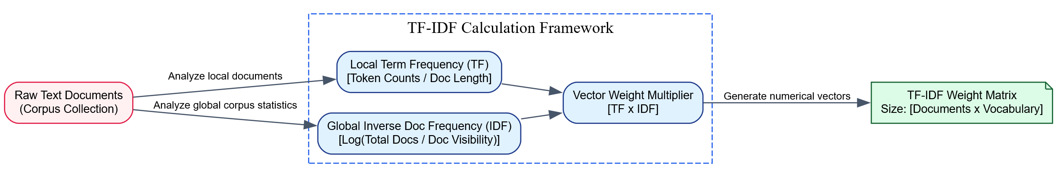Analytical Numerical Verification Example
Consider a small example corpus containing exactly $\left|D\right|=2$ text documents:
- Document 1 ($d_{1}$): “deep learning deep”
- Document 2 ($d_{2}$): “learning basics”
Let us trace the calculation of the exact $\text{TF-IDF}$ weight for the specific word “deep” inside Document 1 ($d_{1}$):

Step 1: Calculate $TF\left(\text{"deep"},d_{1}\right)$
- The term “deep” occurs $2$ times inside $d_{1}$.
- The total count of all terms in $d_{1}=3$.
$$TF\left(\text{"deep"},d_{1}\right)=\frac{2}{3}≈0.667$$

Step 2: Calculate $IDF\left(\text{"deep"},D\right)$
- The total document count $\left|D\right|=2$.
- The number of individual documents containing the word “deep” = 1 (it appears only in $d_{1}$).
$$IDF\left(\text{"deep"},D\right)=log\left(\frac{2}{1}\right)≈0.301$$

Step 3: Compute Final $\text{TF-IDF}$ Product
$$\text{TF-IDF}\left(\text{"deep"},d_{1},D\right)=0.667×0.301≈0.201$$
Conversely, if we evaluate a globally shared term like “learning”:
- It appears in both documents, so its global document visibility count is 2.
- Its resulting $IDF$ calculation drops to $log\left(2/2\right)=log\left(1\right)=0$.
- As a result, its final calculated $\text{TF-IDF}$ weight drops to $0$ across both documents, correctly identifying it as uninformative for distinguishing between the two texts.

5. Conclusion / Summary
The TF-IDF weighting scheme enhances basic word count models by scaling term frequencies based on how rare a word is across an entire corpus. While it introduces structural sparsity and cannot capture semantic word relationships, its statistical grounding makes it a highly effective baseline for informational indexing, search ranking algorithms, and classic text classification tasks. It bridges the gap between simple token counting and advanced, context-aware neural embeddings.

Neural Machine Translation (NMT)

1. Definition / Introduction
Neural Machine Translation (NMT) is an advanced, end-to-end algorithmic approach to automated language translation that utilizes deep artificial neural networks to map a full sentence from a source language to a corresponding sentence in a target language. This paradigm represents a significant evolution beyond traditional Statistical Machine Translation (SMT), which translated text by breaking sentences into isolated phrases and applying separate alignment models, translation tables, and language filters.
Instead of relying on fragmented pipelines, NMT uses a single, integrated neural network architecture—typically built as a Sequence-to-Sequence (Seq2Seq) framework—to read an entire input text stream, learn its structural semantic features, and generate an engineered translation output. It frames machine translation as a conditional language modeling task, directly calculating the conditional probability of producing a target sequence given a source sequence:
$$P\left(Y∣X\right)=\prod_{t=1}^{T_{y}}{P}\left(y_{t}∣y_{<t},X\right)$$
Where $X=\{x_{1},x_{2},…,x_{T_{x}}\}$ represents the sequence of input source tokens, and $Y=\{y_{1},y_{2},…,y_{T_{y}}\}$ represents the generated target language sequence.

2. Detailed Explanation

1. The Architectural Blueprint of Sequence-to-Sequence (Seq2Seq) Model
The standard engine of a Neural Machine Translation pipeline is the Sequence-to-Sequence (Seq2Seq) architecture. This framework consists of two main neural sub-components: an Encoder and a Decoder.

A. The Encoder Network
- Objective: The Encoder processes the variable-length input token sequence from the source language and compresses it into a fixed-length numeric vector that captures the semantic meaning of the text.
- Mechanism: The Encoder processes text step-by-step using recurrent units (such as Recurrent Neural Networks, Long Short-Term Memory networks, or Gated Recurrent Units) or parallel self-attention layers. At each step $t$, the network updates its internal hidden state $h_{t}$ based on the current word embedding input $x_{t}$ and the previous hidden state $h_{t-1}$:
$$h_{t}=f\left(x_{t},h_{t-1}\right)$$
- The Context Vector ($C$): Once the network processes the final source token ($x_{T_{x}}$), the final hidden state is extracted as the Context Vector ($C$). This vector acts as an informational bottleneck, compressing the entire semantic meaning of the source sentence into a single mathematical representation to be passed to the decoder.

B. The Decoder Network
- Objective: The Decoder takes the compressed context vector ($C$) from the encoder and unpacks it step-by-step to generate a sequence of target tokens in the destination language.
- Mechanism: The decoder is initialized by setting its starting hidden state $s_{0}$ equal to the context vector ($C$). At each generation index $t$, the decoder predicts the next target token $y_{t}$ by evaluating its current internal state $s_{t}$, the context vector $C$, and the previously predicted word embedding token $y_{t-1}$:
$$s_{t}=g\left(y_{t-1},s_{t-1},C\right)$$
- Output Processing: The decoder’s internal hidden representation is projected across a dense vocabulary layer using a Softmax activation function, converting the continuous values into an explicit probability distribution over the target vocabulary.

2. Sequence Search Strategies during Inference (Decoding)
When generating text at inference time, the NMT model determines the best sequence output using one of two decoding strategies:
- Greedy Decoding: At each step, the model selects only the single token with the highest absolute probability score. While computationally fast, this approach cannot undo mistakes; if the model picks a sub-optimal word early on, it can skew the remaining translation output.
- Beam Search Decoding: This strategy tracks a fixed number ($B$) of high-probability translation branches (called the beam width) concurrently at each step. It evaluates the cumulative conditional probability scores across these parallel paths, selecting the overall most coherent translation sequence.

3. The Information Bottleneck and the Need for Attention
A major limitation of basic Seq2Seq architectures is the Information Bottleneck. Forcing a neural network to compress an entire complex or long sentence into a single, fixed-size context vector ($C$) can lead to data loss, causing the model to struggle with sentences longer than 20–30 words.
Modern NMT architectures resolve this bottleneck using an Attention Mechanism. Instead of relying on a single static context vector, the attention layer allows the decoder to look back at all intermediate encoder hidden states ($h_{1}$ to $h_{T_{x}}$) at each generation step. It dynamically computes a weighted alignment score, enabling the decoder to focus on the specific source tokens most relevant to the current word being translated.

3. Key Points
- End-to-End Neural Architecture: Replaces complex, multi-stage statistical translation pipelines with a single unified neural network that optimizes translations directly.
- Distributed Vector Processing: Leverages dense continuous vector spaces, allowing the model to generalize across synonyms and vary sentence structures fluidly.
- Seq2Seq Framework Division: Uses a dedicated Encoder to compress the source language and a matching Decoder to generate the target translation sequence.
- Information Bottleneck Vulnerability: Basic fixed-vector architectures can lose contextual nuances when translating long, structurally complex sentences.
- Attention Layer Optimization: Modern models implement attention layers to let the decoder focus on specific input tokens dynamically during translation.

4. Diagram / Example

The Seq2Seq NMT Architecture Workflow

Descriptive Translation Example
Consider translating the French phrase “AI est intelligent” into the English translation “AI is smart”:
- The Encoder step: The network reads the tokens sequentially. The first node processes “AI”, generating vector representation $h_{1}$. The next node accepts “est” along with $h_{1}$ to create state vector $h_{2}$. Finally, “intelligent” is parsed, outputting the final context state vector $C$.
- The Bottleneck transition: Vector $C$ encapsulates the underlying semantic concept of the input phrase, independent of French grammatical rules.
- The Decoder step: The decoder accepts vector $C$ and initializes its system parameters. At output generation index $1$, it predicts the word “AI”. At index $2$, it evaluates the previous prediction “AI” alongside its internal hidden state to output “is”. Finally, at index $3$, it uses the sequence history to output “smart”, concluding the translation process upon generating an end-of-sentence token (<EOS>).

5. Conclusion / Summary
Neural Machine Translation transformed automated translation by replacing rule-bound statistical systems with an end-to-end, deep-learning network approach. Using a dual Sequence-to-Sequence (Seq2Seq) encoder-decoder design, NMT processes full sentence structures within continuous vector spaces, preserving semantic meaning across languages. While basic models face an informational bottleneck on long sentences, the integration of attention mechanisms ensures NMT remains a highly effective and scalable architecture for modern language translation.

Sequence-to-Sequence (Seq2Seq) Models

1. Definition / Introduction
A Sequence-to-Sequence (Seq2Seq) model is an end-to-end deep learning framework designed to map an input sequence of varying length to an output sequence of varying length. First introduced by Ilya Sutskever et al. and Cho et al., it addresses a critical limitation of traditional neural networks, which assume fixed-size input and output vectors.
In Natural Language Processing, Seq2Seq serves as the structural engine for tasks where the input and output dimensions do not line up precisely. For instance, the French phrase “Je vous en prie” (4 tokens) maps to the English translation “You are welcome” (3 tokens). The Seq2Seq architecture manages this structural shift by breaking the processing pipeline into two separate neural stages: an Encoder that compresses the incoming sequence into a dense vector representation, and a Decoder that uses that representation to generate the target sequence.

2. Detailed Explanation
The Seq2Seq model relies on a dual-network configuration. Traditionally, both the encoder and decoder are built using Recurrent Neural Networks (RNNs), Long Short-Term Memory (LSTM) networks, or Gated Recurrent Units (GRUs) to maintain sequential state awareness.

1. The Encoder Stage (Sequence Compression)
The input to the encoder is a variable-length sequence of source tokens $X=\{x_{1},x_{2},…,x_{T_{x}}\}$.
- Word Embedding: Each discrete textual token $x_{t}$ is transformed into a dense, continuous vector representation via an embedding layer matrix.
- Recurrent Step Calculations: The encoder processes the sequence chronologically, one token at a time. At each step $t$, the recurrent unit updates its internal hidden state $h_{t}$ based on the current input embedding $x_{t}$ and the previous hidden state $h_{t-1}$:
$$h_{t}=f\left(x_{t},h_{t-1}\right)$$
- Context Vector Extraction ($C$): The intermediate hidden states ($h_{1}$ to $h_{T_{x}-1}$) pass sequential context forward. Once the final token ($x_{T_{x}}$) is reached, the encoder produces its final internal hidden state, which is extracted as the Context Vector ($C$) (or “thought vector”). This vector compresses the full semantic meaning of the source text into a fixed-length numeric matrix.

2. The Decoder Stage (Sequence Generation)
The decoder is a generative language model tasked with producing the target token sequence $Y=\{y_{1},y_{2},…,y_{T_{y}}\}$.
- Initialization: The decoder initializes its first hidden state $s_{0}$ using the compressed context vector ($C$) from the encoder ($s_{0}=C$).
- Step-by-Step Autoregressive Generation: At generation step $t$, the decoder predicts the next output token based on three inputs: the previous predicted token $y_{t-1}$, its current internal state $s_{t}$, and the context vector $C$:
$$s_{t}=g\left(y_{t-1},s_{t-1},C\right)$$
- Vocabulary Projection: To convert the continuous hidden state $s_{t}$ into a specific word, the vector is projected across a dense linear layer matching the target vocabulary size ($\left|V_{\text{target}}\right|$). A Softmax activation function converts these raw logit values into a clean probability distribution over all words:
$$P\left(y_{t}∣y_{<t},X\right)=\text{Softmax}\left(W_{\text{out}}s_{t}\right)$$
- Termination Boundary: The decoder continues generating tokens sequentially until it produces a specialized End-of-Sentence token (<EOS>) or hits a predefined maximum token length limit.

3. Training Paradigm vs. Live Inference
The Seq2Seq architecture modifies its internal data routing depending on whether it is in the training phase or the live inference phase:
- Training with Teacher Forcing: During training, the model uses a technique called Teacher Forcing to maintain stability. Instead of feeding the decoder’s actual prediction from step $t-1$ as the input for step $t$, the pipeline bypasses mistakes by feeding the ground-truth target word from the training dataset. This prevents early errors from disrupting the rest of the generation sequence.
- Inference Pipeline: During live production deployment, ground-truth targets are unavailable. The decoder must operate autoregressively, taking its actual generated word output from step $t-1$ and feeding it directly as the input token for step $t$.

3. Key Points
- Variable-to-Variable Sequence Mapping: Handles sequence-mapping tasks where input and output lengths do not match.
- Modular Encoder-Decoder Design: Uses an Encoder to compress the input sequence into a vector and a Decoder to generate the target sequence.
- The Context Vector Bottleneck: Compresses the full semantic meaning of the source text into a single, fixed-size vector, which can lead to data loss on long sentences.
- Teacher Forcing Optimization: Uses ground-truth inputs during training to stabilize gradient calculations and accelerate model convergence.
- Foundation for Modern Generative AI: Formed the baseline sequence-processing architecture that paved the way for modern, transformer-based language models.

4. Diagram / Example

Detailed Structural Component Routing Diagram

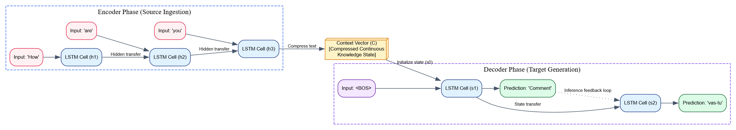Descriptive Conceptual Application Example
Consider an English-to-French translation task using a Seq2Seq model:
- Input Sequence: “How are you” ($T_{x}=3$).
- Processing: The encoder processes the tokens sequentially: “How” $→$ “are” $→$ “you”. It compresses the overall semantic intent—a conversational greeting directed at an individual—into a single numeric context vector $C$.
- Generation: The decoder accepts vector $C$ and receives a starting token (<BOS>). At step 1, it processes the context vector to output the French token “Comment”. In the next step, it evaluates the previous output “Comment” to generate the final token “vas-tu”, concluding the sequence upon producing an end-of-sentence marker (<EOS>) ($T_{y}=2$).

5. Conclusion / Summary
The Sequence-to-Sequence (Seq2Seq) architecture introduced a flexible framework for mapping variable-length input sequences to variable-length outputs. By decoupling sequence processing into an encoder compression stage and a decoder generation stage, it provided a robust solution for complex language tasks like machine translation. While the fixed-length context vector introduces a bottleneck for longer sequences, the foundational encoder-decoder structure of Seq2Seq remains central to modern generative NLP architectures.

PYQ May 2025 (Q6a): Describe the architecture of a Neural Machine Translation (NMT) model and discuss the role of Seq2Seq in NMT. [9 Marks]

1. Definition / Introduction
Neural Machine Translation (NMT) is an end-to-end algorithmic framework for automated language translation that utilizes deep artificial neural networks to map a full text sequence from a source language to a targeted sequence in a destination language. This paradigm directly addresses the structural limitations of legacy Statistical Machine Translation (SMT), which relied on disjointed pipelines consisting of separate phrase-alignment databases, translation tables, and independent language filters.
Instead of translating sentences by breaking them down into isolated phrase fragments, NMT models process the input sentence as a unified mathematical entity. The task is framed as a conditional language modeling objective, where the model maximizes the conditional probability of generating a target token sequence $Y=\{y_{1},y_{2},…,y_{T_{y}}\}$ given an input source sequence $X=\{x_{1},x_{2},…,x_{T_{x}}\}$:
$$P\left(Y∣X\right)=\prod_{t=1}^{T_{y}}{P}\left(y_{t}∣y_{<t},X\right)$$
The structural engine that enables this end-to-end processing is the Sequence-to-Sequence (Seq2Seq) framework, which bridges the gap between variable-length input sequences and variable-length output sequences across different grammatical landscapes.

2. Detailed Explanation

I. Comprehensive Architecture of an NMT Model
A standard Neural Machine Translation model consists of three core structural layer segments: the Embedding Layer, the Encoder Network, and the Decoder Network.

A. The Input Translation and Embedding Layer
- Objective: Text strings cannot be processed directly by neural networks. This layer maps discrete vocabulary tokens into dense continuous vectors.
- Mechanism: Source text tokens $X=\{x_{1},x_{2},…,x_{T_{x}}\}$ are passed through a learned vector embedding matrix $W_{\text{embed}}$. This matrix assigns each word an informational vector of a fixed size (typically $d=256$ or $d=512$). Within this space, words with shared semantic properties are positioned closer to one another.

B. The Encoder Network
- Objective: The encoder reads the sequence of word embeddings from the source language and compresses them into a single, dense continuous state vector that captures the semantic meaning of the sentence.
- Mechanism: Built using recurrent networks (such as LSTMs or GRUs) or modern self-attention Transformer blocks, the encoder processes tokens sequentially. At each input step $t$, the node updates its current internal hidden state $h_{t}$ using the incoming token vector $x_{t}$ and the preceding state $h_{t-1}$:
$$h_{t}=\text{EncoderRecurrentUnit}\left(x_{t},h_{t-1}\right)$$
- The Context Vector ($C$): When the encoder reaches the end of the sentence (the <EOS> token), it outputs its final internal hidden state. This vector, denoted as $C$ (the context or “thought” vector), acts as an informational bottleneck that encapsulates the semantic intent of the entire source sentence.

C. The Decoder Network
- Objective: The decoder accepts the compressed context vector ($C$) and processes it step-by-step to generate the corresponding translation sequence in the target language.
- Mechanism: The decoder initializes its first hidden state $s_{0}$ using the context vector $C$ ($s_{0}=C$). At each generation step $t$, the decoder updates its internal state $s_{t}$ based on the previous predicted token $y_{t-1}$, its previous hidden state $s_{t-1}$, and the context vector $C$:
$$s_{t}=\text{DecoderRecurrentUnit}\left(y_{t-1},s_{t-1},C\right)$$
- Vocabulary Projection: The continuous state vector $s_{t}$ is projected via a linear layer to match the target vocabulary size ($\left|V_{\text{target}}\right|$). A Softmax function maps these raw logit outputs into an explicit probability distribution:
$$P\left(y_{t}∣y_{<t},X\right)=\text{Softmax}\left(W_{\text{projection}}s_{t}\right)$$

II. The Critical Role of Seq2Seq in NMT
The Sequence-to-Sequence (Seq2Seq) model serves as the foundational structural blueprint for modern Neural Machine Translation. Its significance in NMT can be broken down into three key roles:

1. Managing Variable-Length Input and Output Sequences
In machine translation, sentences conveying identical meanings across different languages rarely match in token count or grammatical sequence. Traditional neural networks require rigid, fixed-size input vectors. Seq2Seq resolves this constraint by decoupling sequence processing into two distinct phases:
- The Encoder handles the variable-length input sequence ($T_{x}$) and maps it to a fixed-size internal representation.
- The Decoder takes this fixed internal representation and unpacks it to generate an independent variable-length output sequence ($T_{y}$).

2. Decoupling Syntactic Structures via the Semantic Bottleneck
Human languages use distinct grammatical layouts; for example, English follows a Subject-Verb-Object (SVO) structure, while Hindi uses a Subject-Object-Verb (SOV) structure. By funneling the input sequence through an intermediate context vector ($C$), Seq2Seq allows the encoder to focus entirely on capturing the semantic meaning of the source text, independent of the target language’s grammar rules. This leaves the decoder free to generate text tailored directly to the syntactic patterns of the target language.

3. Enabling Autoregressive Generation during Live Inference
Seq2Seq establishes an autoregressive generation loop required for text synthesis during live deployment. At each inference step, the decoder feeds its actual predicted word output from step $t-1$ back into the network as the input token for step $t$, allowing the model to construct fluent translation strings dynamically without requiring external supervision.

3. Key Points
- End-to-End System Integration: Replaces multi-stage statistical translation pipelines with a single neural network optimized directly for translation.
- Modular Encoder-Decoder Structure: Uses an encoder network to compress the source input and a matching decoder network to generate the target translation.
- Variable Sequence Management: Enables the mapping of source texts to target translations when input and output token counts differ.
- Semantic Bottleneck Vector: Compresses the underlying meaning of a source sentence into a continuous context vector, decoupling the grammatical rules of the source and target languages.
- Autoregressive Generation: Feeds the model’s previous word choices back into the decoder step-by-step to generate cohesive, fluent output sequences during live inference.

4. Diagram / Example

Detailed Component Routing Architecture

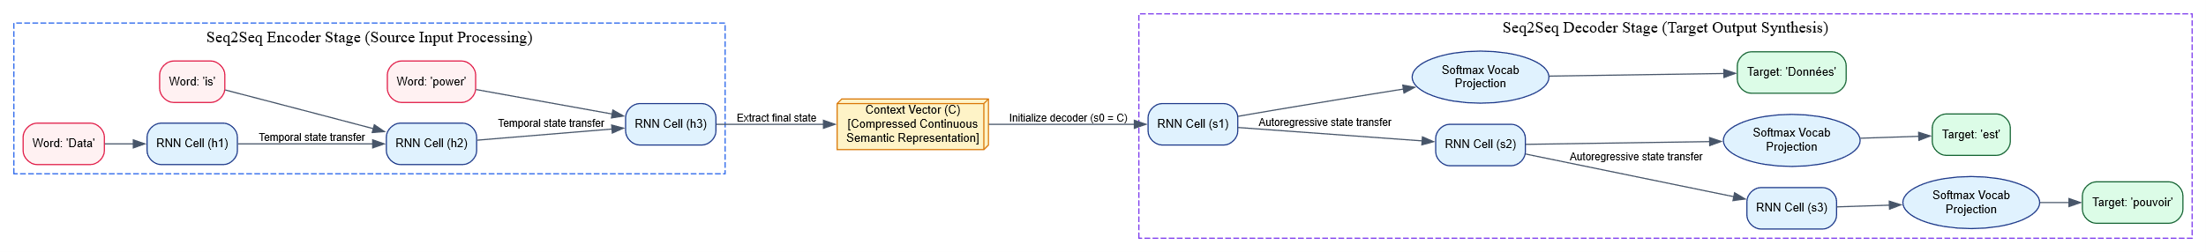Descriptive Translation Example
Consider translating the English sentence “Data is power” into the French equivalent “Données est pouvoir”:
- The Encoder Step: The NMT encoder reads the English tokens sequentially: “Data” $→$ “is” $→$ “power”. The network processes these inputs step-by-step to generate a final context vector $C$ that captures the underlying semantic meaning of the statement, independent of English grammar.
- The Bottleneck Step: The model transitions from the source language to the target language via the vector $C$, which encapsulates the core concept of the sentence.
- The Decoder Step: The decoder accepts vector $C$ to initialize its parameters and receives a structural start token (<BOS>). At step 1, it references the context vector to output the French word “Données”. At step 2, it evaluates the previous word choice “Données” alongside its current internal state to output “est”. Finally, at step 3, it generates the word “pouvoir”, concluding the translation process upon encountering an end-of-sentence marker (<EOS>).

5. Conclusion / Summary
Neural Machine Translation provides an end-to-end framework for language translation by replacing disjointed statistical systems with unified deep neural networks. Within this framework, the Sequence-to-Sequence (Seq2Seq) model serves as the core architectural engine. By dividing the processing pipeline into an encoder that compresses the source input and a decoder that generates the target output, Seq2Seq allows NMT models to handle variable-length sentences and map meaning effectively across different grammatical structures.

PYQ May 2024 (Q5b): Explain the architecture of a Seq2Seq model and its role in neural machine translation? [9 Marks] (Repeated/Overlapping Question)

1. Definition / Introduction
A Sequence-to-Sequence (Seq2Seq) model is an end-to-end generative deep learning architecture designed to map an input sequence of varying length to an output sequence of varying length. First introduced by Sutskever et al. and Cho et al., it addresses a critical limitation of traditional neural networks, which assume fixed-size input and output dimensions.
In the domain of Neural Machine Translation (NMT), the Seq2Seq framework serves as the structural engine. NMT frames language translation as a conditional sequence modeling task, where the model calculates the conditional probability of producing a target sequence $Y=\{y_{1},y_{2},…,y_{T_{y}}\}$ given a source sequence $X=\{x_{1},x_{2},…,x_{T_{x}}\}$:
$$P\left(Y∣X\right)=\prod_{t=1}^{T_{y}}{P}\left(y_{t}∣y_{<t},X\right)$$
The Seq2Seq model solves this task by decoupling the translation pipeline into two main stages: an Encoder that compresses the incoming sequence into a dense vector space, and a Decoder that uses that representation to generate the target sequence.

2. Detailed Explanation

I. Comprehensive Architecture of a Seq2Seq Model
The standard implementation of a Seq2Seq model comprises three primary structural building blocks: the Embedding Layer, the Encoder Network, and the Decoder Network. Traditionally, the recurrent blocks consist of Long Short-Term Memory (LSTM) networks or Gated Recurrent Units (GRUs) to maintain sequential state awareness.

A. The Token Embedding Layer
- Objective: Converts discrete categorical text characters or words into continuous representations.
- Mechanism: Source text tokens are mapped to a dense, continuous vector space via a trained embedding weight matrix $W_{\text{embed}}$. This step scales down high-dimensional sparse representations into a fixed feature space (typically $d=256$ or $d=512$), grouping semantically similar words close together.

B. The Encoder Network
- Objective: Processes the variable-length input token sequence from the source language and compresses its semantic meaning into a single, dense continuous state vector.
- Mechanism: The encoder processes the sequence chronologically, one token at a time. At each input step $t$, the recurrent unit updates its internal hidden state $h_{t}$ based on the current word embedding $x_{t}$ and the previous hidden state $h_{t-1}$:
$$h_{t}=\text{RecurrentUnit}\left(x_{t},h_{t-1}\right)$$
- The Context Vector ($C$): When the encoder processes the final source token ($x_{T_{x}}$), it outputs its final internal hidden state. This vector, denoted as $C$ (the context or “thought” vector), acts as an informational bottleneck, compressing the semantic intent of the entire source sentence into a single mathematical representation to be passed to the decoder.

C. The Decoder Network
- Objective: Unpacks the compressed context vector ($C$) and processes it step-by-step to generate a sequence of target tokens in the destination language.
- Mechanism: The decoder initializes its starting hidden state $s_{0}$ using the context vector $C$ ($s_{0}=C$). At each generation index $t$, the decoder predicts the next target token $y_{t}$ by evaluating its current internal state $s_{t}$, the context vector $C$, and the previously predicted word embedding token $y_{t-1}$:
$$s_{t}=\text{RecurrentUnit}\left(y_{t-1},s_{t-1},C\right)$$
- Output Processing: The continuous vector $s_{t}$ is projected across a dense linear layer matching the target vocabulary size ($\left|V_{\text{target}}\right|$). A Softmax activation function converts these raw logit outputs into a clean probability distribution over all target words:
$$P\left(y_{t}∣y_{<t},X\right)=\text{Softmax}\left(W_{\text{projection}}s_{t}\right)$$

II. The Structural Role of Seq2Seq in Neural Machine Translation
The Seq2Seq architecture acts as the fundamental structural engine of modern NMT. Its key roles are broken down below:

1. Resolving the Variable-Length Sequence Constraint
In machine translation, sentences conveying identical meanings across different languages rarely match in token count or word order. Traditional deep neural networks require rigid, fixed-size input vectors. Seq2Seq resolves this limitation by separating sequence processing: the Encoder reads the variable input sequence length ($T_{x}$) into a fixed-size internal representation, and the Decoder unpacks it to generate an independent variable-length output sequence ($T_{y}$).

2. Overcoming Structural and Syntactic Alignment Barriers
Human languages use distinct grammatical layouts; for example, English follows a Subject-Verb-Object (SVO) layout, while Japanese follows a Subject-Object-Verb (SOV) layout. By funneling the input sequence through an intermediate context vector ($C$), Seq2Seq allows the encoder to focus entirely on capturing the semantic meaning of the source text, independent of the target language’s grammar rules. This leaves the decoder free to generate text tailored directly to the syntactic patterns of the target language.

3. Autoregressive Output Synchronization during Inference
Seq2Seq establishes an autoregressive generation loop required for text synthesis during live deployment. At each inference step, the decoder feeds its actual predicted word output from step $t-1$ back into the network as the input token for step $t$, allowing the model to construct fluent translation strings dynamically without requiring external supervision.

3. Key Points
- Variable-Length Sequence Management: Enables the mapping of source texts to target translations when input and output token counts differ.
- Modular Encoder-Decoder Structure: Uses an encoder network to compress the source input and a matching decoder network to generate the target translation.
- Semantic Bottleneck Vector: Compresses the underlying meaning of a source sentence into a continuous context vector, decoupling the grammatical rules of the source and target languages.
- Autoregressive Token Generation: Feeds the model’s previous word choices back into the decoder step-by-step to generate cohesive, fluent output sequences during live inference.
- Teacher Forcing Optimization: Uses ground-truth target inputs during the training phase to stabilize gradient calculations and accelerate model convergence.

4. Diagram / Example

Detailed Component Routing Architecture

Descriptive Application Example
Consider an English-to-French translation task using a Seq2Seq NMT model:
- Input Sequence: “AI creates value” ($T_{x}=3$).
- Encoder Step: The encoder reads the tokens sequentially: “AI” $→$ “creates” $→$ “value”. It compresses the overall semantic intent—technological automation producing utility—into a single numeric context vector $C$.
- Decoder Step: The decoder accepts vector $C$ and receives a structural start token (<BOS>). At step 1, it references the context vector to output the French token “L’IA”. At step 2, it evaluates the previous word choice “L’IA” alongside its current internal state to output “crée”. Finally, at step 3, it generates the phrase “la valeur”, concluding the translation process upon encountering an end-of-sentence marker (<EOS>) ($T_{y}=3$).

5. Conclusion / Summary
The Sequence-to-Sequence (Seq2Seq) model is a foundational development in modern Neural Machine Translation (NMT). By dividing the processing pipeline into an encoder compression stage and a decoder generation stage, it provides a flexible framework for handling variable-length text sequences across different grammatical systems. While the fixed-size context vector introduces an informational bottleneck for longer sentences, the fundamental encoder-decoder design of Seq2Seq remains central to advanced generative NLP architectures.

Translation Metrics (BLEU Score & BERT Score)
PYQ May 2025 (Q6b - Part 1): Define BLEU Score and BERT Score as metrics for evaluating machine translation.

1. Definition / Introduction
Evaluating how well a machine translation system performs requires comparing its generated output (the candidate text) against one or more human-generated translations (the reference text). This section defines two prominent evaluation metrics used in Natural Language Processing: BLEU Score and BERT Score.
- BLEU (Bilingual Evaluation Understudy) Score: A traditional, string-matching metric that calculates the geometric mean of modified $n$-gram precisions between the candidate and reference translations, adjusted for length mismatches.
- BERT Score: A modern, neural evaluation metric that leverages dense, contextualized token embeddings from a pre-trained BERT model to calculate semantic similarity using cosine similarity matrices, moving beyond exact surface-level string matching.

2. Detailed Explanation

I. BLEU Score (Bilingual Evaluation Understudy)
Introduced by Kishore Papineni et al. at IBM, BLEU operates on a structural, word-level verification paradigm. It counts how many words or phrases in the machine-generated candidate translation appear in the human reference translation.

1. Modified n-gram Precision ($p_{n}$)
Standard precision can be easily gamed by repeating a single high-probability word (e.g., generating “the the the the” for a target reference sentence containing “the”). BLEU resolves this by capping the maximum count of any $n$-gram to the maximum number of times it appears in any single reference translation:
pn=C∈{Candidates}​n-gram∈C​Countclipn-gramC∈{Candidates}​n-gram∈C​Countn-gram
BLEU typically averages precisions from unigrams ($1$-grams) up to 4-grams ($n=1,2,3,4$).

2. The Brevity Penalty ($BP$)
Precision naturally favors short translations because generating fewer words makes it easier to ensure all of them are correct. To prevent models from outputting artificially brief fragments (e.g., translating a long sentence down to a single verified token), BLEU introduces a Brevity Penalty:
$$BP=\left\{\begin{matrix}1 & \text{if }c>r \\ e^{\left(1-r/c\right)} & \text{if }c≤r\end{matrix}\right.$$
Where $c$ is the total token length of the candidate translation sequence, and $r$ is the effective target reference sequence length.

3. Final BLEU Equation
The total metric score is computed by multiplying the brevity penalty by the exponential weighted geometric average of the modified precisions:
$$\text{BLEU}=BP×exp\left(\sum_{n=1}^{N}{w_{n}}logp_{n}\right)$$
(Typically, $N=4$ and uniform weights $w_{n}=\frac{1}{N}=0.25$ are used).

II. BERT Score
Developed by Tianyi Zhang et al., BERT Score addresses a key limitation of string-matching metrics: they penalize valid translations that use synonyms or paraphrasing instead of exact word matches. BERT Score handles this by replacing exact lexical string matching with continuous vector space similarity calculations.

1. Contextual Embedding Extraction
The candidate sentence $X$ and the reference sentence $Y$ are passed independently through a pre-trained BERT model. Instead of reducing words to static lookups, BERT generates a sequence of continuous contextual vectors:
- ${\vec{x}}_{i}$: Contextualized representation vector for candidate token at index $i$.
- ${\vec{y}}_{j}$: Contextualized representation vector for reference token at index $j$.

2. Cosine Similarity Matrix Generation
The metric builds a complete pairwise cross-similarity matrix by computing the cosine angle between every vector in the candidate sentence and every vector in the reference sentence:
$$\text{Similarity}\left(x_{i},y_{j}\right)=\frac{{\vec{x}}_{i}^{T}{\vec{y}}_{j}}{∥{\vec{x}}_{i}∥∥{\vec{y}}_{j}∥}$$

3. Precision, Recall, and F1 Formulation
Instead of relying on heuristic combinatorial alignments, BERT Score evaluates semantic coverage using greedy maximum-matching tracking across sentence matrices:
- BERT Recall ($R_{\text{BERT}}$): Measures how well the candidate translation captures the meaning of the reference text. For each token in the reference, it identifies and averages the highest-scoring matching token in the candidate:
RBERT=1Yyj∈Y​maxxi∈XxiTyj
- BERT Precision ($P_{\text{BERT}}$): Measures how much of the generated candidate translation is relevant to the reference text. For each token in the candidate, it identifies and averages the highest-scoring matching token in the reference:
PBERT=1Xxi∈X​maxyj∈YxiTyj
- BERT F1 Score ($F_{\text{BERT}}$): Combines precision and recall into a single balanced evaluation metric:
$$F_{\text{BERT}}=2×\frac{P_{\text{BERT}}×R_{\text{BERT}}}{P_{\text{BERT}}+R_{\text{BERT}}}$$

3. Key Points

BLEU Score:
- Exact Lexical Matching: Relies entirely on surface-level matches between word characters.
- Brevity Adjustment: Applies a length-based penalty to prevent models from gaming precision scores by outputting short, clipped fragments.
- Context Blindness: Evaluates text using rigid $n$-gram intervals, which can penalize structurally valid reorderings or the use of synonyms.
- Computationally Light: Very fast to calculate, making it an efficient option for live validation loops during training.

BERT Score:
- Semantic Vector Mapping: Evaluates translations in a continuous vector space, allowing it to recognize synonyms and paraphrasing without requiring exact character matches.
- Context-Aware Embeddings: Uses a pre-trained transformer model to generate word representations that adapt dynamically to the surrounding sentence structure.
- Greedy Alignment Strategy: Uses a maximum-value matching loop across cross-similarity matrices to align token meanings without manual engineering.
- Resource Intensive: Requires a deep neural network pass to generate embeddings, making evaluation slower and more computationally demanding.

4. Diagram / Example

Visual Comparison of Evaluation Paradigms

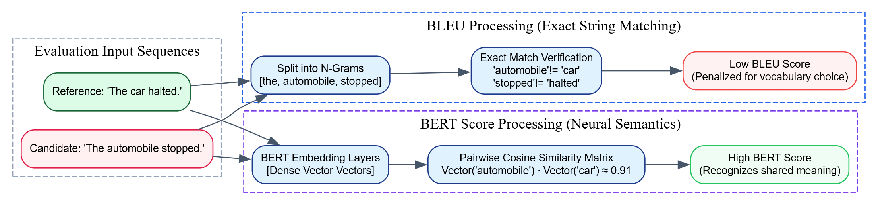Descriptive Conceptual Example
Consider evaluating a machine translation system where a human reference text reads: “The cat is smart.”, and the model outputs a candidate translation reading: “The feline is intelligent.”
- BLEU Evaluation: The model splits the sentences into $n$-grams and looks for exact character matches. While it matches “The” and “is”, it treats “feline” and “cat”, as well as “intelligent” and “smart”, as entirely incorrect matches because the strings do not align. As a result, the candidate receives a low BLEU score, penalizing a clear and accurate translation.
- BERT Score Evaluation: The sentences are passed through a pre-trained BERT encoder to generate dense contextual vectors for each token. When computing the similarity matrix, the dot product between the vector for “feline” (${\vec{x}}_{\text{feline}}$) and “cat” (${\vec{y}}_{\text{cat}}$) produces a high cosine similarity score (e.g., $0.89$), because the model recognizes their shared semantic meaning. The same occurs for “intelligent” and “smart”. Consequently, the system outputs a high BERT Score, accurately reflecting the quality of the translation.

5. Conclusion / Summary
BLEU Score and BERT Score represent two different generations of machine translation evaluation metrics. BLEU is a fast, lightweight approach that uses exact string matching and length constraints, making it a reliable choice for tracking structural precision during model training. BERT Score leverages dense contextual embeddings from transformer models to evaluate translations based on semantic meaning rather than exact word choices. This allows it to accommodate natural variations in vocabulary and phrasing, providing an evaluation that aligns more closely with human judgment.

Traditional Versus Neural Metrics for Machine Translation Evaluation
PYQ May 2025 (Q6b - Part 2): Compare traditional metrics with neural metrics in machine translation evaluation.

1. Definition / Introduction
Evaluating the quality of Machine Translation (MT) systems requires reliable, automated metrics that can compare a system’s generated output (the candidate text) against human-validated target translations (the reference text). Historically, this task relied on Traditional Metrics like BLEU, ROUGE, and METEOR, which use string-matching heuristics to count exact token overlaps.
With the emergence of deep learning, the field has transitioned toward Neural Metrics like BERTScore and COMET. These modern frameworks use pre-trained language transformers to evaluate translation quality within continuous vector spaces, allowing them to measure semantic similarity rather than relying on direct character-for-character string matching.

2. Detailed Explanation

I. Traditional Metrics (Lexical String-Matching Paradigm)
Traditional metrics treat text as a collection of discrete, categorical tokens. They measure translation quality by calculating the overlap of words or word sequences ($n$-grams) between the candidate translation and the reference translation.

Underlying Mechanics:
- BLEU (Bilingual Evaluation Understudy): Calculates the precision of $n$-grams (typically up to 4-grams) in the candidate text against the reference text, applying a brevity penalty to discourage overly short outputs.
- ROUGE (Recall-Oriented Understudy for Gisting Evaluation): Focuses primarily on recall, measuring the coverage of reference $n$-grams captured within the candidate text. It is commonly used for summarization and translation tasks.
- METEOR (Metric for Evaluation of Translation with Explicit ORdering): Improves on basic string matching by incorporating lemmatization (matching root words like “running” and “runs”) and synonym matching using external dictionaries like WordNet.

Core Architectural Limitations:
- The Synonymy Penalty: Traditional metrics treat words as independent entities. If a candidate text uses a valid synonym instead of the exact word in the reference (e.g., using “infant” instead of “baby”), traditional string-matching metrics penalize the choice as an outright error.
- Grammatical and Structural Inflexibility: These metrics rely on strict $n$-gram sequences, meaning they can penalize grammatically correct sentence reorderings if the word pairs do not align exactly with the reference text.
- Weak Correlation with Human Judgment: Because they focus on surface-level text alignment, traditional metrics can score poorly written, literal translations higher than fluid, natural-sounding ones that capture the true intent of the source text.

II. Neural Metrics (Semantic Vector Space Paradigm)
Neural metrics replace surface-level string matching with deep semantic evaluation. They use large, pre-trained language models (such as BERT or RoBERTa) to project both the candidate and reference texts into dense continuous vector spaces.

Underlying Mechanics:
- BERTScore: Passes the candidate and reference sentences through a pre-trained transformer model to extract contextual embedding vectors for each token. It then generates a pairwise similarity matrix using cosine distance calculations and uses a greedy matching strategy to compute precision, recall, and F1 scores based on semantic alignment.
- COMET (Crosslingual Optimized Metric for Evaluation of Translation): An advanced metric trained directly on human quality ratings. It evaluates translations by analyzing the source sentence alongside the candidate and reference texts, using a unified transformer backbone to predict an explicit quality score.

Key Advantages:
- Semantic Awareness: Because these metrics operate within a continuous vector space, they naturally recognize synonyms, paraphrasing, and idiom matches without requiring exact character alignment.
- Context-Dependent Evaluation: The underlying transformer models generate word embeddings dynamically based on the surrounding sentence structure, allowing the metric to differentiate meanings for homonyms or polysemous words.
- Stronger Alignment with Human Judgment: Neural metrics correlate much more closely with human assessments of fluency, adequacy, and overall translation quality.

3. Key Points

Traditional Metrics:
- Exact Lexical Matching: Relies entirely on direct character-level overlaps between string sequences.
- No Resource Overhead: Requires minimal computing power and can be executed quickly using simple statistical calculations.
- Semantic Blindness: Penalizes valid translations that use alternative phrasing, synonyms, or structural reorderings.
- Domain Independent: Operates purely on token frequencies, meaning its computational efficiency is unaffected by shifting technical domains or specialized vocabularies.

Neural Metrics:
- Continuous Vector Evaluation: Measures similarity using dense embeddings generated by deep learning models.
- High Computational Cost: Requires a dedicated neural network pass, making evaluation slower and dependent on GPU availability.
- Robust Paraphrase Recognition: Tolerates natural variations in vocabulary, accurately scoring semantically equivalent words.
- Model Biases: Can inherit underlying data biases or unexpected blind spots present within the pre-trained transformer model.

4. Diagram / Example

Architectural Breakdown Matrix
Evaluation Parameter | Traditional Metrics (e.g., BLEU, ROUGE) | Neural Metrics (e.g., BERTScore, COMET)
Primary Data Objective | Counts exact surface-level token overlaps. | Computes similarity over continuous vector spaces.
Context Awareness | Limited to fixed, localized $n$-gram windows. | Captures full sentence context using attention layers.
Handling of Synonyms | Penalizes alternative word choices as errors. | Accurately identifies and rewards shared meanings.
Computational Footprint | Extremely fast; requires minimal CPU resources. | Slower; requires memory-intensive GPU acceleration.
Correlation with Humans | Weak, especially for creative or varied phrasing. | Strong; aligns closely with professional human metrics.

Descriptive Conceptual Example
Consider evaluating a machine translation system where a human-validated reference translation states: “The presentation was brief.”, and a model outputs a candidate translation reading: “The talk was short.”
- 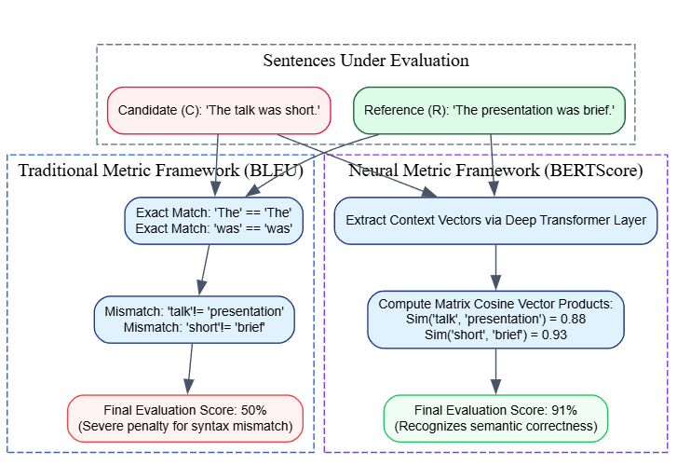BLEU (Traditional) Analysis: The sentences are split into $n$-grams. While the tokens “The” and “was” match perfectly, the pairs (“talk”, “presentation”) and (“short”, “brief”) are treated as complete mismatches because the characters do not align. As a result, the candidate receives a low BLEU score, penalizing a translation that is accurate and easy to understand.
- BERTScore (Neural) Analysis: The tokens are converted into dense contextual vectors. When computing the similarity matrix, the dot product between the vector for “talk” and “presentation” yields a high cosine similarity score (e.g., $0.88$), because the model recognizes their shared semantic meaning. The same occurs for “short” and “brief”. Consequently, the system outputs a high neural score, accurately reflecting the true quality of the translation.

5. Conclusion / Summary
Traditional and neural metrics offer different trade-offs for evaluating machine translation quality. Traditional metrics like BLEU are fast, lightweight, and rely on exact string matching, making them highly efficient for quick validation loops during model training. However, they struggle to accommodate natural variations in language. Neural metrics like BERTScore address this limitation by evaluating translations within continuous vector spaces, allowing them to measure semantic meaning rather than exact word choices. This provides an evaluation that aligns much more closely with human judgment, making them an essential tool for assessing modern generative NLP applications.

Neural Style Transfer
PYQ May 2025 (Q5b): Explain the process of Neural Style Transfer and discuss its applications.

1. Definition / Introduction
Neural Style Transfer (NST) is an optimization technique rooted in computer vision and computational intelligence that blends two distinct images—a Content Image and a Style Image—to create a single Generated Image. First introduced by Leon A. Gatys, Alexander S. Ecker, and Matthias Bethge in 2015, NST leverages the feature representations of pre-trained Deep Convolutional Neural Networks (CNNs), typically VGG-16 or VGG-19, to separate and recombine visual content and artistic style.
The core objective is to preserve the structural arrangement, objects, and shapes of the content source while superimposing the textures, brushstrokes, color palettes, and localized geometric patterns of the style source. This turns style transfer into an optimization problem focused on minimizing a combined loss function by adjusting pixel values directly via gradient descent.

2. Detailed Explanation

I. Core Architectural Concept
NST operates on the premise that different layers of a deep Convolutional Neural Network extract different levels of abstraction from an image:
- Lower Layers: Capture low-level features such as raw pixels, sharp edges, simple lines, and basic color gradients.
- Higher Layers: Discard precise pixel tracking in favor of high-level spatial layouts, abstract structures, and object configurations.
By utilizing a network pre-trained on a massive dataset (like ImageNet), NST can extract content features from the higher layers and style features across multiple intermediate layers simultaneously.

II. The Mathematical Loss Framework
The algorithm starts with a blank canvas or a copy of the content image (the Generated Image, $G$) and uses backpropagation to iteratively alter its pixels. This optimization loop is guided by three separate loss equations:

1. Content Loss ($L_{\text{content}}$)
Content loss measures how much the structural layout of the generated image ($G$) deviates from the original content image ($C$). It is calculated using the squared error between their respective feature activation maps in a deep layer $l$:
LcontentC,G,l=12i,j​FijlC-FijlG2
Where $F_{ij}^{l}$ represents the activation of the $i$-th filter at position $j$ in layer $l$.

2. Style Loss ($L_{\text{style}}$)
Style cannot be captured by evaluating single layer activations because it is distributed across an image as texture and color correlations. To capture these style textures, NST computes a Gram Matrix ($G^{l}$) for multiple layers. The Gram Matrix represents the inner product of the vectorized feature maps, capturing how different feature channels activate together across the image space:
Gijl=k​FiklFjkl
The style loss at a specific layer $l$ is the squared difference between the Gram Matrix of the style image ($A^{l}$) and the Gram Matrix of the generated image ($G^{l}$):
El=14Nl2Ml2i,j​Gijl-Aijl2
Where $N_{l}$ is the number of feature maps and $M_{l}$ is the height times the width of the feature maps. The total style loss aggregates these errors across a selection of multiple layers using specific weights ($w_{l}$):
LstyleS,G=l​wlEl

3. Total Loss Optimization Objective
The system minimizes a joint loss function that balances content preservation against stylistic alteration using two scalar hyperparameters, $α$ and $β$:
$$L_{\text{total}}\left(C,S,G\right)=αL_{\text{content}}\left(C,G\right)+βL_{\text{style}}\left(S,G\right)$$
By computing gradients with respect to the input image pixels ($\frac{∂L_{\text{total}}}{∂G}$), the algorithm updates the generated image iteratively until it converges on a final styled output.

3. Key Points
- Feature Representation Separation: Uses deep CNN layers to separate an image’s underlying structural content from its stylistic texture.
- Gram Matrix Representation: Computes style profiles by analyzing spatial correlations between different feature channels across multiple network layers.
- Pixel Optimization Paradigm: Unlike standard deep learning, which trains network weights, NST leaves network weights locked and optimizes the input image pixels directly.
- Loss Balance Control: Uses hyperparameters ($α/β$ ratio) to let users control whether the final output prioritizes clear content structure or expressive artistic style.
- End-to-End Generative Process: Relies on iterative optimization loops to blend content and style into a single image.

4. Diagram / Example

Optimization Feedback Loop Workflow

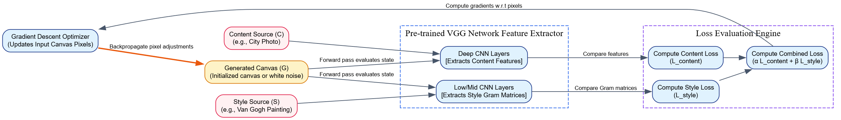Real-World Applications of NST
- Digital Art and Creative Entertainment: Enables graphic designers and digital artists to transform standard photos into stylized artwork that mimics classical painting techniques.
- Commercial Marketing and Video Production: Used in video editing and advertising to apply consistent visual themes and artistic textures across video frames or commercial brand imagery.
- Fashion and Architectural Prototyping: Helps designers project texturized patterns, cultural motifs, or unique fabric styles onto structural fashion mockups and 3D architectural models.
- Data Augmentation for Autonomous Systems: Used to expand training datasets by stylizing clear daytime driving photos into low-visibility weather variants (such as fog, snow, or rain), helping to train vision systems for autonomous vehicles.

5. Conclusion / Summary
Neural Style Transfer is an optimization framework that uses deep convolutional neural networks to separate and recombine image content and style. By using a multi-layered loss framework to balance structural precision against stylistic texture, NST changes how digital images are processed and created. Its applications range from digital art and creative production to generating synthetic training data for computer vision systems, making it a valuable tool across multiple domains.

Pretrained NLP BERT Model and its Applications

1. Definition / Introduction
BERT, which stands for Bidirectional Encoder Representations from Transformers, is a landmark self-supervised language representation model developed by Jacob Devlin et al. at Google in 2018. It fundamentally transformed the Natural Language Processing (NLP) landscape by introducing a deeply bidirectional contextual pre-training framework based on the Transformer architecture.
Unlike traditional text representation models that read sequences linearly from left-to-right or right-to-left independently, BERT is designed to pre-train deep bidirectional representations from unlabeled text by conditioning on both left and right context across all layers simultaneously. This structural formulation allows a pre-trained BERT model to be fine-tuned with just one additional output layer to create state-of-the-art models for a wide variance of downstream engineering tasks, such as question answering, sentiment analysis, and named entity recognition, without requiring heavy task-specific architectural modifications.

2. Detailed Explanation

I. Core Architectural Mechanics: How BERT Works
BERT’s core backbone is built entirely on the multi-layer bidirectional Transformer encoder architecture. Rather than relying on recurrent links (like LSTMs) that parse words step-by-step, BERT processes full sentences concurrently using self-attention mechanisms to map long-range dependencies between tokens.

1. Input Representation Engineering
Before text enters the hidden transformer stacks, BERT constructs a unified input embedding by summing three distinct token attributes:
- Token Embeddings: Transforms text tokens into dense continuous vectors. BERT uses the WordPiece vocabulary system ($30,000$ tokens) to break complex or out-of-vocabulary terms into smaller sub-word components (e.g., “embeddings” $→$ “embed”, "##dings"), completely neutralizing the Out-of-Vocabulary (OOV) problem.
- Segment Embeddings: Assigns a specific vector identifier to differentiate between two sentences (Sentence $A$ and Sentence $B$) when working on tasks like question answering or text pair checking.
- Position Embeddings: Because the underlying transformer mechanism processes all tokens concurrently and lacks structural sequential awareness, explicit vectors are added to indicate each token’s position in the sentence.

2. Specialized Non-Linguistic Structural Tokens
BERT injects specific markers directly into the input stream to manage classification and separation boundaries:
- [CLS] (Classification): Inserted at the absolute beginning of every sequence. The final hidden vector corresponding to this specific token acts as an aggregated representation of the entire sentence, making it ideal for downstream classification tasks.
- [SEP] (Separator): Inserted to separate distinct sentences or indicate structural sentence ends.
- [MASK]: Used to obscure words during the self-supervised pre-training phase.

II. The Dual Pre-training Framework
BERT achieves its deep bidirectional context by training on massive unlabeled text corpora (such as Wikipedia and BookCorpus) using two simultaneous self-supervised objectives:

1. Masked Language Modeling (MLM)
Traditional language models must be directional (left-to-right) because allowing a bidirectional view would let tokens “see themselves” in multi-layered networks, trivializing the task of predicting the next word. BERT overcomes this limitation using Masked Language Modeling (MLM):
- The algorithm randomly selects and replaces 15% of all input tokens across the corpus.
- Out of the chosen tokens, 80% are replaced with a literal [MASK] token, 10% are replaced with a completely random alternative word, and 10% are kept entirely unchanged (to prevent discrepancies during downstream fine-tuning where [MASK] tokens do not exist).
- The model’s objective is to predict the original identity of the obscured words by using the context from all other unmasked tokens in the sentence.

2. Next Sentence Prediction (NSP)
Many downstream NLP tasks, such as Natural Language Inference (NLI) and Question Answering, rely on understanding the structural relationship between two separate sentences. To teach the model these relationships, BERT pre-trains on the Next Sentence Prediction (NSP) objective:
- The network is fed pairs of sentences ($A$ and $B$).
- In 50% of cases, Sentence $B$ is the actual sequential sentence that follows Sentence $A$ in the text source (labeled as IsNext).
- In the remaining 50% of cases, Sentence $B$ is a completely random sentence pulled from a different part of the corpus (labeled as NotNext).
- The model uses the output vector of the [CLS] token to classify whether the sentence pair represents a genuine sequential transition.

III. Advantages Over Traditional Language Models
- Deeply Non-Linear Bidirectional Context: Traditional models like Word2Vec and GloVe generate static vectors that lack contextual flexibility. Earlier neural sequence models like ELMo combined independent left-to-right and right-to-left LSTMs, but this approach only captures shallow, concatenated context. BERT extracts rich context from both directions simultaneously across all transformer layers.
- Dynamic Contextualized Embeddings: BERT resolves the problem of polysemy. Instead of mapping a word to a single static vector, it evaluates the surrounding text to generate a dynamic vector. For example, it assigns distinct, context-specific representations to the word “apple” depending on whether it appears alongside the word “orchard” or “iPhone”.
- Unified Transfer Learning Backbone: It acts as a general-purpose feature extractor. Instead of requiring complex, task-specific architectures for different applications, teams can take a pre-trained BERT model and fine-tune it for a new task by adding a simple output layer, significantly reducing training time and data requirements.

3. Key Points
- Deeply Bidirectional Representation: Conditions on both left and right context simultaneously across all layers of the network.
- Transformer Encoder Foundation: Replaces recurrent connections with self-attention mechanisms, allowing the model to capture long-range token dependencies efficiently.
- Sub-word WordPiece Ingestion: Eliminates out-of-vocabulary errors by breaking complex words into smaller, sub-word tokens.
- Self-Supervised Pre-training Tasks: Uses Masked Language Modeling (MLM) and Next Sentence Prediction (NSP) to learn language patterns without human annotations.
- Efficient Fine-Tuning Paradigm: Allows a single pre-trained model to adapt to a wide variety of downstream tasks with minimal architectural changes.

4. Diagram / Example

Complete Data Routing Pipeline: Pre-training to Downstream Fine-Tuning

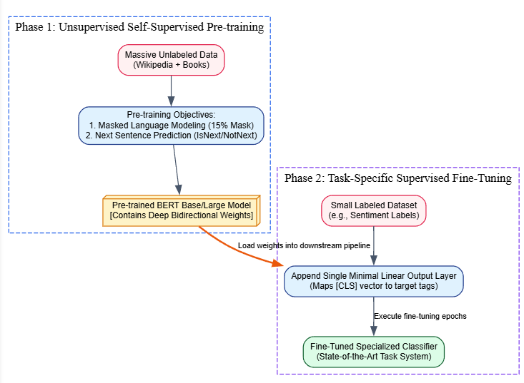Real-World Applications of BERT
- Search Engine Query Intelligence: Used by search engines (such as Google Search) to better understand the true search intent behind conversational queries. For example, in a search like “2019 brazil traveler to usa need visa”, BERT captures the significance of the word “to”, allowing the engine to return relevant visa requirements for Brazilian citizens traveling to the US, rather than showing generic US travel information.
- Automated Customer Question Answering Systems: Acts as the processing engine for reading comprehension platforms. The model reads an unstructured document, analyzes a user’s question, and extracts the precise text segment containing the answer.
- Toxic Text Filter Moderation: Powers automated content moderation systems on social media platforms. By analyzing context bidirectionally, it can distinguish between harmless banter and genuine toxicity or hate speech, even when complex or nuanced phrasing is used.
- Biomedical Clinical Information Extraction (BioBERT): Fine-tuned variants are deployed in healthcare analytics to automatically parse complex medical reports, clinical records, and research papers to extract relationships between specific symptoms, drugs, and medical diagnoses.

5. Conclusion / Summary
BERT represents a major milestone in Natural Language Processing by introducing deeply bidirectional contextual pre-training built on the Transformer architecture. By shifting the field away from shallow static embeddings and moving toward dynamic, context-aware vector spaces learned through Masked Language Modeling, BERT fundamentally changed how computers process human language. Its ability to serve as a versatile foundation model that can be fine-tuned for a wide variety of downstream tasks makes it an essential component of modern conversational AI, semantic search engines, and enterprise text classification pipelines.

PYQ May 2025 (Q5c): Discuss the significance of pre-trained NLP BERT models and provide examples of their applications. [5 Marks]

1. Definition / Introduction
BERT (Bidirectional Encoder Representations from Transformers) is a milestone self-supervised language representation model developed by Google in 2018. It fundamentally transformed the Natural Language Processing (NLP) landscape by shifting the field away from traditional context-blind text representations (such as Word2Vec or GloVe) and moving toward deeply contextualized word representations.
The core significance of a Pre-trained BERT Model lies in its underlying Transfer Learning paradigm. Instead of training an NLP network from scratch for every unique problem, a massive transformer-based network is first pre-trained on generic text corpora (like Wikipedia and BookCorpus) to learn the structural rules, syntax, grammar, and conceptual semantic abstractions of human language. This foundational “knowledge engine” can then be loaded and fine-tuned with just one minimal additional output layer to excel at various downstream specialized engineering tasks.

2. Detailed Explanation

I. The Significance of Pre-trained BERT Models
The profound architectural impact and operational value of deploying pre-trained BERT networks can be broken down into three major dimensions:

1. Deeply Non-Linear Bidirectional Context Awareness
Traditional language models were either entirely static (assigning a fixed vector to a word regardless of its position) or strictly directional (reading text from left-to-right, or left-to-right and right-to-left independently via concatenated LSTMs). BERT relies on a multi-layer Transformer encoder backbone that conditions on both left and right context across all layers simultaneously. This allows it to capture complex structural relations between words across an entire sentence at once.

2. Dynamic Semantic Vector Generation (Polysemy Resolution)
Because BERT generates word representations dynamically based on the surrounding sentence structure, it handles polysemous words exceptionally well. Instead of squeezing a token into a single fixed vector, it adjusts its math representation to match the text.
For instance, consider the word “run”:
- Sentence A: “The athlete will run a marathon.”
- Sentence B: “The company will run a new marketing campaign.”
- Sentence C: “There is a run in her stocking.”
A pre-trained BERT model generates three entirely distinct, context-specific vectors for the token “run” across these sentences, accurately isolating physical exertion from corporate execution and material damage.

3. Radical Reduction in Labeled Data Constraints and Compute Costs
Training massive multi-layer transformer networks from scratch requires millions of documents and weeks of intensive GPU cluster calculations. Pre-trained BERT models democratize state-of-the-art NLP performance:
- The computational bottleneck is absorbed once during Google’s self-supervised pre-training phase via Masked Language Modeling (MLM) and Next Sentence Prediction (NSP).
- Downstream developers can download these pre-trained weights and fine-tune them on small, domain-specific labeled datasets (containing only a few thousand samples) in a fraction of the time, achieving high accuracy with minimal computing resources.

3. Key Points
- True Bidirectional Encoder Backbone: Uses self-attention layers to analyze word context from both directions simultaneously across the entire sentence.
- Effective Transfer Learning Framework: Pre-trained on massive unlabeled datasets to capture general language structures before being fine-tuned for specific tasks.
- Dynamic, Context-Driven Embeddings: Resolves word meaning conflicts by altering a word’s vector representation based on its surrounding context.
- Mitigation of Labeled Data Scarcity: Enables high accuracy on specialized tasks using small labeled datasets during the fine-tuning phase.
- Neutralization of Out-of-Vocabulary (OOV) Terms: Implements the WordPiece vocabulary system to break unknown or complex words into smaller, manageable sub-word segments.

4. Diagram / Example

The BERT Transfer Learning Pipeline

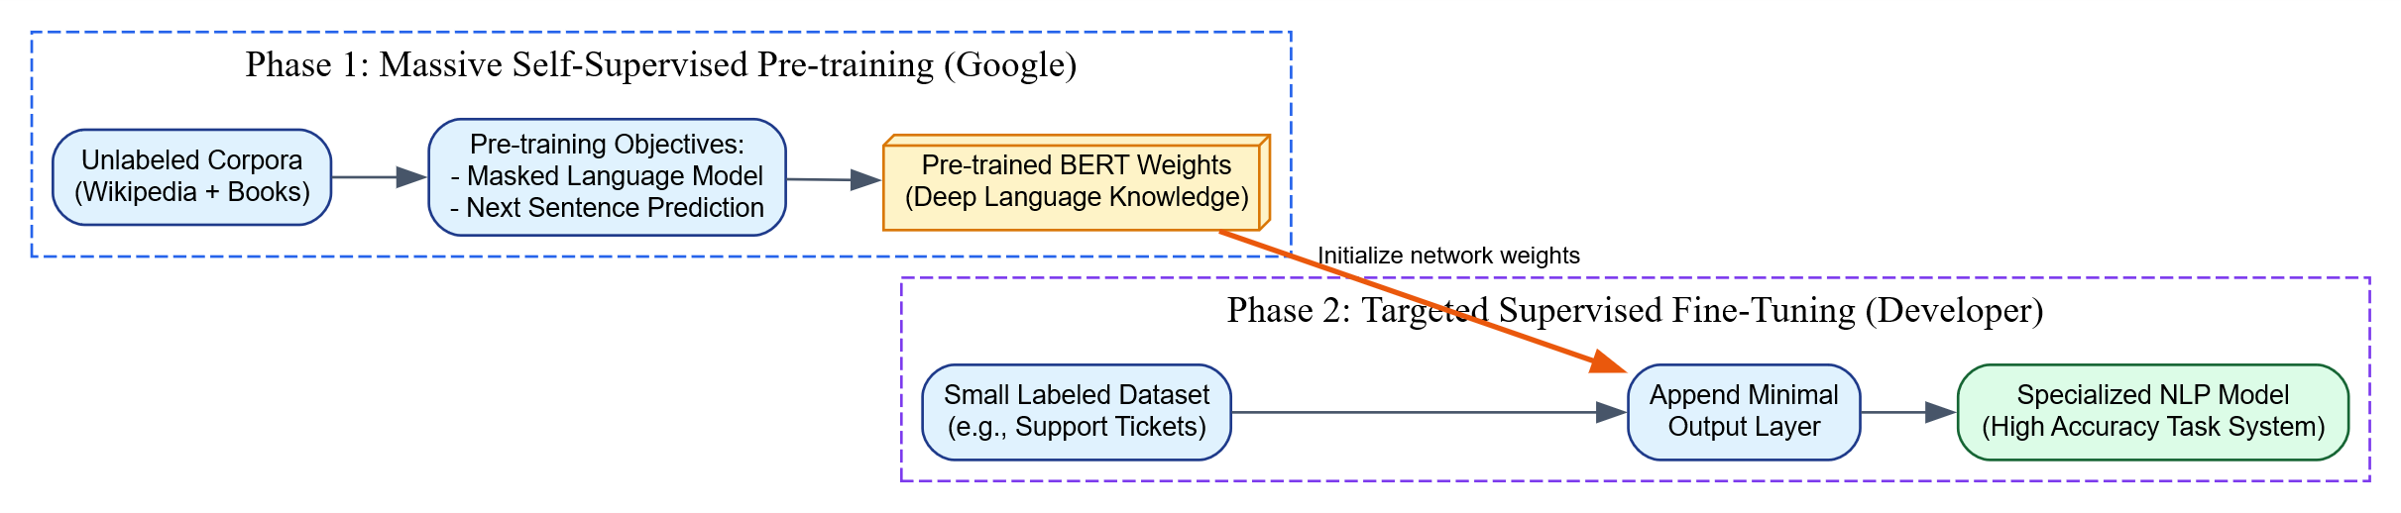Practical Real-World Applications of BERT
- Conversational Question Answering and Reading Comprehension: Powers advanced search systems and reading platforms. The pre-trained model reads an unstructured reference text, analyzes a user’s question, and isolates the exact text block containing the answer.
- Semantic Search Engine Intent Mapping: Deployed within modern web search architectures (such as Google Search) to better parse the structural meaning behind conversational search queries. It ensures search results align with the user’s true intent rather than simply matching surface-level keywords.
- Contextual Sentiment and Emotion Classification: Used by enterprise analytics platforms to evaluate product reviews, social media mentions, and support tickets, accurately classifying the underlying sentiment even when complex phrasing, negation, or sarcasm is present.
- Automated Named Entity Recognition (NER): Implemented in legal and financial workflows to automatically extract key entities—such as corporate names, monetary values, legal statutes, and dates—from dense, unstructured documents.
- Domain-Specific Variants (BioBERT / ClinicalBERT): The pre-trained framework can be adapted to highly technical domains. For example, BioBERT is fine-tuned on biomedical literature to help medical systems extract relationships between specific genes, complex chemical structures, and disease profiles.

5. Conclusion / Summary
Pre-trained NLP BERT models represent a major milestone in language processing by introducing deep, bidirectional context modeling built on the Transformer architecture. By shifting the field away from static, context-blind word lookups and providing a versatile transfer learning foundation, BERT enables highly accurate text processing with minimal task-specific data and computing resources. Its architecture forms the processing backbone for modern search engines, customer automation systems, and domain-specific analytical workflows across the AI industry.

PYQ May 2024 (Q6a): How does BERT (Bidirectional Encoder Representations from Transformers) work, and what are its advantages over traditional language models? [9 Marks]

1. Definition / Introduction
BERT, which stands for Bidirectional Encoder Representations from Transformers, is a seminal self-supervised language representation model introduced by Google AI in 2018. It marked a major paradigm shift in Natural Language Processing (NLP) by transitioning the field away from context-blind word lookups and moving toward deeply contextualized language understanding.
The fundamental innovation of BERT lies in its deeply bidirectional architecture. While traditional language models process text sequentially (either scanning left-to-right or stacking independent left and right passes), BERT conditions its representations on both left and right contexts simultaneously across all transformer network layers. This allows the system to read an entire sentence at once, capture structural syntax, and resolve ambiguous term meanings based on the overall sentence context.

2. Detailed Explanation

I. Core Architectural Mechanics: How BERT Works
BERT’s internal mechanics operate on a multi-layer Transformer Encoder backbone, utilizing self-attention mechanisms instead of recurrent links (like LSTMs) to track connections between words regardless of their distance from one another. Its execution pipeline is divided into two distinct operational segments: Input Feature Engineering and Dual Task Pre-training.

1. Input Representation Engineering
Before text arrays pass through the deep internal transformer stacks, tokens are transformed into a unified input vector. This vector is generated by mathematically summing three distinct embedding variants:
- Token Embeddings: Converts alphanumeric words into continuous vector blocks. BERT utilizes the WordPiece vocabulary system ($30,000$ tokens) which splits complex, variant, or out-of-vocabulary words into discrete sub-word units (e.g., “embeddings” $→$ “embed”, “##dings”). This structural division entirely neutralizes the Out-of-Vocabulary (OOV) failure state.
- Segment Embeddings: Assigns a specific vector identifier to distinguish between two distinct strings (Sentence $A$ and Sentence $B$) within a single input block, which is essential for text pairing or question-answering tasks.
- Position Embeddings: Because the underlying transformer mechanism processes all input tokens in parallel rather than sequentially, it lacks inherent awareness of token order. Explicit position vectors are added to indicate each token’s position in the sentence.

2. Specialized Structural Non-Linguistic Tokens
BERT appends dedicated markers directly into the input token array to manage processing boundaries:
- [CLS] (Classification): Inserted at the absolute beginning of every sequence. The final hidden state vector corresponding to this specific token accumulates an aggregated representation of the entire text sequence, serving as the primary input for downstream sequence classification layers.
- [SEP] (Separator): Implemented to indicate structural sentence splits or explicitly mark the end of an input string.
- [MASK]: Applied to obscure target tokens during the self-supervised learning cycle.

II. The Dual Self-Supervised Pre-training Framework
To learn human language patterns without manually labeled data, BERT undergoes pre-training on massive unstructured text collections (such as English Wikipedia and BookCorpus) using two simultaneous self-supervised training tasks:

1. Masked Language Modeling (MLM)
Standard language models can only be trained directionally (left-to-right) because a bidirectional view in multi-layered networks would let words implicitly “see themselves” in higher layers, making the task of predicting the next word trivial. BERT solves this limitation by using Masked Language Modeling (MLM), often called a “cloze task”:
- The network randomly selects and samples 15% of all input tokens across the text stream for evaluation.
- Out of the sampled tokens, 80% are replaced with a literal [MASK] token, 10% are swapped with a completely random word from the vocabulary dictionary, and 10% are kept entirely unchanged (to ensure the model remains robust when fine-tuned on real-world datasets where mask markers do not exist).
- The model leverages bidirectional self-attention layers to predict the original identity of the hidden tokens by analyzing the surrounding unmasked context.

2. Next Sentence Prediction (NSP)
To handle downstream NLP applications that depend on understanding the structural relationship between two separate sentences (such as Question Answering or Natural Language Inference), BERT implements the Next Sentence Prediction (NSP) objective:
- The network is systematically fed pairs of sentences ($A$ and $B$).
- In 50% of the training samples, Sentence $B$ is the actual consecutive sentence that follows Sentence $A$ in the source text (labeled as IsNext).
- In the remaining 50% of samples, Sentence $B$ is a random sentence pulled from a completely different document in the corpus (labeled as NotNext).
- The model passes the final vector from the [CLS] token through a binary classifier to predict whether the pair represents a genuine sequential transition.

3. Key Points

Advantages of BERT over Traditional Language Models:
- Deep, Simultaneous Bidirectionality: Traditional models like Word2Vec and GloVe rely on static context lookups. Advanced recurrent variants like ELMo train a left-to-right LSTM and a right-to-left LSTM independently, concatenating their outputs at the end. BERT evaluates left and right context concurrently across all hidden layers, capturing deeper syntactic and semantic nuances.
- Dynamic Polysemy Resolution: Traditional language models map each word to a single static vector. This means the token “bank” receives the identical mathematical vector whether it refers to a financial company or a river bank. BERT generates dynamic, contextualized embeddings, adjusting the token’s vector configuration based on the surrounding words in the active sentence.
- Unified General-Purpose Feature Engine: Unlike classic architectures that require task-specific modifications (e.g., adding distinct convolutional loops for sentiment analysis or sequential CRF modules for translation), a single pre-trained BERT engine can be fine-tuned for a wide range of applications by simply appending a minimal linear output layer.
- Mitilization of Labeled Data Scarcity: It shifts the computational burden away from task training. Because the pre-trained BERT base model already understands general language structures, developers can fine-tune it to high accuracy on small, domain-specific labeled datasets using minimal training epochs.

4. Diagram / Example

Performance Comparison Matrix for Exam Presentation
Assessment Parameter | Traditional Language Models (e.g., Word2Vec, GloVe, classic RNNs) | Pre-trained BERT Architecture
Contextual Footprint | Context-independent (Static) or Shallow Unidirectional. | Deeply Contextualized and Jointly Bidirectional.
Word Meaning Map | Fixed vector per word; cannot natively resolve polysemy. | Dynamic vector allocation based on live sentence context.
Feature Extraction Style | Relies heavily on task-specific architectures or manual feature engineering. | Uses a unified Transformer backbone with a simple, task-agnostic output layer.
Handling of OOV Terms | Fails or replaces unknown terms with a generic <UNK> token. | Uses WordPiece sub-word tokenization to eliminate out-of-vocabulary errors.
Data Training Overhead | Requires large labeled training datasets to achieve high task accuracy. | Leverages massive unlabeled data via self-supervised pre-training, minimizing labeled data requirements.

Descriptive Conceptual Example
Consider how a traditional model and BERT process the word “Apple” across two distinct sentences:
- Sentence 1: “Apple share prices dropped on the financial market today.”
- Sentence 2: “He ate a fresh, crisp red Apple for breakfast.”
- 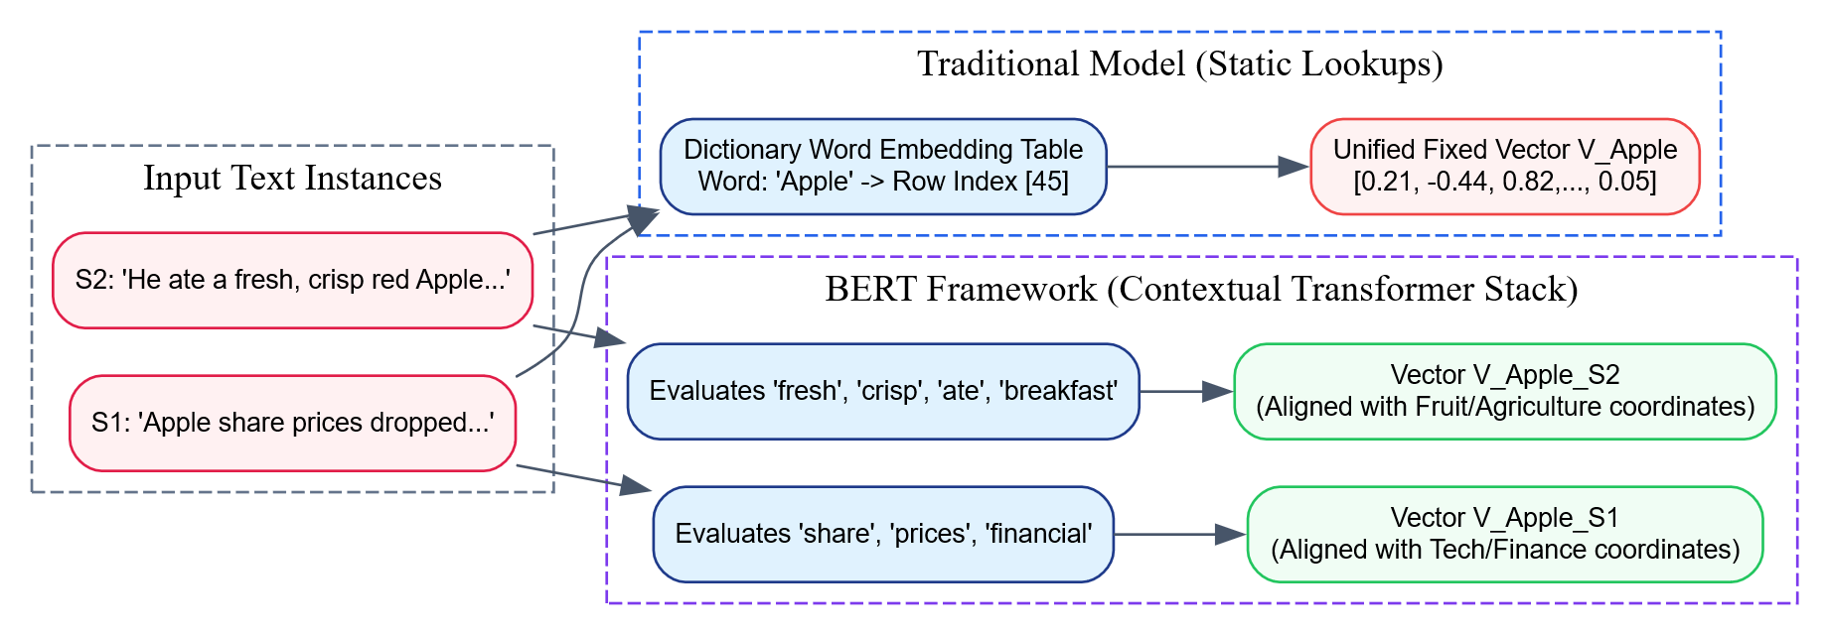Traditional Model Processing: The system strips away the context and looks up the token “Apple” in a static embedding matrix. Both sentences receive the exact same vector representation. As a result, down-stream classifiers struggle to distinguish between a multinational technology brand and an agricultural fruit product, which can lead to classification errors.
- BERT Model Processing: BERT ingests the full sentences in parallel. When processing Sentence 1, the bidirectional self-attention layer connects “Apple” with contextual terms like “share”, “prices”, and “financial”, shifting its vector representation into a tech-corporate feature coordinate space. For Sentence 2, the attention layers focus on words like “fresh”, “crisp”, and “ate”, shifting the output vector into an agricultural/food coordinate space, resolving the polysemy mismatch.

5. Conclusion / Summary
BERT represents a milestone development in Natural Language Processing by introducing deep, bidirectional context modeling built on the Transformer architecture. By replacing rigid, static vocabulary lookups with dynamic contextual embeddings optimized through Masked Language Modeling (MLM) and Next Sentence Prediction (NSP), BERT enables systems to capture the subtle nuances of human language. Its versatile transfer learning foundation allows a single pre-trained architecture to be fine-tuned for a wide variety of specialized tasks, making it a foundational model for modern text classification, semantic search engines, and complex conversational AI.

Unit VI: Artificial Immune Systems

Topic 1: The Natural Immune System
This section maps directly to the following university question:
- PYQ May 2025 (Q8b - Part 1): Explain the concept of the natural immune system. [Marks combined with Part 2]

1. Definition / Introduction
The Natural Immune System (NIS) is a highly complex, decentralized, and adaptive biological defense network found within living organisms. Its primary objective is to maintain physiological homeostasis and preserve cellular integrity by continuously monitoring, detecting, identifying, and neutralizing pathogenic intrusions (such as bacteria, viruses, fungi, and parasites) as well as internal malfunctions (such as cancerous cellular mutations).
In the context of Computational Intelligence (CI), the natural immune system serves as the biological inspiration for Artificial Immune Systems (AIS). The NIS is treated as an advanced information-processing structure characterized by pattern recognition, distributed autonomous control, reinforcement learning, error-tolerant identification, and long-term memory management. Its operational essence relies on the robust distinction between Self (the organism’s legitimate, healthy cellular components) and Non-Self (foreign, harmful entities or abnormal cellular variations).

2. Detailed Explanation
The biological architecture of the natural immune system functions through a multi-layered, coordinated defense network that integrates structural barriers, generalized cellular defenses, and targeted adaptive responses.

I. Multi-Layered Defense Architecture
- Physical and Chemical Barriers (Anatomical Defense): The first line of defense consists of skin tissue, mucous membranes, and chemical secretions (such as gastric acids and antimicrobial enzymes). These components block pathogens mechanically and chemically from accessing internal tissues.
- Innate Immune System (Non-Specific Defense): If a pathogen bypasses the anatomical barriers, the innate immune system activates immediately. This system reacts uniformly to all threats without requiring previous exposure. It relies on phagocytic white blood cells (such as macrophages and neutrophils) and soluble plasma proteins to engulf foreign particles, cause inflammation, and alert the broader immune network.
- Adaptive Immune System (Specific Defense): If the innate response cannot clear the infection, the adaptive immune system engages. This system creates a targeted, pathogen-specific counterattack. It adapts dynamically to completely unfamiliar pathogens, eliminates them efficiently, and retains a permanent memory of the encounter to prevent future reinfections.

II. Primary Cellular Mechanics of Adaptive Immunity
The adaptive immune response is driven primarily by specialized white blood cells called Lymphocytes, which circulate through the blood and lymphatic vessels:
- T-Lymphocytes (T-Cells): Generated in the bone marrow and matured within the thymus gland, T-cells manage Cell-Mediated Immunity. They are sub-divided into:
  - Helper T-Cells ($CD4^{+}$): Act as communication coordinators, scanning molecular structures presented by antigen-presenting cells to trigger B-cell activation and chemical deployment.
  - Killer/Cytotoxic T-Cells ($CD8^{+}$): Directly target and destroy body cells that have been compromised by viruses or altered by malignant mutations.
- B-Lymphocytes (B-Cells): Developed and matured within the bone marrow, B-cells manage Humoral Immunity. Each B-cell presents unique surface receptors (antibodies) capable of binding to specific foreign molecular configurations, known as Antigens.

III. Fundamental Computational Properties of the NIS
The structural mechanics of the biological immune system provide several properties that are useful for computational modeling:
- Self/Non-Self Discrimination: The system screens developing lymphocytes to eliminate any that bind to the body’s own healthy tissues. This process ensures the immune network attacks only foreign threats and maintains self-tolerance.
- Clonal Selection and Hypermutation: When a B-cell encounters a matching foreign antigen, it reproduces rapidly (Clonal Selection). During this replication, its genetic code undergoes high rates of mutation (Somatic Hypermutation), refining the binding efficiency of successive generations to neutralize the pathogen more effectively.
- Immune Memory: After clearing an infection, the system preserves a fraction of the optimized lymphocytes as long-lived Memory Cells. If the same pathogen returns, these cells trigger a rapid response that neutralizes the threat before it can cause illness.
- Decentralized and Distributed Processing: The system operates without a central coordinator. Autonomous immune cells interact locally throughout the body, providing high resilience—the failure of individual cells does not compromise the overall integrity of the network.

3. Key Points
- Decentralized Biological Network: Operates autonomously without a central controlling organ, relying on local cellular interactions to coordinate system-wide defenses.
- Binary Classification Paradigm: Continually distinguishes between healthy host tissue (Self) and foreign or hazardous elements (Non-Self).
- Dual Operational Strategy: Integrates a fast, generalized Innate Layer with a targeted, highly precise Adaptive Layer.
- Dynamic Feature Optimization: Uses clonal selection and somatic hypermutation to iteratively improve cellular affinity toward unfamiliar target antigens.
- Long-Term Pattern Memory: Preserves specialized memory cells post-infection, allowing for immediate recognition and defense upon subsequent exposures.

4. Diagram / Example

Multi-Tiered Response Hierarchy of the Natural Immune System

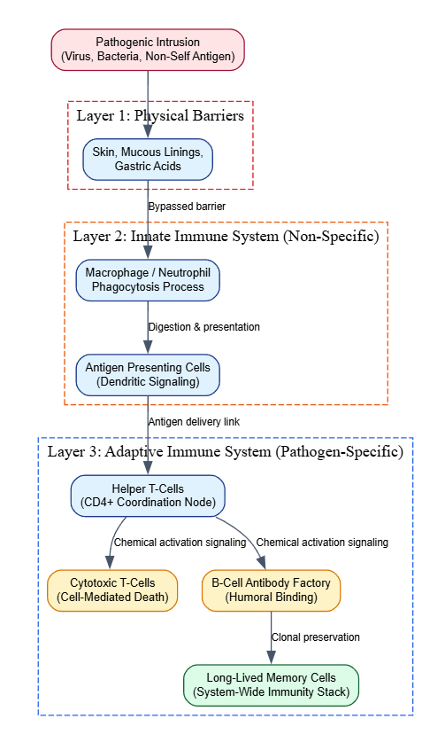Descriptive Biological Example
Consider how the body responds to an influenza virus intrusion:
- The virus evades nasal mucous linings (Physical Barrier failure) and enters respiratory tissues.
- Local macrophages detect the foreign virus and begin engulfing particles blindly (Innate Immune response). This causes local inflammation and recruits specialized dendritic cells.
- These dendritic cells ingest the viral proteins, travel to the nearest lymph node, and present the viral molecules on their cell surface to Helper T-cells.
- The matching Helper T-cell activates and releases chemical signals that trigger specific B-cells. These B-cells reproduce rapidly and mutate to produce targeted antibodies that bind to and neutralize the virus.
- Once the virus is cleared, the active B-cells die off, but a subset remains behind as Influenza Memory Cells, providing long-term immunity against future infections from that specific viral strain.

5. Conclusion / Summary
The Natural Immune System is a highly effective, decentralized multi-layered defense network that preserves an organism’s health through pattern recognition and adaptive learning. By balancing a fast, generalized innate response with a highly targeted adaptive response, it protects the body from a shifting landscape of threats. Its core properties—including self/non-self discrimination, autonomous decentralized control, clonal selection, and long-term memory—provide the structural blueprint for developing Artificial Immune System algorithms used to solve complex anomaly detection, pattern recognition, and optimization problems in computational intelligence.

Artificial Immune Models
PYQ May 2024 (Q7a): Explain the concept of Artificial Immune Models and their significance in computational intelligence?

1. Definition / Introduction
Artificial Immune Models (AIM) are adaptive, bio-inspired computational frameworks designed within Computational Intelligence (CI) that emulate the structure, defense mechanisms, and information-processing principles of the biological or natural immune system. The field that unifies these approaches is known as Artificial Immune Systems (AIS).
The primary objective of Artificial Immune Models is to utilize the biological immune system’s properties—including pattern recognition, distributed autonomous control, learning, error tolerance, and memory management—to construct robust engineering problem-solvers. In computational frameworks, an immune system is viewed as an advanced, decentralized, anomaly-detection mechanism. At its core, it frames computational problems around the binary classification of data patterns into Self (normal, authorized, or legitimate system parameters) and Non-Self (anomalous, malicious, or foreign data anomalies).

2. Detailed Explanation

I. Core Foundational Concepts of Artificial Immune Models
To understand how Artificial Immune Models function, biological components must be mathematically mapped into abstract computational structures:
- Antigens and Shape Space: In biology, an antigen is any foreign particle that triggers an immune response. In computational models, an Antigen represents an input vector, target pattern, or data point under evaluation ($A=\{x_{1},x_{2},…,x_{n}\}$). The continuous coordinate plane where these features reside is called the Shape Space. The geometric or symbolic distance between coordinates defines the level of compatibility between components.
- Antibodies and Receptors: In computational models, Antibodies or white blood cells are modeled as candidate solution vectors, network nodes, or classification detectors ($D=\{y_{1},y_{2},…,y_{n}\}$). These detectors are initialized throughout the shape space to monitor and identify target antigens.
- Affinity and Distance Metrics: The binding strength between an antibody receptor and an antigen is defined as Affinity. Mathematically, affinity is inversely proportional to the spatial distance between vectors in the shape space. It is quantified using standard metric distance formulas, such as Euclidean Distance for continuous spaces or Manhattan Distance for discrete domains:
$$\text{Distance}\left(A,D\right)=\sqrt{\sum_{i=1}^{n}{{\left(x_{i}-y_{i}\right)}^{2}}}$$
- If the calculated distance falls below a predefined cross-reactive metric boundary called the Affinity Threshold ($ϵ$), the detector triggers an active recognition event.

II. Primary Computational Architectures of Artificial Immune Models
The field of Artificial Immune Models is divided into four primary algorithmic abstractions, each mirroring a specific biological theory:

1. Negative Selection Model (For Anomaly Detection)
Inspired by how the thymus gland filters out self-reactive T-cells, this model generates detectors that match only anomalous data.
- Process: The system compiles a dedicated reference set of normal parameters (Self Set). It then generates candidate detector vectors at random. If a candidate vector matches any data point in the Self Set, it is discarded. If it fails to match, it is retained as a valid anomaly detector.
- Use Case: Once trained, this independent collection of detectors is deployed to monitor live systems. If a live data point triggers a detector match, it is immediately flagged as a Non-Self anomaly, making it useful for computer network intrusion detection and equipment fault identification.

2. Clonal Selection Model (For Optimization)
Emulates how the immune system refines its antigen-binding efficiency through selective reproduction and targeted mutations.
- Process: High-affinity detectors that successfully locate or match target parameters are selected for replication (Cloning). The number of clones generated is directly proportional to the detector’s affinity score. During replication, these clones undergo mutations (Somatic Hypermutation), where the mutation rate is inversely proportional to affinity—allowing higher-scoring solutions to perform fine-grained local tuning while lower-scoring solutions explore broader areas of the shape space.

3. Immune Network Model (For Clustering and Data Representation)
Based on Jerne’s Idiotypic Network Theory, this model assumes immune cells interact not only with external antigens but also with each other to maintain balance.
- Process: Detectors can stimulate or suppress one another based on mutual affinity. This creates a self-organizing network where stable clusters form to represent data structures natively without requiring centralized coordination.

4. Danger Theory Model (For Context-Aware Alerting)
Addresses a limitation of the classical Self/Non-Self model, which can struggle with normal system changes (such as software updates) that trigger false positives.
- Process: The model requires two validation signals to trigger an alert: a target data match and a co-stimulatory Danger Signal emitted by local system components experiencing actual damage or functional disruption (e.g., high CPU usage or system errors).

III. Significance in Computational Intelligence
Artificial Immune Models introduce several properties that enhance classical Computational Intelligence workflows:
- Decentralized and Distributed Processing: Like the natural immune system, AIS algorithms operate without a central coordinator. Autonomous agents interact locally to detect anomalies or optimize parameters, making the overall system resilient to single-point failures.
- Robust Dynamic Adaptation: Unlike fixed rule-based security systems, AIM platforms continually update their detector populations via mutation and selection loops, allowing them to adapt to changing data streams and recognize completely novel threats.
- Noise and Error Tolerance: Recognition relies on an affinity threshold rather than exact character matches. This allows the model to generalize across noisy datasets, making it reliable for real-world applications like pattern recognition.
- Long-Term Memory Maintenance: Successful configurations are preserved as memory vectors, allowing the system to rapidly re-engage and neutralize recurring anomalies or optimization challenges.

3. Key Points
- Biological Algorithmic Abstraction: Translates biological immune defenses into mathematical vector operations over a structured feature space.
- Binary Classification Framework: Specializes in separating complex datasets into baseline normal patterns (Self) and anomalous pattern variations (Non-Self).
- Affinity-Driven Matching: Quantifies recognition events using spatial distance metrics evaluated against an affinity threshold ($ϵ$).
- Four Core Model Typologies: Includes Negative Selection, Clonal Selection, Immune Network, and Danger Theory models.
- Decentralized Resilience: Operates via distributed, autonomous interactions, eliminating reliance on a single central controller.

4. Diagram / Example

Data Mapping Pipeline of Artificial Immune Models

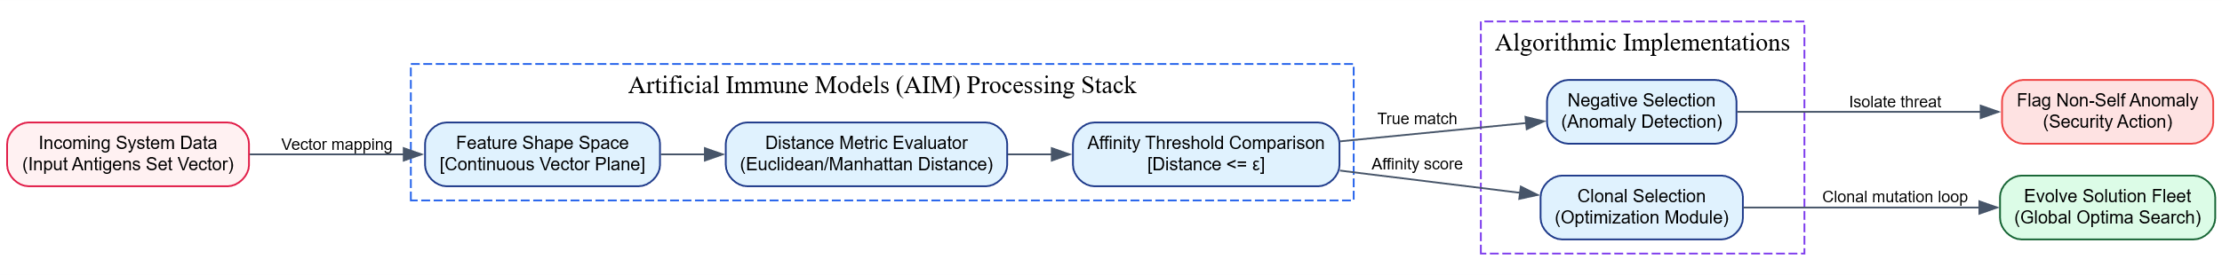Detailed Conceptual Application Example
Consider deploying an Artificial Immune Model based on the Negative Selection paradigm to protect an industrial manufacturing facility’s IoT sensor network against cyber-attacks and mechanical failures:
- Self Space Compilation: During normal operations, the system records data from temperature, pressure, and vibration sensors to establish a Self Set vector space representing safe operating parameters.
- Detector Generation: The algorithm generates a large pool of random candidate detector vectors within the multi-dimensional shape space. Any candidate vector that falls within the safe “Self Set” zone is automatically eliminated, ensuring the remaining Mature Detectors monitor only abnormal parameter zones.
- Live Monitoring (Antigen Encounter): During production, real-time sensor streams are treated as incoming Antigens. The metric engine calculates the Euclidean distance between these real-time streams and the mature detectors.
- Anomaly Classification: If a sensor vector exhibits anomalous behavior (e.g., high temperature combined with low pressure) due to a cyber-intrusion or mechanical failure, its coordinates will shift into the non-self territory, matching a mature detector. Because the calculated distance drops below the affinity threshold ($ϵ$), the model flags the event as a Non-Self anomaly, alerting operators to the specific issue.

5. Conclusion / Summary
Artificial Immune Models provide a robust, decentralized, and adaptive framework for computational intelligence by translating the principles of biological defense into mathematical structures. By transforming complex data patterns into antigens and using distance-based affinity metrics to evaluate them, these models excel at complex pattern recognition, anomaly detection, and optimization tasks. Their ability to adapt continuously to novel threats without relying on a centralized controller makes them an essential tool for building modern, resilient AI architectures, such as network security systems and autonomous anomaly detectors.

PYQ May 2025 (Q8b - Part 2): Compare it [natural immune system] with artificial immune models. [5 Marks total for Q8b]

1. Definition / Introduction
Evaluating biological defense mechanisms alongside engineering applications requires a systematic look at both the Natural Immune System (NIS) and Artificial Immune Models (AIM).
- The Natural Immune System is an organic, decentralized biological network composed of specialized organs, chemical secretions, and signaling cells (such as T-cells, B-cells, and dendritic cells). Its primary objective is to maintain biological homeostasis and defend a living organism against physical pathogens or internal mutations.
- Artificial Immune Models are computational abstractions within Computational Intelligence (CI) that translate these organic defense principles into mathematical vectors, distance metrics, and optimization routines.
The structural connection between them relies on mapping biological pattern-recognition techniques onto a digital feature space. This setup frames complex engineering challenges around classifying data strings into baseline normal states (Self) or anomalous variations (Non-Self).

2. Detailed Explanation
To map biological immunity to digital engineering, components must be mathematically translated from biological structures to continuous vector spaces.

I. Mapping Structural Components
- Antigen $↔$ Input Data Feature Vector: In biology, an antigen is an invading molecular structure that triggers an immune response. In computational models, an antigen is modeled as a multi-dimensional data point or input vector under review ($A=\{x_{1},x_{2},…,x_{n}\}$).
- Antibody / Lymphocyte $↔$ Anomaly Detector Node: Biological B-cells and T-cells act as specialized surveillance agents that scan the body for matching threats. In AIM, these are represented as engineered detector profiles or candidate solution vectors ($D=\{y_{1},y_{2},…,y_{n}\}$) scattered across the data space.
- Chemical Binding Affinity $↔$ Metric Distance Math: The organic attraction and physical binding efficiency between an antibody receptor and an antigen is known as affinity. Computational systems quantify this relationship using geometric or symbolic spatial distances. The standard approach calculates the Euclidean Distance between the coordinates of an input antigen and a mature detector node:
$$\text{Distance}\left(A,D\right)=\sqrt{\sum_{i=1}^{n}{{\left(x_{i}-y_{i}\right)}^{2}}}$$
- If the calculated spatial distance drops below a specific metric threshold called the Affinity Threshold ($ϵ$), the model flags a cross-reactive match, triggering an active classification or optimization alert.

II. Mapping Functional Paradigms
The operational behaviors of the natural immune system map directly to distinct computational algorithms within Artificial Immune Models:
- T-Cell Maturation in Thymus $↔$ Negative Selection Algorithm: The human body eliminates developing T-cells that react against its own healthy tissues to prevent autoimmune disorders. The Negative Selection Model replicates this behavior by evaluating randomly generated candidate detectors against a baseline profile of normal data (Self Set). Any candidate vector that falls within this normal zone is discarded. The remaining, non-reactive detectors are retained to monitor live production data, instantly flagging any matches as foreign (Non-Self) anomalies.
- B-Cell Proliferation & Mutation $↔$ Clonal Selection Algorithm: When a biological B-cell matches an active antigen, it replicates rapidly to mount a targeted defense. The Clonal Selection Model uses this concept for global optimization tasks. The system selects high-performing detector probes for replication (Cloning). During this process, these clones undergo mutations (Somatic Hypermutation) at rates that scale inversely with their fitness scores. This allows top-tier solutions to perform local adjustments while lower-scoring variations explore broader regions of the search space.
- Immune Suppression Balance $↔$ Network Theory Algorithm: Jerne’s Idiotypic Network Theory suggests that biological immune cells do not just target external pathogens; they stimulate and suppress each other to maintain internal equilibrium. The Artificial Immune Network Model uses this dynamic to support unsupervised machine learning, enabling detector nodes to link together and form distinct data clusters without requiring a central controller.

3. Key Points

Comparative Parameter Variations for Exam Presentation:
- Medium of Operation: The natural immune system relies on organic, biochemistry-driven cellular interactions. Artificial models run entirely on digital, matrix-based vector arithmetic.
- Information Format: NIS reads complex, variable molecular structures natively. AIM processes structured numeric input arrays or standardized multi-dimensional floating-point strings.
- Matching Precision Profile: Biological matching is inherently stochastic and approximate, depending on structural shapes. Computational models define matching precision strictly using mathematical distance metrics measured against an affinity threshold ($ϵ$).
- Primary Implementation Purpose: The biological system focuses on protecting physical organisms from infection and illness. The computational model serves as an engineering tool designed for anomaly detection, network security, pattern recognition, and mathematical optimization.
- System Control Dynamics: Both architectures share a decentralized structure, operating through distributed, autonomous agents that coordinate responses locally without relying on a central master node.

4. Diagram / Example

Complete Structural Matrix: Biology versus Computation
Biological Defense Metric Profile | Computational System Counterpart (AIM) | Engineering Utility
Pathogenic Antigen Intrusion | Input Feature Vector Pattern ($A$) | Live Data Stream Sample
Antibody / Lymphocyte Receptor | Candidate Detector Node Vector ($D$) | Pattern Classification Mask
Chemical Binding Match | Distance Value $≤$ Affinity Threshold ($ϵ$) | Anomaly/Target Event Confirmation
Thymic Negative Selection | Pre-filtering against Baseline Self Data | Anomaly Detector Fleet Generation
Somatic Hypermutation | Inversely Scaled Mutation Operators | Local Optimization Optimization
Immune Memory Cell Preservation | Archiving Optimal Coordinate States | Fast Recognition of Recurring Targets

Conceptual System Mapping Flowchart

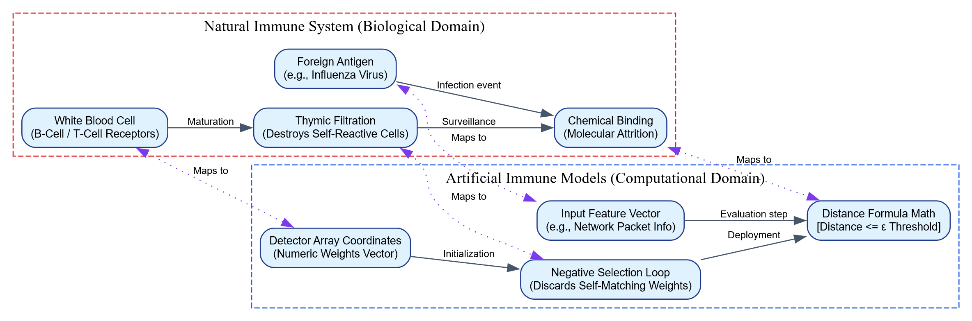Descriptive Application Example
Consider how an engine diagnostics platform handles a sudden drop in fuel delivery line pressure:
- The Biological Analogy: This drop matches an internal tissue rupture or bacterial threat that alters the organism’s baseline normal state.
- The Computational Translation: The diagnostics platform views the current telemetry stream (including pressure, RPM, and temperature metrics) as an incoming Antigen.
- The Defense Processing Pass: This data point is mapped into a pre-computed Shape Space. The algorithm calculates the distance between these real-time coordinates and a set of trained anomaly detectors generated via Negative Selection.
- The Alarm Trigger: Because the telemetry data deviates significantly from normal operational parameters (Self), its coordinates shift into non-self territory and trigger a mature detector node. The calculated distance drops below the affinity threshold ($ϵ$), prompting the model to flag a Non-Self anomaly that alerts operators to the fuel line pressure drop.

5. Conclusion / Summary
Comparing the Natural Immune System with Artificial Immune Models demonstrates how biological pattern recognition and defensive workflows can be effectively translated into computational tools. By converting organic concepts like antigens, antibodies, and cellular selection into multi-dimensional vectors, distance metrics, and mutation operators, Artificial Immune Models provide a robust framework for complex pattern recognition, anomaly detection, and global optimization tasks. This decentralized approach allows AI engineers to design resilient, adaptive defense networks—such as automated intrusion detection platforms and server monitoring architectures—capable of identifying novel threats without relying on a centralized controller.
Discuss the limitations and challenges of applying Artificial Immune System models in real-world applications?

1. Definition / Introduction
Artificial Immune Systems (AIS) are adaptive, bio-inspired algorithmic frameworks that translate the decentralized defense mechanisms, pattern-recognition capabilities, and evolutionary memory profiles of the biological immune system into mathematical problem-solvers. Within Computational Intelligence (CI), these models—including Negative Selection, Clonal Selection, Immune Networks, and Gated Dendritic Cell processes—excel at framing engineering problems around anomaly detection, data clustering, and global parameter optimization.
However, moving Artificial Immune Systems from controlled theoretical setups to complex, large-scale real-world applications introduces significant design constraints and performance challenges. In production environments, AIS algorithms face hurdles like exponential computational overhead, fragile hyperparameter dependencies, severe scaling limits within high-dimensional data spaces, and high rates of false-positive classification errors. These limitations can restrict their reliability compared to established deep learning and statistical machine learning frameworks.

2. Detailed Explanation
The practical limitations and engineering challenges of applying Artificial Immune System models to real-world industrial infrastructure can be systematically grouped into five major functional areas:

I. The Scalability and Dimensional Explosion Barrier
A primary challenge for AIS algorithms—particularly the Negative Selection Algorithm (NSA) used for anomaly tracking—is the exponential increase in resource costs when operating in high-dimensional datasets.
- The Hole-Closing Bottleneck: To detect anomalies effectively, the algorithm must generate a comprehensive set of non-reactive detectors that cover the entire non-self space without overlapping the normal parameters (Self Set). As the number of data dimensions ($n$) increases, the volume of the multi-dimensional Shape Space expands exponentially according to the Curse of Dimensionality.
- Computational Cost: The number of random candidate detectors that must be generated, checked against the self set, and maintained to ensure adequate security coverage scales exponentially ($O\left(e^{n}\right)$). This makes it computationally impractical to secure large-scale enterprise databases or high-definition streaming networks without consuming immense amounts of computer memory and processing power.

II. Hyperparameter Vulnerability and the Affinity Threshold Problem
Artificial Immune Models rely heavily on manual hyperparameter tuning, making them sensitive to minor configuration changes.
- The Radius Dilemma: Recognition events depend entirely on the Affinity Threshold ($ϵ$), which defines the spatial activation radius around a detector node. If $ϵ$ is set too small, the detectors become overly specific, missing close variations and leading to high False Negative Rates (missed anomalies).
- The Overlap Problem: Conversely, if the radius $ϵ$ is expanded too far, the detector zones bleed into the legitimate self space. This causes the system to flag normal operational deviations as hostile threats, causing high False Positive Rates that can disrupt production environments. Striking a stable balance requires exhaustive, trial-and-error optimization loops.

III. Inherent Structural Vulnerability to Concept Drift
In real-world deployment, baseline data environments are rarely static. Systems evolve continuously due to software updates, changing user behaviors, and seasonal data shifts—a phenomenon known as Concept Drift.
- Fragile Self Set Baselines: Traditional AIS models assume the trained “Self Set” profile represents an absolute, immutable definition of normal behavior. When a legitimate system behavior shifts naturally, it can drift out of the safe baseline zone and cross paths with mature anomaly detectors.
- Autoimmune Failure States: Because the system lacks an automated way to update its definitions in real time, it triggers false alarms on legitimate changes. This creates a computational “autoimmune reaction,” where the defense system actively blocks authorized processes, degrading system reliability.

IV. Representation Constraints in Complex Feature Spaces
AIS algorithms evaluate relationships using simple geometric distance metrics, such as Euclidean or Manhattan distance formulas:
$$\text{Distance}\left(A,D\right)=\sqrt{\sum_{i=1}^{n}{{\left(x_{i}-y_{i}\right)}^{2}}}$$
- Symmetric Distance Limitations: These geometric metrics treat the data space as entirely symmetric and uniform. They struggle to capture complex, non-linear dependencies, hierarchical structures, or categorical relationships embedded within unstructured real-world datasets (such as raw text or layered industrial telemetry streams).
- Comparison with Modern Deep Learning: Unlike deep neural networks that automatically extract hierarchical features from raw data, AIS models require manual feature engineering to map inputs into a flat coordinate shape space, which can limit their capacity to handle highly intricate data patterns.

V. The Cold-Start Vulnerability and Definitional Incompleteness
For an Artificial Immune Model to build an effective defense, it must have complete information during its initial setup phase.
- The Clean Baseline Requirement: Generating a reliable detector fleet via negative selection requires a purely clean “Self Set” training dataset that is entirely free of hidden attacks or data corruptions.
- The Clean Baseline Failure State: If a system is compromised or experiencing hidden errors during the initial baseline recording, those malicious patterns are permanently hardcoded as safe “Self” parameters. The model will systematically ignore those specific threats, creating a permanent security blind spot that allows vulnerabilities to pass undetected.

3. Key Points
- Exponential Computational Footprint: Storage and execution costs scale exponentially as data dimensions expand, making it difficult to scale the system for large enterprise applications.
- High Sensitivity to Threshold Tuning: Small changes to the affinity threshold radius ($ϵ$) can cause the system to swing between high rates of false positives and missed anomalies.
- Vulnerability to Concept Drift: Struggles to adapt to natural changes in baseline data, which can lead to false alarms and disruptive “autoimmune” system blockages.
- Simplistic Distance Metrics: Relies on basic geometric distance calculations that can fail to capture complex, non-linear relationships within multi-dimensional datasets.
- Strict Training Cleanliness Constraints: Requires a completely error-free baseline dataset during the training phase to avoid building permanent blind spots into the defense network.

4. Diagram / Example

System Failure Analysis: The AIS Optimization Bottleneck

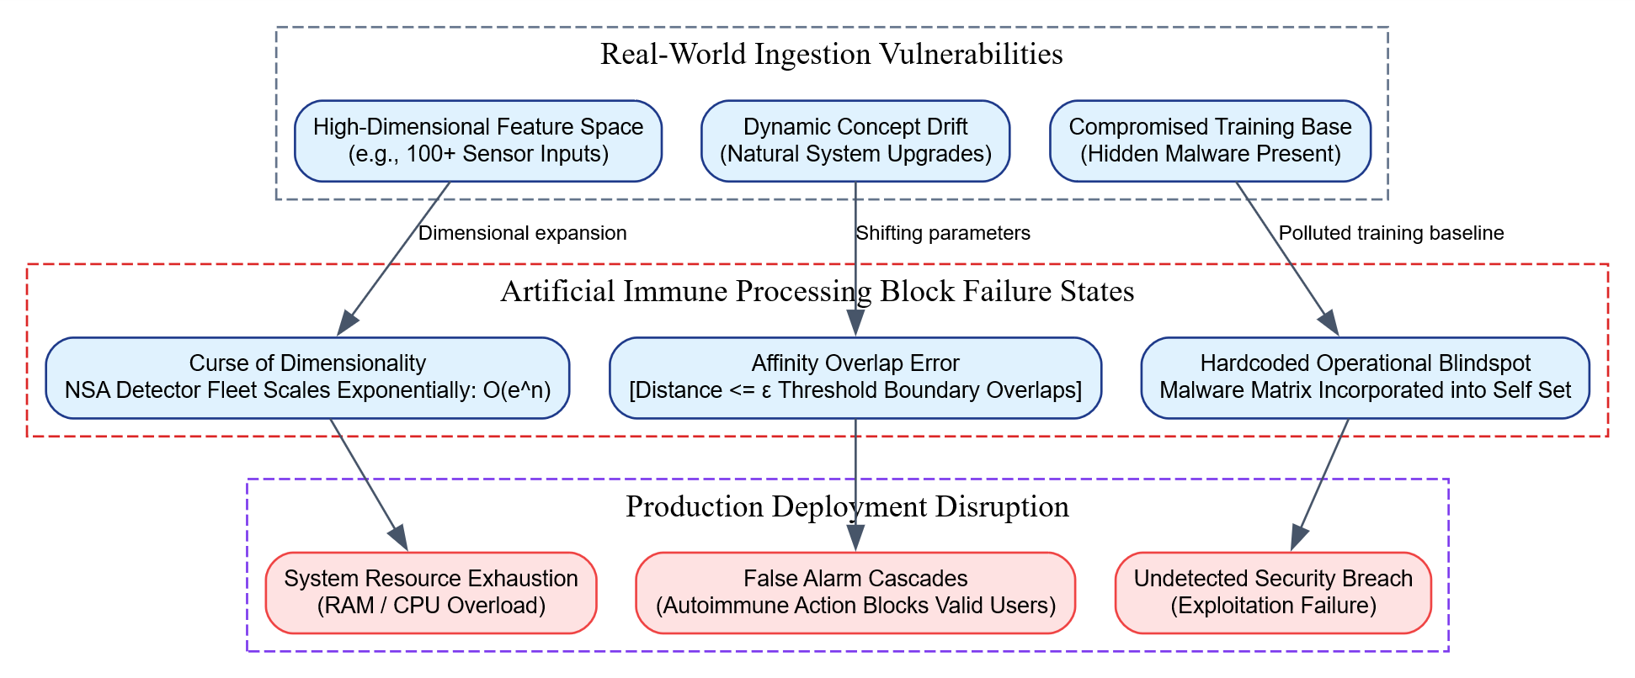Descriptive Engineering Example
Consider deploying an AIS-driven Negative Selection Algorithm to monitor a high-frequency financial trading system for fraudulent transactions:
- The Dimensionality Challenge: Each transaction contains over 80 distinct feature dimensions (e.g., transaction volume, geographic coordinates, execution delays, IP routing logs). To secure this 80-dimensional space, the algorithm attempts to generate random candidate detectors. Because the volume of this high-dimensional shape space is immense, the network must compute and store billions of detectors to provide adequate coverage, which can quickly exhaust server memory and cause processing delays.
- The Concept Drift Challenge: During a major market event like Black Friday, trading volumes and processing frequencies naturally spike far beyond normal baseline levels. The AIS framework interprets these legitimate, high-velocity transactions as Non-Self anomalies because they fall outside the historical training baseline. The affinity thresholds overlap, triggering a cascade of false alarms that mistakenly freeze legitimate institutional trading accounts.
- The Clean Baseline Failure State: If a slow, stealthy data-exfiltration attack was already running undetected during the initial baseline training phase, the algorithm incorporates those malicious data patterns directly into its Self Set. Consequently, the model creates a permanent blind spot, classifying the ongoing cyber-attack as normal behavior and allowing it to continue completely undetected.

5. Conclusion / Summary
While Artificial Immune Systems provide an innovative, decentralized framework for anomaly detection and optimization, their practical deployment in complex real-world applications reveals several key engineering challenges. The exponential computational cost driven by high-dimensional data spaces, high sensitivity to hyperparameter tuning, and vulnerability to natural shifts in baseline data can limit their reliability in dynamic environments. To build dependable, enterprise-ready systems, developers often combine AIS models with modern deep learning representations or adaptive statistical filters, balancing bio-inspired pattern recognition with robust, scalable data processing.

Artificial Immune System Algorithm
PYQ May 2025 (Q7b): Describe the working of the Artificial Immune System Algorithm.

1. Definition / Introduction
The Artificial Immune System (AIS) Algorithm is a multi-agent, population-based computational metaheuristic inspired by the adaptive pattern-recognition and defense mechanisms of the biological immune system. Within the domain of Computational Intelligence (CI), it abstracts biological evolutionary principles to solve complex engineering challenges such as multi-dimensional optimization, data clustering, and anomaly detection.
The algorithmic engine treats optimization problems or dataset configurations as an environment populated by incoming foreign target patterns, termed Antigens. To counter these threats, the algorithm initializes and evolves a parallel population of candidate solutions, termed Antibodies (or detectors). Through iterative selection, adaptive cloning, and targeted mutation operations, the AIS algorithm drives the population toward optimal regions of a structured multi-dimensional coordinate space, termed the Shape Space.

2. Detailed Explanation
The operational execution of a generalized Artificial Immune System Algorithm is a structured loop that models the lifecycle of biological lymphocytes. It balances broad exploration of the search space with precise, local exploitation.

Step-by-Step Algorithmic Workflow:

Step 1: Ingestion of Antigens (Problem Setup)
The algorithm defines the target problem space as a set of antigens, denoted as $A$. In optimization tasks, an antigen represents the objective fitness landscape or target profile vector:
$$A=\{x_{1},x_{2},…,x_{n}\}$$

Step 2: Population Initialization (The Naive Antibody Fleet)
A population of $M$ candidate solution vectors (antibodies), denoted as $P$, is generated across the shape space:
$$P=\{D_{1},D_{2},…,D_{M}\}$$
These detectors can be initialized randomly or via problem-specific heuristics to ensure diverse coverage of the feature landscape.

Step 3: Affinity Evaluation (Fitness Calculation)
The algorithm evaluates how closely each antibody matches the target antigen by calculating a spatial metric called Affinity. In continuous shape spaces, affinity is inversely proportional to the geometric distance between the vectors. The standard approach utilizes the Euclidean Distance formula:
$$\text{Distance}\left(A,D_{i}\right)=\sqrt{\sum_{j=1}^{n}{{\left(x_{j}-y_{ij}\right)}^{2}}}$$
$$\text{Affinity}\left(D_{i}\right)=\frac{1}{1+\text{Distance}\left(A,D_{i}\right)}$$
Antibodies with shorter geometric distances to the target yield higher affinity scores.

Step 4: Selection and Proliferation (Cloning)
The algorithm selects the top $N$ highest-affinity antibodies from the population pool. These elite candidates undergo duplication, creating a sub-population of clones. The number of clones ($N_{c}$) generated for a specific selected antibody is directly proportional to its affinity score:
$$N_{c}\left(D_{i}\right)=\text{round}\left(\frac{β⋅M}{i}\right)$$
Where $β$ is a user-defined scaling factor, $M$ is the total population size, and $i$ is the rank of the antibody sorted by descending affinity. Higher-performing solutions receive more clones to intensify focus on promising regions of the search space.

Step 5: Somatic Hypermutation (Adaptive Local Search)
To discover better solutions, the cloned population undergoes mutation. To preserve the structure of high-quality solutions while encouraging broader exploration from lower-quality ones, the mutation rate ($α$) is scaled inversely with affinity:
$$α\left(D_{i}\right)=exp\left(-γ⋅\text{Affinity}\left(D_{i}\right)\right)$$
Where $γ$ is a mutation scale parameter.
- High-Affinity Clones: Experience minor mutations, performing fine-grained local adjustments around known strong solutions.
- Low-Affinity Clones: Experience significant variations, allowing them to jump out of local optima and discover completely new regions of the shape space.

Step 6: Selection and Population Refinement
The mutated clones are re-evaluated against the target antigen. If a mutated clone achieves a higher affinity score than its original parent antibody, it replaces that parent in the main population pool.

Step 7: Population Metadynamics (Introduction of Diversity)
To prevent the population from stagnating in local optima (premature convergence), a fraction ($d$) of the lowest-performing antibodies are removed from the population pool at each iteration. They are replaced with completely new, randomly generated candidate detectors, introducing fresh diversity into the search process.

Step 8: Convergence Check
The algorithm checks its termination criteria, such as reaching a maximum number of generational iterations or satisfying a target affinity threshold. If the criteria are met, the algorithm outputs the highest-affinity antibody as the optimal solution. Otherwise, it increments the generation count and loops back to Step 3.

3. Key Points
- Dual-Search Synergy: Combines cloning and hypermutation to balance broad exploration of the search space with precise local exploitation.
- Inversely Scaled Hypermutation: Scales mutation rates inversely with solution quality, allowing top-performing probes to stabilize while lower-scoring ones search for new optima.
- Proportional Resource Allocation: Allocates clones proportionally based on affinity scores, focusing computational power on the most promising solution branches.
- Automated Population Refreshing: Periodically replaces poorly performing detectors with random new samples to prevent premature convergence.
- Zero-Order Metric Flexibility: Evaluates solutions using geometric distance calculations over continuous shape spaces, eliminating the need for complex mathematical gradients.

4. Diagram / Example

Generational Processing Loop Pipeline

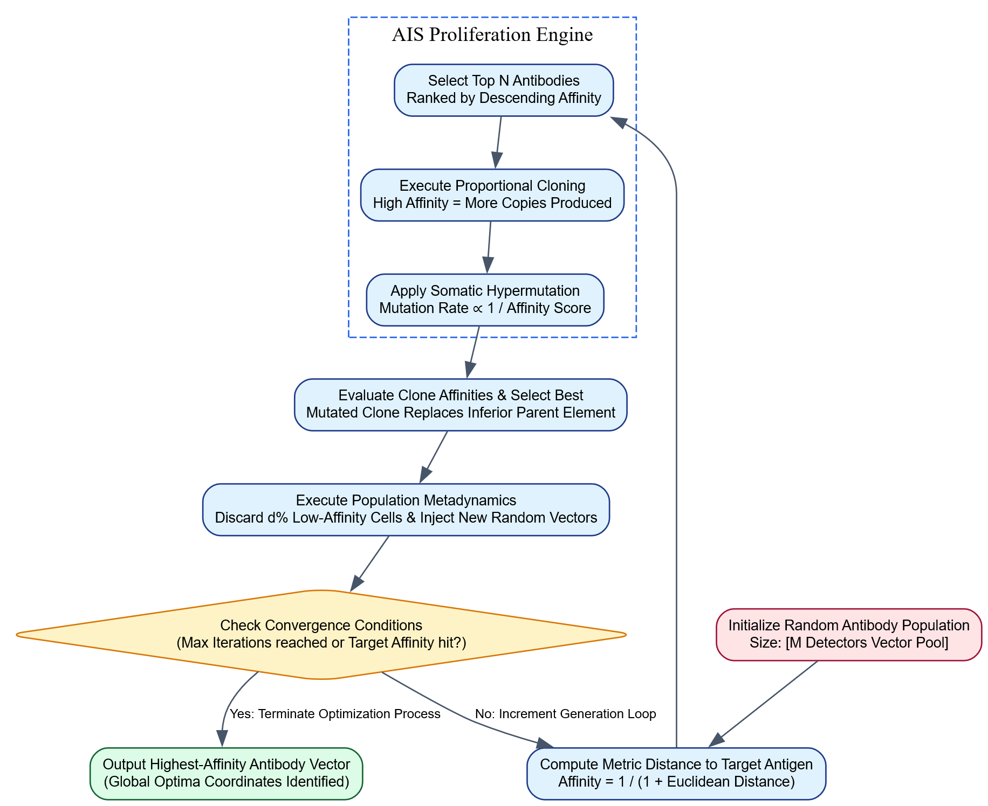Descriptive Application Example
Consider deploying the Artificial Immune System Algorithm to optimize the scheduling and routing of an autonomous delivery drone fleet across a complex layout of delivery locations:
- Problem Definition: The target delivery requirements and terrain constraints are defined as the environmental Antigen.
- Initialization: The algorithm initializes a diverse population of $M=50$ distinct drone routing paths (Antibodies) scattered across the multi-dimensional search space.
- Affinity Mapping: The system calculates an affinity score for each routing path based on efficiency metrics like total flight time, battery consumption, and safety parameters. Shorter, safer routes yield lower geometric distances and higher affinity scores.
- Evolutionary Selection: The top 10 routing profiles are selected. An exceptional path ranking at index 1 is cloned 20 times, while a mediocre route ranking at index 10 receives only 2 copies.
- Targeted Mutation: The system introduces mutations to the cloned paths. Clones from the top-ranked route undergo tiny modifications to fine-tune flight turns, while clones from the 10th-ranked route undergo large adjustments to break out of poor local paths.
- Replacement and Refresh: If any mutated clone outperforms its parent route, it takes its place in the primary population. The bottom 5 underperforming routes are removed from the fleet and replaced with completely new, randomly generated path options to maintain diversity.
- Convergence: This loop iterates for 150 generations until the population converges on a robust, highly optimized flight path configuration that minimizes delivery times, demonstrating the practical value of the AIS optimization cycle.

5. Conclusion / Summary
The Artificial Immune System Algorithm provides a highly effective, decentralized framework for solving global optimization and pattern recognition tasks by translating biological immune defense mechanisms into a structured computational model. By balancing proportional cloning with inversely scaled hypermutation, the algorithm systematically refines high-quality solutions while exploring new areas of the search space. Supported by population refreshing mechanisms to prevent stagnation, this approach offers a resilient tool for building automated anomaly detectors, complex routing schedulers, and global parameter optimizers across computational intelligence platforms.

Classical View Models

1. Definition / Introduction
In the field of Artificial Immune Systems (AIS), Classical View Models represent the foundational, early computational frameworks that replicate the traditional understanding of the biological immune system. This paradigm centers around the strict binary classification of cellular structures and data patterns into two mutually exclusive sets: Self and Non-Self.
The context of Classical View Models is deeply rooted in the “Self/Non-Self Theory” formulated by Frank Macfarlane Burnet in the mid-20th century. In a computational environment, the model establishes a static, rigid boundary defining what constitutes normal system behavior (“Self”). Any entity, data packet, or state vector that deviates from this predefined baseline is automatically categorized as foreign or hostile (“Non-Self”) and targeted for eradication. This model provides the foundational framework for early bio-inspired anomaly detection algorithms.

2. Detailed Explanation
The structural mechanics of Classical View Models translate biological screening processes into explicit algorithmic operations over multi-dimensional feature coordinates.

I. Mathematical Paradigm of the Shape Space
To implement a Classical View Model, all computational metrics must be projected into an abstract coordinate system known as the Shape Space ($S$).
- The Self Set ($U_{\text{self}}$): This subset represents the collection of all normal, legitimate, or authorized patterns within the system. It forms the protected zone of the shape space.
- The Non-Self Set ($U_{\text{non-self}}$): This subset contains all possible anomalous, malicious, or unmapped patterns. It represents the complement of the Self space within the universe of discourse:
$$U_{\text{non-self}}=S\backslash U_{\text{self}}$$

II. Detector Ingestion and Tolerization Mechanics
The operational lifecycle of a Classical View Model depends on creating a fleet of independent surveillance detectors ($D$) that monitor the non-self territory without encroaching upon the self domain. This process is called Tolerization:
- Random Generation: The algorithm generates a series of candidate detector vectors at random locations across the shape space.
- Affinity Matching Analysis: The system computes the spatial distance between the candidate detector ($d$) and every element ($s$) within the verified Self Set ($U_{\text{self}}$). This distance is calculated using standard distance metrics like the Euclidean Distance formula:
$$\text{Distance}\left(d,s\right)=\sqrt{\sum_{i=1}^{n}{{\left(d_{i}-s_{i}\right)}^{2}}}$$
- The Elimination Phase: If the calculated distance falls below a predefined cross-reactive metric boundary called the Affinity Threshold ($ϵ$), it indicates that the candidate detector would attack normal system data. Consequently, the detector fails tolerization and is immediately destroyed.
- Fleet Deployment: Candidate detectors that show no reactivity to any element in the Self Set are accepted into the Mature Detector Pool. These mature detectors are then deployed to monitor real-time system data streams.

III. Monitoring and Anomaly Activation
During the active monitoring phase, real-time data inputs are treated as incoming Antigens. The metric engine calculates the geometric distance between these live vectors and the mature detectors.
- If a data point’s coordinates trigger a match—meaning its distance to a mature detector is less than or equal to the affinity threshold ($ϵ$)—the system flags a Non-Self violation.
- This triggers an immediate security alert, isolating the anomalous data point.

IV. Structural Limitations of Classical View Models
While foundational, the rigid design of Classical View Models introduces several structural limitations when applied to modern, real-world systems:
- Inflexibility to Concept Drift: The model treats the definition of “Self” as static and absolute. In real-world environments, normal system behaviors evolve naturally over time due to software updates or seasonal trends. The Classical View cannot accommodate these shifts without rebuilding its entire detector fleet, often leading to high false-alarm rates.
- The Hole-Closing Problem: Due to the geometric constraints of using fixed-radius hyperspheres to protect irregular data clusters, certain small regions of the non-self space can remain uncovered by detectors. These unprotected gaps, known as “holes,” can allow subtle anomalies or clever exploits to pass completely undetected.

3. Key Points
- Binary Categorization Foundation: Partitions the feature space into two distinct, non-overlapping domains: normal behavior (Self) and anomalous variations (Non-Self).
- Negative Tolerization Filtering: Eliminates any candidate detectors that show reactivity to healthy baseline data, ensuring the monitoring fleet targets only foreign patterns.
- Affinity Radius Constraints: Uses explicit spatial distance thresholds ($ϵ$) to govern pattern recognition and trigger anomaly alerts.
- Static Baseline Assumptions: Assumes the normal operating environment remains fixed, making the system vulnerable to false positives if the baseline data naturally drifts.
- Foundational Algorithmic Engine: Establishes the core structural pipeline for traditional bio-inspired security frameworks and early negative selection models.

4. Diagram / Example

Algorithmic Component Processing Pipeline

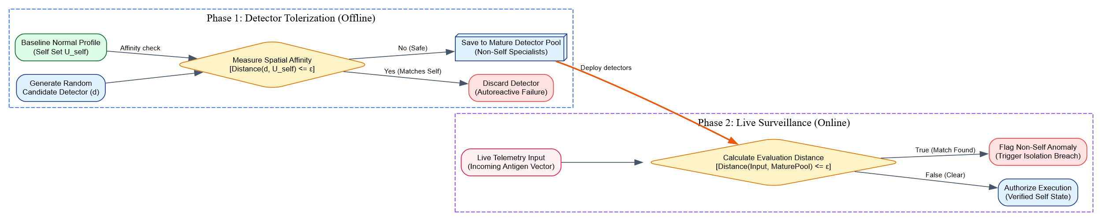Descriptive Engineering Example
Consider applying a Classical View Model to monitor a secure data server against unauthorized intrusions:
- Compiling the Self Baseline: The system monitors the server for a week during normal operations, mapping indicators like authorized IP ranges, typical login times, and standard file transfer sizes into an $n$-dimensional shape space to establish the Self Set.
- Generating the Detector Fleet: The algorithm generates random candidate detector points across the coordinate space. If a detector lands near typical server behaviors (e.g., standard daytime logins from local IP addresses), its calculated distance falls below the threshold ($ϵ$), and it is immediately discarded. Only detectors that map to abnormal coordinates (e.g., midnight login attempts from unrecognized external IPs) are retained in the mature pool.
- Live Surveillance: During active server monitoring, an administrator logs in from a local terminal at 2:00 PM. The system maps this transaction vector into the shape space. Because the data point aligns directly with the verified Self Set, it remains far from the mature detectors and is authorized immediately.
- Anomaly Activation: Later, an external connection attempts to modify system files at 3:00 AM. This telemetry stream creates a vector that falls far outside normal parameters (Non-Self territory), landing directly within the activation radius of a mature detector. Because the calculated distance falls below the threshold ($ϵ$), the system instantly flags a Non-Self violation, blocking the connection and alerting the security team.

5. Conclusion / Summary
Classical View Models provide a foundational approach to bio-inspired anomaly detection by dividing data feature spaces into strict “Self” and “Non-Self” domains. By using negative selection routines to ensure detectors ignore normal baseline behavior and target only foreign patterns, this framework delivers an effective, decentralized strategy for capturing outright system anomalies. While its rigid, static design makes it sensitive to natural changes in baseline data (concept drift), the principles established by Classical View Models serve as the essential baseline for advanced, context-aware artificial immune algorithms.
Clonal Selection Theory Model
PYQ May 2025 (Q8a): Explain how the Clonal Selection Theory Model contributes to the development of artificial immune systems?

1. Definition / Introduction
The Clonal Selection Theory Model is a foundational biological paradigm formulated by Frank Macfarlane Burnet in 1957 to explain how the adaptive immune system reacts to foreign pathogen invasions and optimizes its defensive response over time. The theory asserts that when an unfamiliar foreign antigen invades a host organism, only those pre-existing lymphocytes (B-cells or T-cells) whose surface receptors happen to match the structural shape of that antigen are selected to proliferate, clone, and mature into highly specialized effector cells.
In the domain of Computational Intelligence (CI), the Clonal Selection Theory Model serves as a core algorithmic engine for developing advanced Artificial Immune Systems (AIS). It translates the biological principles of population-based selection, cell cloning, and affinity maturation into robust mathematical architectures. It contributes a powerful optimization framework—best exemplified by the CLONALG algorithm—that balances broad environmental exploration with precise local exploitation, making it highly effective for solving multi-dimensional global optimization, pattern recognition, and machine learning tasks.

2. Detailed Explanation

I. Biological Principles of Clonal Selection
The biological model operates on an evolutionary selection mechanism that takes place directly within an organism’s cell population:
- Prior Diversity: The organism maintains a large pool of unique, naive lymphocytes with distinct receptor configurations scattered throughout the body.
- Antigen Binding (Selection): When a foreign antigen enters the body, it encounters this diverse pool of cells. The lymphocytes whose surface receptors exhibit a high binding strength (Affinity) to the antigen are selectively activated.
- Clonality Proliferation: Once activated, these chosen cells replicate rapidly (Cloning), producing exact genetic duplicates of themselves. Cells that fail to bind remain inactive.
- Somatic Hypermutation: During replication, the genetic code of these clones undergoes a high rate of mutation. This introduces slight structural variations into their receptors.
- Affinity Filtering: The mutated clones face a continuous affinity filter. Clones whose mutations improved their binding strength to the antigen are selected to survive, while those with degraded affinity are eliminated. This iterative optimization loop is known as Affinity Maturation.
- Memory Preservation: After clearing the infection, a subset of these high-affinity optimized cells is preserved as long-lived Memory Cells, providing fast defense if the same pathogen returns.

II. Algorithmic Contribution to Artificial Immune Systems
AIS engineers adapt these biological steps into a structured mathematical pipeline to solve complex engineering problems.

1. Mathematical Mapping of Components
- Antigen ($A$): Represents the target problem space. In optimization, it maps to the fitness function landscape, while in pattern recognition, it corresponds to an input feature vector or target pattern configuration.
- Antibody ($D$): Represents a candidate solution vector or exploratory probe located within a multi-dimensional coordinate space called the Shape Space.
- Affinity: Represents the quantitative measure of solution quality. It is calculated using the spatial distance between the antibody coordinates and the target antigen. In continuous spaces, this is computed using distance formulas like Euclidean Distance:
$$\text{Distance}\left(A,D_{i}\right)=\sqrt{\sum_{j=1}^{n}{{\left(x_{j}-y_{ij}\right)}^{2}}}$$
$$\text{Affinity}\left(D_{i}\right)=\frac{1}{1+\text{Distance}\left(A,D_{i}\right)}$$
- As the geometric distance decreases, the affinity score increases, indicating a higher-quality solution.

2. Proportional Cloning Architecture
The model introduces a resource allocation strategy where the number of clones ($N_{c}$) generated for an individual antibody is directly proportional to its affinity score. Higher-performing solutions receive more clones to intensify focus on promising areas:
$$N_{c}\left(D_{i}\right)=\text{round}\left(\frac{β⋅M}{i}\right)$$
Where $β$ is a user-defined scaling factor, $M$ is the total size of the antibody pool, and $i$ is the rank of the candidate vector when sorted by descending affinity.

3. Inversely Scaled Somatic Hypermutation
To maintain structural stability while exploring new possibilities, the mutation rate ($α$) applied to the cloned population is scaled inversely with affinity:
$$α\left(D_{i}\right)=exp\left(-γ⋅\text{Affinity}\left(D_{i}\right)\right)$$
Where $γ$ is a mutation scaling constant.
- High-Affinity Clones: Experience minor mutations, allowing them to perform fine-grained local adjustments around known strong solutions.
- Low-Affinity Clones: Experience significant variations, allowing them to jump out of local optima and discover completely new regions of the shape space.

4. Population Metadynamics and Memory Maintenance
The model helps maintain diversity across the solution pool by periodically eliminating a fraction ($d$) of the lowest-performing antibodies at each iteration. They are replaced with completely new, randomly initialized vectors, preventing the system from stalling in local optima. Simultaneously, the top-performing vectors are preserved in a dedicated Memory Set, archiving optimal coordinates across generational runs.

3. Key Points
- Bio-Inspired Optimization Engine: Translates biological cell selection and affinity maturation into a robust population-based engineering optimization framework.
- Proportional Resource Allocation: Focuses computational power on promising solution branches by adjusting clone counts based on affinity scores.
- Dual Exploration-Exploitation Balance: Uses an inversely scaled hypermutation strategy to allow top-tier solutions to perform local adjustments while lower-scoring ones explore new areas.
- Prevention of Premature Convergence: Implements population metadynamics to periodically replace underperforming vectors with random new options, maintaining diversity and avoiding local optima.
- Gradient-Free Evaluation: Evaluates solutions using distance-based affinity calculations over continuous shape spaces, eliminating the need for complex mathematical gradients.

4. Diagram / Example

The AIS Clonal Selection Algorithmic Pipeline

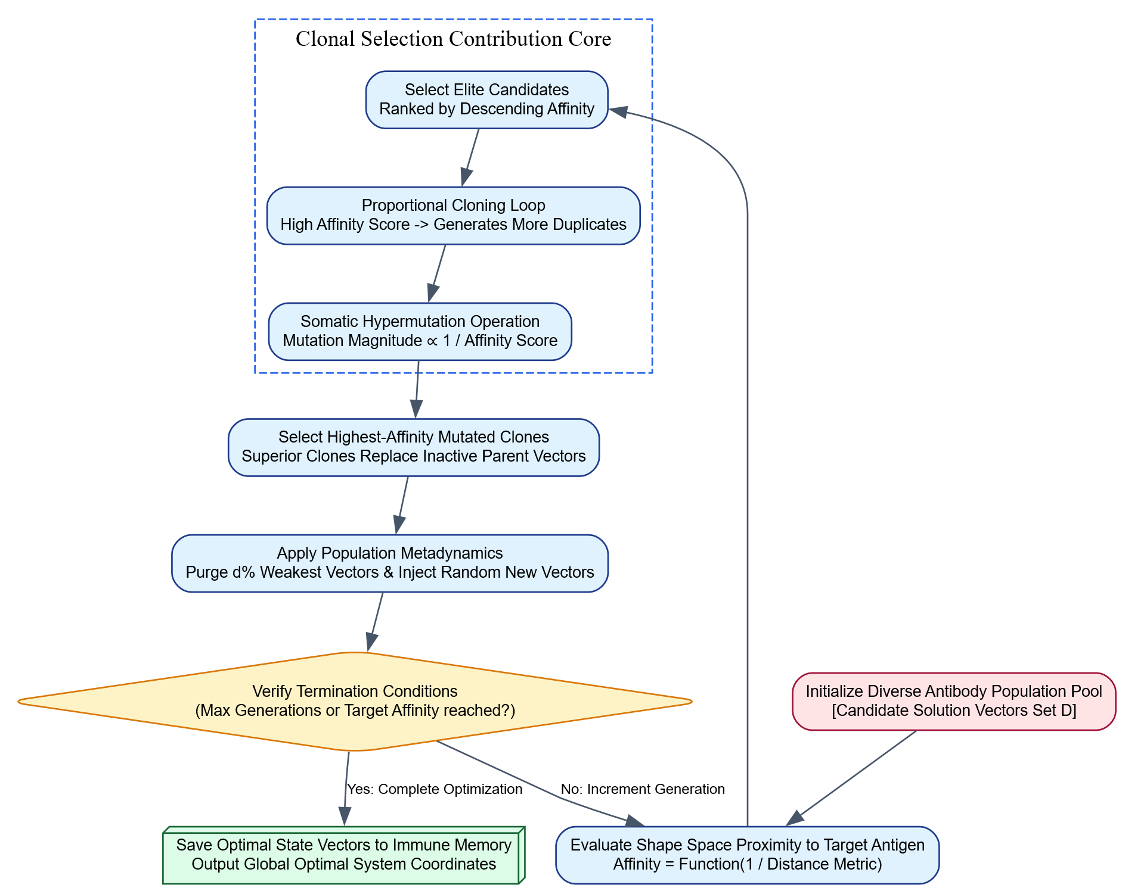Descriptive Application Example
Consider deploying a Clonal Selection Theory algorithm to optimize the placement and configuration of cell towers across a major city to maximize network coverage while minimizing signal interference:
- Problem Setup: The city’s geography, terrain layout, and user density maps are treated as the target environmental Antigen.
- Initialization: The algorithm initializes a diverse population of 100 random cell tower placement configurations, which act as the Antibody Fleet.
- Affinity Evaluation: The system calculates an affinity score for each configuration based on coverage efficiency and interference rates. High-quality layouts yield lower geometric distances to the ideal configuration, producing higher affinity scores.
- Clonal Expansion: The algorithm ranks the configurations. The best layout (Rank 1) is cloned 30 times, while a mediocre layout (Rank 10) receives only 3 clones.
- Targeted Hypermutation: The clones undergo mutation. Clones from the Rank 1 layout are shifted by tiny margins (e.g., a few meters) to fine-tune signal boundaries, while clones from the Rank 10 layout are shifted by large distances across the city grid to search for entirely better tower placements.
- Selection and Refresh: The highest-performing mutated clones replace their less effective parent vectors. The bottom 15 underperforming layouts are completely purged and replaced with new, randomly generated configurations to maintain diversity.
- Convergence: This optimization cycle iterates for 200 generations until the population converges on an optimal cell tower placement configuration, demonstrating the practical value of the clonal selection process.

5. Conclusion / Summary
The Clonal Selection Theory Model provides a robust framework for development within Artificial Immune Systems by translating biological cell selection and affinity maturation into powerful computational tools. By combining proportional cloning with inversely scaled somatic hypermutation, it balances broad environmental exploration with precise local optimization. Supported by automated population refreshing to maintain diversity, this approach gives AI engineers a resilient, gradient-free tool for solving complex anomaly detection, pattern recognition, and global optimization challenges.

Network Theory Model
PYQ May 2025 (Q7a): Describe the Network Theory Model in artificial immune systems.

1. Definition / Introduction
The Network Theory Model—also known as the Artificial Immune Network (aiNet) model—is an advanced unsupervised machine learning and data representation framework within Artificial Immune Systems (AIS). It is inspired by Nils Jerne’s biological Idiotypic Network Theory proposed in 1974, which revolutionized theoretical immunology.
Unlike classical view models that assume immune cells remain completely dormant until activated by an external threat, the Network Theory Model asserts that the immune system is a self-organizing, interconnected network of lymphocytes that continuously stimulate and suppress one another, even in the absolute absence of foreign invaders. In computational intelligence, this model shifts the paradigm from a collection of isolated detectors to a dynamic, graph-based network structure. It is primarily used for complex unsupervised machine learning tasks such as data clustering, dimensionality reduction, multi-modal optimization, and structural data abstraction.

2. Detailed Explanation
The Network Theory Model translates biological cellular interaction rules into a continuous mathematical graph space, mapping data topologies through automated cell population dynamics.

I. Mathematical and Structural Mapping
To formalize the network model into an algorithm, biological entities are projected as mathematical nodes and edges:
- Network Nodes (B-Cells / Antibodies): Represented as a population of continuous feature vectors $W=\{w_{1},w_{2},…,w_{M}\}$ residing within a multi-dimensional coordinate space called the Shape Space. Each vector acts as an internal image or data prototype.
- Antigens: Represented as the incoming input dataset under analysis ($Ag=\{{ag}_{1},{ag}_{2},…,{ag}_{N}\}$).
- Edges (Idiotypic Connections): Represent the degree of interaction between network nodes. The relationship between any two nodes $w_{i}$ and $w_{j}$ is quantified by calculating their spatial distance. The standard approach utilizes the Euclidean Distance formula:
$$\text{Distance}\left(w_{i},w_{j}\right)=\sqrt{\sum_{k=1}^{n}{{\left(w_{ik}-w_{jk}\right)}^{2}}}$$

II. Governing Metadynamics: Activation, Stimulation, and Suppression
The structural alignment of the network graph is controlled by two opposing interaction forces evaluated against an Affinity Threshold ($σ_{s}$):

1. Antigen Stimulation (External Force)
When an input data point (antigen) enters the shape space, it exerts an attractive force on neighboring network nodes. Nodes that fall within a close metric radius are stimulated. This stimulation level determines their fitness score and triggers the deployment of the clonal selection mechanism: high-affinity nodes are cloned and mutated to match the data point more precisely.

2. Idiotypic Suppression (Internal Inter-Node Force)
This is the core innovation of the Network Theory Model. Nodes that drift too close to one another in the shape space experience Idiotypic Suppression:
$$\text{If Distance}\left(w_{i},w_{j}\right)≤σ_{s}⟹\text{Suppression Event}$$
When a suppression event occurs, the system identifies the two nodes as redundant duplicates that are tracking the exact same information cluster. To eliminate redundancy and minimize computational overhead, the algorithm purges the node with the lower antigen affinity from the network graph.

III. Step-by-Step Algorithmic Execution Pipeline (aiNet)
The construction of an Artificial Immune Network follows a structured iterative pipeline designed to capture data distributions:
- Initialization: Initialize a small population of network nodes at random coordinates within the shape space.
- Antigen Ingestion: Present an input data sample ${ag}_{k}$ from the dataset to the network.
- Affinity Extraction & Cloning: For the active input sample, calculate the Euclidean distance to all existing network nodes. Select the top-performing nodes and clone them proportionally based on their proximity to the data point.
- Somatic Hypermutation: Mutate the generated clones. The mutation rate scales inversely with affinity, allowing highly accurate nodes to perform fine-grained adjustments while lower-scoring ones make larger spatial jumps to discover new data boundaries.
- Clonal Selection: Re-evaluate the mutated clones against the input data point. The single highest-affinity clone is selected to join the main network node pool.
- Network Connection & Suppression Loop: Calculate the pairwise distance matrix across all nodes in the updated pool. Identify any node pairs whose mutual spatial distance falls below the suppression threshold ($σ_{s}$). Purge the lower-performing node from each pair to eliminate redundancy and maintain structural efficiency.
- Diversity Injection (Metadynamics): To prevent network stagnation, inject a small set of completely new, randomly generated node vectors into the shape space, allowing the network to expand into unmapped regions.
- Convergence Check: Repeat the process across all data points until the node coordinates stabilize. The final configuration yields an optimized network graph where the remaining nodes act as centroid anchors representing the underlying clusters of the dataset.

3. Key Points
- Self-Organizing Network Graph: Relies on autonomous local interactions between nodes to establish a stable graph architecture without requiring a central coordinator.
- Dual Force Control Dynamics: Balances external antigen stimulation with internal idiotypic suppression to accurately map data distributions.
- Redundancy Mitigation via Suppression: Uses the suppression threshold ($σ_{s}$) to automatically prune duplicate nodes, preventing computational bloat and maintaining lean network structures.
- Unsupervised Clustering Engine: Automatically discovers natural clusters and geometric patterns within complex datasets without needing target labels.
- Adaptive Variable Network Size: Dynamically scales the number of network nodes up or down based on the complexity and distribution of the incoming data stream.

4. Diagram / Example

Dynamic Interaction Topology of the Network Model

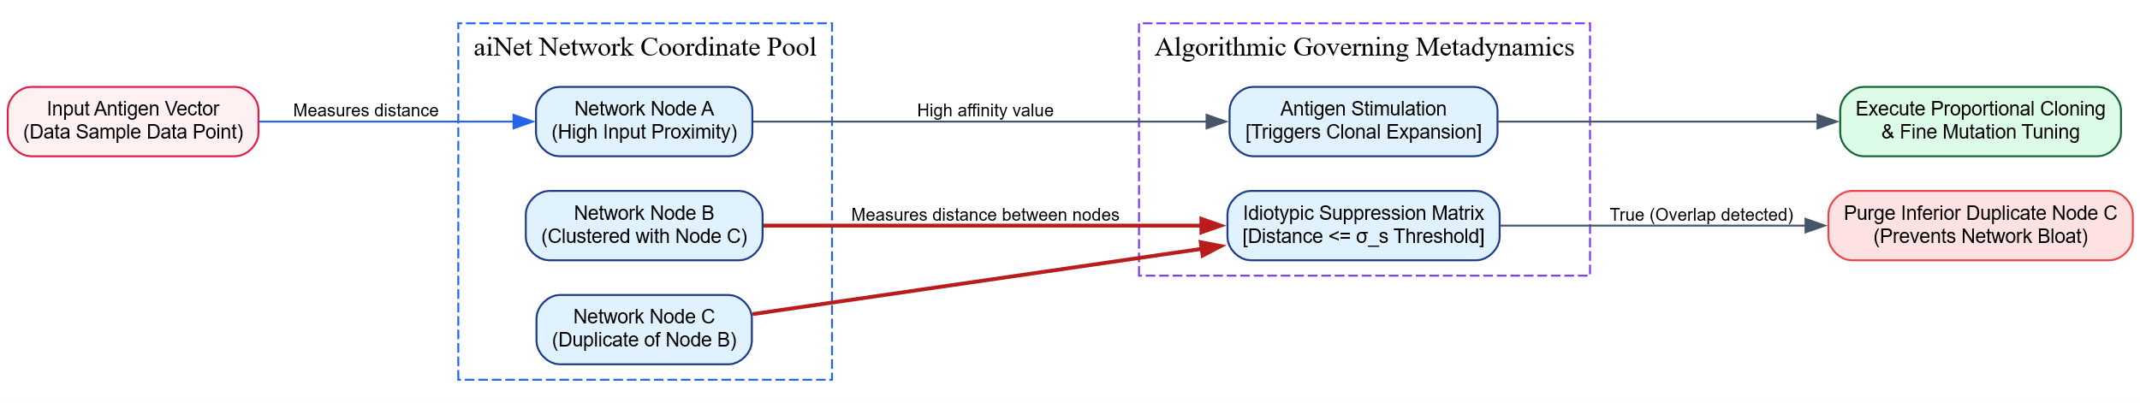Real-World Application Example
Consider utilizing the Network Theory Model (aiNet) for Unsupervised Customer Segmentation in an e-commerce platform’s transaction database:
- Data Ingestion: The dataset consists of thousands of customer profiles mapped across metrics like annual purchase frequency and average spending values (Antigens).
- Network Setup: The algorithm initializes a small pool of random baseline profiling nodes across the shape space coordinates.
- Stimulation and Adaptation: As consumer data points are fed into the system, the closest profiling nodes are strongly stimulated. These nodes clone and mutate their coordinates, shifting closer to genuine customer behavior clusters.
- Suppression and Refinement: If multiple profiling nodes drift into the same high-density region (e.g., a tight cluster representing “High Frequency, Low Spend” buyers), they recognize each other as redundant coordinates. The distance between them falls below the suppression threshold ($σ_{s}$), prompting the model to remove the redundant nodes and leave a single optimized cluster anchor.
- Final Abstraction: At convergence, the network stabilizes into a lean, optimized graph structure where the remaining nodes serve as clean cluster anchors. This maps out distinct consumer archetypes without requiring manual data labeling, highlighting the practical value of the network theory model.

5. Conclusion / Summary
The Network Theory Model provides a powerful, self-organizing framework for computational intelligence by translating Jerne’s idiotypic network principles into graph-based data structures. By balancing antigen stimulation with internal idiotypic suppression, it naturally refines its architecture to capture data topologies while actively pruning redundant nodes. This dynamic adaptability makes the model an essential tool for unsupervised learning tasks, providing an efficient alternative to traditional clustering techniques for high-dimensional data compression, pattern recognition, and multi-modal optimization.

PYQ May 2024 (Q7b): Describe the principles of Network Theory Model and its application in understanding immune system behaviour? [8 Marks] (Repeated/Overlapping Question)

1. Definition / Introduction
The Network Theory Model—frequently formalized as the Artificial Immune Network (aiNet) framework—is an advanced engineering paradigm within Artificial Immune Systems (AIS) used to capture data structures without supervision. The model is directly inspired by Niels Jerne’s biological Idiotypic Network Theory (1974), which reshaped theoretical immunology.
Classical view models assume that the immune system remains completely dormant until it encounters an external foreign threat. In contrast, the Network Theory Model views the immune system as a self-organizing, interconnected network of lymphocytes that continuously stimulate and suppress one another, even in the complete absence of foreign invaders. In computational intelligence, this model shifts the architecture from a set of isolated detectors to a dynamic, graph-based network. This approach is highly effective for unsupervised machine learning tasks, including multi-modal optimization, data clustering, data compression, and mapping complex structural topologies.

2. Detailed Explanation

I. Core Principles of the Network Theory Model
The model operates on a set of mathematical and structural principles that translate biological cellular networks into digital engineering tools:

1. Shape Space Representations and Multi-Dimensional Nodes
The network is modeled as a population of nodes residing within a continuous multi-dimensional feature space, termed the Shape Space ($S$).
- Each node represents a network B-cell or an antibody vector ($w_{i}=\{w_{i1},w_{i2},…,w_{in}\}$), which acts as an internal prototype or cluster anchor.
- External problems, anomalies, or incoming datasets are treated as Antigens (${ag}_{j}=\{ag_{j1},ag_{j2},…,ag_{jn}\}$).

2. Complementarity and Inter-Node Affinities
In traditional machine learning models (like $k$-Means), data points interact exclusively with cluster centroids, and centroids never interact with one another. The Network Theory Model introduces Idiotypic Connectivity, meaning network nodes interact with both external antigens and other internal nodes. The interaction strength (Affinity) between any two components is inversely proportional to their spatial distance in the shape space, typically calculated using the Euclidean Distance formula:
$$\text{Distance}\left(w_{i},w_{j}\right)=\sqrt{\sum_{k=1}^{n}{{\left(w_{ik}-w_{jk}\right)}^{2}}}$$

3. The Balance of Dual-Force Metadynamics
The structural configuration of the network graph is governed by two opposing operational forces evaluated against an Affinity Threshold ($σ_{s}$):
- External Antigenic Stimulation: When an input data point enters the space, it attracts nearby network nodes. Nodes with high affinity are stimulated to clone and mutate, shifting the population closer to genuine data concentrations.
- Internal Idiotypic Suppression: When two network nodes drift too close to one another ($\text{Distance}\left(w_{i},w_{j}\right)≤σ_{s}$), they recognize each other as redundant coordinates tracking the same data cluster. To prevent computational bloat, the network triggers a suppression event, purging the node with lower antigen affinity from the graph.

II. Application in Understanding Immune System Behaviour
Beyond its utility as a computational clustering tool, the Network Theory Model serves as a valuable mathematical framework for simulating, analyzing, and understanding complex biological immune system behaviors:

1. Simulating Autogenous Homeostasis and Steady-State Stability
A major challenge in immunology was explaining how the body maintains stable lymphocyte populations without constant infections. The network model demonstrates how internal stimulation and suppression forces form a self-regulating feedback loop. This loop maintains a stable baseline of immune cell populations (Homeostasis), ensuring the system remains responsive without over-proliferating or causing autoimmune issues.

2. Modeling Immune Memory as Emergent Network States
Traditional theories view immune memory as the preservation of isolated, long-lived “memory cells.” Jerne’s network model offers an alternative explanation: immune memory is an emergent property maintained by stable, self-sustaining cycles within the cell network. When a pathogen is cleared, the structural changes left behind in the network graph create self-stimulating pathways. These pathways preserve a permanent trace of the threat, allowing for a rapid response if the pathogen returns.

3. Explaining Cross-Reactivity and Structure-Tolerant Recognition
Biological immune systems can neutralize mutated variations of a virus they have never explicitly encountered before. The network theory explains this behavior through the geometry of Shape Space Coverage. Because the network nodes form interconnected webs with overlapping activation radii ($σ_{s}$), the system provides continuous defensive coverage across entire regions of the shape space. This allows the network to generalize across variations, enabling robust pattern recognition in the presence of noise or structural mutations.

3. Key Points
- Self-Organizing Graph Architecture: Relies on local node interactions to form stable cluster structures automatically without requiring a central coordinator.
- Dual Force Regulation: Balances antigen attraction with internal idiotypic suppression to accurately map complex data topologies.
- Redundancy Pruning via Suppression: Uses the suppression threshold ($σ_{s}$) to automatically eliminate duplicate nodes, preventing computational bloat and maintaining lean models.
- Simulation of Homeostasis: Models how biological immune networks maintain stable, responsive cell populations through internal feedback loops.
- Network-Driven Memory: Views immune memory as self-sustaining activation loops within the graph topology rather than relying on isolated memory cells.

4. Diagram / Example

Dynamic Interaction and Processing Pipeline of aiNet

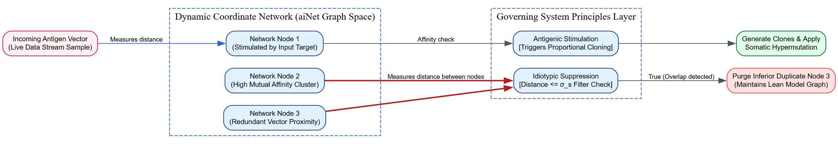Analytical Biological Application Example
Consider using a mathematical Network Theory Model to analyze how an organism’s immune system responds to a rapidly mutating viral strain, such as influenza:
- Initial State (Homeostasis): Before an infection, the network model simulates stable baseline cell interactions. Internal nodes stimulate and suppress each other, maintaining a steady, diverse population of immune receptors without triggering an active response.
- Viral Intrusion (Antigenic Stimulation): A mutated variant of the influenza virus enters the body, represented as an incoming Antigen vector. The model projects this variant into the shape space, where it matches a subset of neighboring network nodes. These nodes are strongly stimulated, triggering rapid reproduction (Clonal Expansion) and targeted mutation loops.
- Refining the Network (Idiotypic Suppression): As the immune cells proliferate to fight the virus, multiple high-affinity clones gather in the same region of the shape space. The model detects that these nodes are becoming redundant, as they target the exact same viral features. The system applies internal suppression, pruning lower-performing clones to keep the immune response efficient and prevent resource waste.
- Preserving Memory: Once the virus is cleared, the remaining high-affinity nodes settle into a stable, self-sustaining loop within the network graph. This configuration preserves the memory of the encounter within the network’s structure, ensuring the system can quickly recognize and neutralize future variations of the virus.

5. Conclusion / Summary
The Network Theory Model provides a powerful, self-organizing framework for both computational intelligence and theoretical immunology by translating Jerne’s idiotypic network principles into graph-based data structures. By balancing external antigen stimulation with internal idiotypic suppression, it allows computational systems to naturally map complex data topologies while actively pruning redundant nodes. At the same time, this dual-force mechanic provides an effective framework for understanding biological immune behaviors—including homeostasis, emergent immune memory, and structure-tolerant recognition—making it a versatile tool for both unsupervised machine learning and biological system simulation.

Danger Theory Model
PYQ May 2025 (Q7c): Explain the concept of danger theory in the context of artificial immune systems.

1. Definition / Introduction
The Danger Theory Model is an advanced, context-aware architectural paradigm in Artificial Immune Systems (AIS) that redefines how anomalies and hostile patterns are detected. It is directly inspired by a biological theory proposed by immunologist Polly Matzinger in 1994, which challenged the classical “Self/Non-Self” paradigm of immunology.
In classical view models, the immune system is thought to react blindly to any foreign particle characterized as “Non-Self.” In contrast, the Danger Theory Model asserts that the immune system does not inherently care about foreignness; it cares about damage. It responds only when localized host tissues emit specific biochemical alarm signals caused by cellular distress, unprogrammed cell death (necrosis), or active destruction.
In computational intelligence, Danger Theory shifts the focus from global static pattern comparisons to localized, context-sensitive alerting mechanics. It requires a system to validate an anomaly using a combination of two signals: a standard data pattern match and a co-stimulatory “Danger Signal” indicating functional damage or system distress.

2. Detailed Explanation
The Danger Theory Model addresses a key limitation of the classical Self/Non-Self paradigm in engineering, particularly when applied to dynamic real-world networks.

I. The Engineering Limitations of Classical AIS
In standard anomaly detection models (such as the Negative Selection Algorithm), an environment is strictly partitioned into two immutable halves: normal parameters (Self) and anomalies (Non-Self). This creates severe operational challenges in production networks:
- The Software Update False-Alarm: When an enterprise server undergoes a legitimate software patch, its system files, memory footprint, and network packet structures change naturally. A classical AIS views these changes as unfamiliar “Non-Self” variants and triggers false alarms, mistakenly blocking authorized processes.
- The Symbiotic Tolerance Gap: Conversely, some foreign processes are beneficial (like data backup agents), while some native processes are destructive (like internal memory leaks). Classical systems struggle to handle these scenarios because they rely on rigid shape-space lookups rather than assessing actual system impact.

II. Governing Structural Mechanics of Danger Theory
The Danger Theory Model resolves these limitations by establishing a strict multi-signal validation loop, partitioning the problem space into localized zones called Danger Zones.
[Signal 1: Pattern Match] ----\
+---> [Affinity Gating Node] ---> [Trigger Active Alarm]
[Signal 2: Danger Signal] ----/
An immune cell or computational detector will not trigger a system-wide alert unless it receives two separate signals simultaneously:

Signal 1: The Primary Antigenic Signal
This signal matches traditional distance metrics. The model monitors incoming data vectors ($A=\{x_{1},x_{2},…,x_{n}\}$) against a pool of generated detectors ($D=\{y_{1},y_{2},…,y_{n}\}$). A match is confirmed if the calculated distance falls below a specific threshold:
$$\text{Distance}\left(A,D\right)≤ϵ$$

Signal 2: The Co-Stimulatory Danger Signal
This signal acts as the context validation check. It is an independent telemetry metric broadcast only when a system component experiences functional failure or distress. Examples include:
- A sudden spike in CPU temperature or memory usage.
- Rapid generation of operating system error logs or disk corruption faults.
- Unexpected drops in network throughput or application crashes.

III. The Danger Zone Gating Logic
When a primary detector detects a pattern match (Signal 1), it defines a spatial Danger Zone around that coordinate. It then checks for a co-stimulatory Danger Signal (Signal 2) within that zone.
The system evaluates three distinct states based on this interaction:
- Antigen Match WITHOUT Danger Signal: The system recognizes the pattern change but notices no functional damage or system distress. It classifies the change as a harmless, natural variation (such as a routine software update) and suppresses the alarm. The detector is often re-tolerized to adapt to this new safe state.
- Danger Signal WITHOUT Antigen Match: The system notes functional distress (e.g., high CPU load) but no known malicious data signatures are matched. It flags the event for standard diagnostics without triggering a security shutdown.
- Antigen Match WITH Danger Signal: Both conditions are satisfied concurrently. The data change is confirmed to be causing active damage, prompting the system to trigger a high-priority alert that isolates the component immediately.

3. Key Points
- Context-Driven Anomaly Gating: Replaces rigid, static pattern lookups with dynamic verification that requires both an structural change and functional distress before alerting.
- Reduction of False-Alarm Cascades: Minimizes false positives by ignoring harmless system shifts (such as software updates) that do not cause active operational damage.
- Multi-Signal Activation Requirement: Requires the simultaneous presence of a primary pattern match and an independent danger metric to trigger a response.
- Localization via Danger Zones: Restricts detector activation to specific local windows where distress signals are actively being broadcast.
- Dynamic Self-Tolerance Adaptation: Allows the system’s definition of normal behavior to update naturally over time, providing flexibility when dealing with naturally evolving data streams.

4. Diagram / Example

Complete Computational Flow of the Danger Theory Model

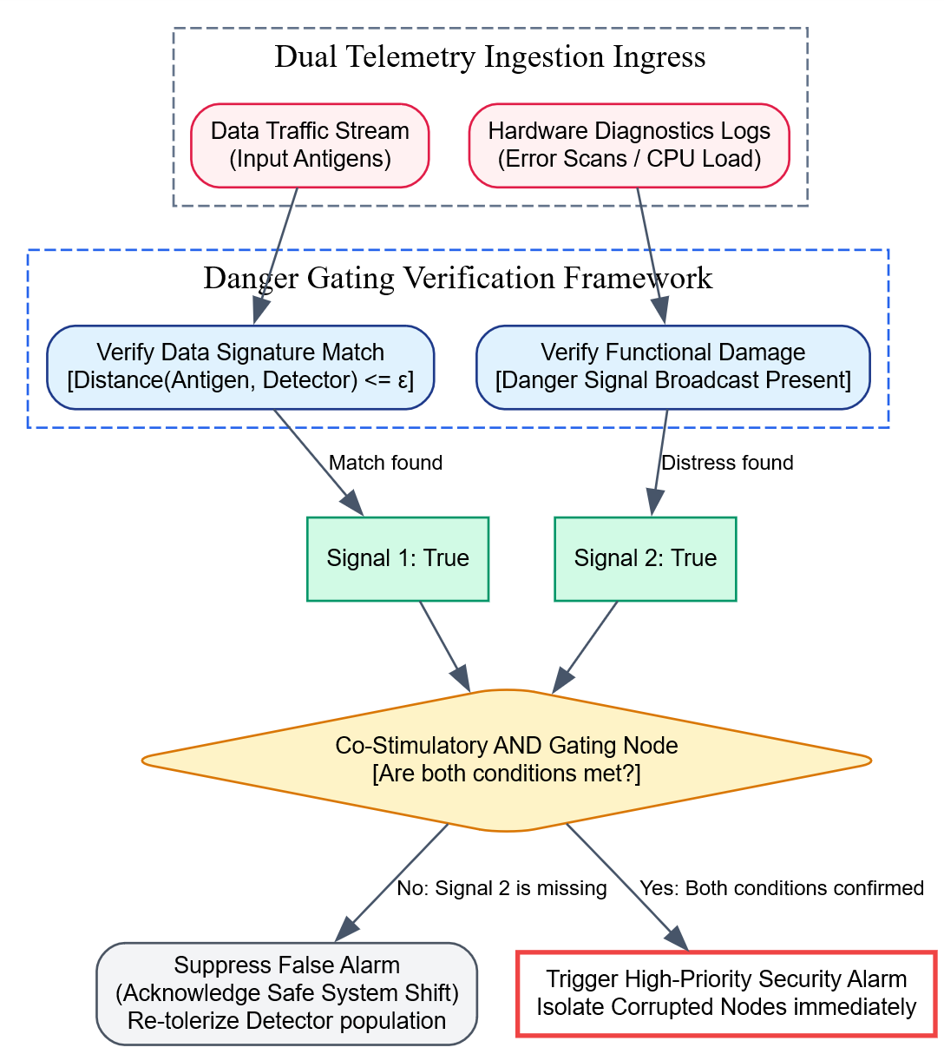Detailed Conceptual Application Example
Consider deploying a Danger Theory Model to secure an automated smart electrical power grid against cyber-intrusions and localized equipment faults:
- The Scenario (A Legitimate System Change): The power grid operators push a major firmware update across thousands of local transformer control units at midnight.
- The Pattern Detection Phase (Signal 1): The AIS monitoring engine immediately notes that the new cryptographic signatures and transmission frequencies deviate sharply from the historical database baseline. The calculated distance drops below the threshold ($ϵ$), satisfying Signal 1. Under a classical view model, this would trigger a false alarm, shutting down electricity distribution to parts of the city.
- The Context Verification Check (Signal 2): The Danger Theory framework stops the immediate shutdown and queries the local hardware monitors for Danger Signals. It checks parameters like transformer core temperatures, oil pressures, and diagnostic error loops.
- The Resolution Processing Outcomes:
  - Case A (The Safe Firmware Update): The hardware monitors return normal telemetry values—pressures are stable, temperatures are low, and no errors are present. Because the co-stimulatory Danger Signal is missing, the model classifies the structural shift as a harmless, natural update. It suppresses the alarm and updates its baseline to accommodate the new signatures.
  - Case B (An Active Cyber-Attack): Conversely, if an attacker uses compromised code to alter configuration files, the transformation triggers Signal 1. Simultaneously, the rogue instructions force circuit breakers to cycle rapidly, causing transformer temperatures to spike and error logs to fill the diagnostic channel. The system flags this as a co-stimulatory Danger Signal (Signal 2). Since both criteria are satisfied concurrently within the danger zone, the model confirms an active threat and immediately cuts off the affected transformers to protect the grid from damage.

5. Conclusion / Summary
The Danger Theory Model enhances bio-inspired anomaly detection by shifting focus from rigid string comparisons to context-sensitive behavior verification. By requiring a primary pattern match to be validated by an independent danger signal indicating functional distress or system damage, it reduces false alarms caused by natural system updates or routine operational changes. This context-aware approach provides an efficient tool for securing dynamic engineering applications, such as industrial IoT monitoring networks, cloud server management platforms, and smart automated infrastructure.

Dendritic Cell Model
PYQ May 2024 (Q8a): Discuss the role of antigen-presenting cells in immune activation and its representation in the Dendritic Cell Model?

1. Definition / Introduction
Antigen-Presenting Cells (APCs) are specialized biological components within the natural immune system—primarily consisting of macrophages, B-cells, and dendritic cells—that bridge the gap between non-specific innate immunity and specific adaptive immunity. Their role is to ingest foreign pathogens, break down their structures into identifiable protein fragments (antigens), and display them on their cell surface via Major Histocompatibility Complex (MHC) molecules to activate naive T-lymphocytes.
In the domain of Computational Intelligence (CI), this biological activation loop is modeled by the Dendritic Cell Model (DCM), introduced by Julie Greensmith in 2005. The DCM is a context-aware machine learning and pattern-recognition algorithm that shifts away from simple static data string lookups. It treats text data or operational networks as an environment monitored by multi-sensor computational agents. These agents process multiple continuous data signals concurrently to accurately classify inputs as safe or anomalous based on environmental context.

2. Detailed Explanation

I. The Biological Role of APCs in Immune Activation
In the human body, the adaptive immune system cannot recognize circulating foreign pathogens on its own. It requires antigen-presenting cells to act as messengers:
- Pathogen Ingestion (Phagocytosis): An APC encounters a foreign entity, engulfs it, and digests its internal proteins inside an acidic cellular chamber.
- Antigen Display Parsing: The APC transfers these broken protein fragments to its outer cell surface, binding them to specialized molecular receptors called MHC Class II molecules.
- Signal Coordination (The Three-Signal Loop): The APC travels to the nearest lymph node to activate naive T-lymphocytes. This activation requires the coordination of three distinct biochemical signals:
  - Signal 1 (The Identification Tag): The physical binding of the T-Cell Receptor (TCR) to the antigen-MHC complex presented by the APC.
  - Signal 2 (Co-stimulation Validation): Binding of surface proteins (such as CD80/CD86 on the APC to CD28 on the T-cell), which acts as a safety confirmation step to prevent accidental activation.
  - Signal 3 (Cytokine Direction): The APC releases chemical signaling proteins (cytokines) that instruct the T-cell whether to transform into a killer cell or an antibody coordinator.

II. Representation within the Dendritic Cell Model (DCM)
The Dendritic Cell Model converts this biological three-signal activation loop into a multi-stream data filtering algorithm. The model abstracts individual dendritic cells into computational agents that transition through three distinct lifecycles: Unmature, Semi-Mature (Safe Context), or Mature (Anomalous Context).

1. Input Signal Mapping Architecture
Instead of evaluating a single data attribute, the DCM handles complexity by parsing the environment into four distinct input streams simultaneously:
- Antigen Array Stream ($Ag$): The core identifier or data packet under review (e.g., a system log string, a network IP connection block, or a database query vector).
- Safe Signals ($P_{\text{safe}}$): Telemetry indicators that explicitly confirm normal, healthy system operations (e.g., successful user logins or balanced CPU usage metrics).
- Danger Signals ($P_{\text{danger}}$): Telemetry indicators that hint at potential system distress or increased risk of failure (e.g., elevated system temperatures, memory warnings, or non-fatal syntax errors).
- Pathogenic PAMP Signals ($P_{\text{pamp}}$): Pathogen-Associated Molecular Patterns represent unambiguous signatures of known malicious attacks or definitive hardware crashes (e.g., a confirmed database injection signature or an immediate server failure).

2. Signal Combination Weights Matrix
A computational dendritic cell agent acts as a leaky integrator, accumulating these input signals over time. It transforms the four input telemetry streams into three internal output variables using a standard linear combination matrix with distinct weights ($W$):
$${\text{Output}}_{\text{csm}}=\left(1×P_{\text{pamp}}\right)+\left(2×P_{\text{danger}}\right)+\left(3×P_{\text{safe}}\right)$$
$${\text{Output}}_{\text{semi}}=\left(0×P_{\text{pamp}}\right)+\left(0×P_{\text{danger}}\right)+\left(1×P_{\text{safe}}\right)$$
$${\text{Output}}_{\text{mat}}=\left(2×P_{\text{pamp}}\right)+\left(1×P_{\text{danger}}\right)+\left(-1×P_{\text{safe}}\right)$$
- Co-stimulatory Molecule ($\text{CSM}$): Tracks the overall volume of signals processed by the agent. When the accumulated CSM value exceeds a predefined Migration Threshold ($τ$), the cell stops gathering data and enters its processing phase.
- Semi-Mature Signal ($\text{Semi}$): Driven by safe parameters, this signal guides the agent to classify its collected data as normal or safe.
- Mature Signal ($\text{Mat}$): Driven by danger and PAMP parameters, this signal guides the agent to classify its collected data as anomalous or hazardous.

3. Lifecycle Transitions and Anomaly Scoring
Once an agent’s CSM level passes its migration threshold, it evaluates its accumulated internal variables to determine its final maturity state:
$$\text{If }{\text{Output}}_{\text{semi}}>{\text{Output}}_{\text{mat}}⟹\text{Semi-Mature State Assigned (Context: Safe Self)}$$
$$\text{If }{\text{Output}}_{\text{mat}}≥{\text{Output}}_{\text{semi}}⟹\text{Mature State Assigned (Context: Anomalous Non-Self)}$$
The algorithm combines the classifications from the entire active agent population to compute a continuous anomaly metric called the Anomaly Context Value ($MCAV$) for each unique data point ($Ag$):
$$MCAV\left(Ag\right)=\frac{\text{Number of Mature Cells that collected }Ag}{\text{Total Cells that collected }Ag}$$
If the computed $MCAV$ score passes a designated system threshold, the platform flags the target data point as a confirmed anomaly, triggering a security response.

3. Key Points
- Multi-Signal Context Integration: Evaluates security by processing four separate input streams—Antigens, Safe Signals, Danger Signals, and PAMPs—simultaneously.
- Leaky Integrator Population Modeling: Uses distributed, autonomous computational agents that collect data locally until they pass an activation threshold.
- Dynamic Lifecycle Transitions: Translates accumulated input combinations into distinct operational phases: semi-mature (safe) or mature (anomalous).
- Probabilistic Anomaly Scoring ($MCAV$): Quantifies threat levels based on the proportion of mature agents that flag a given data point, reducing false positives caused by isolated sensor anomalies.
- Context-Aware Discrimination: Minimizes false alarms by evaluating the overall health of the environment, ensuring structural data variations are not mistakenly flagged as threats unless they are actively causing system distress.

4. Diagram / Example

Complete Computational Pipeline of the Dendritic Cell Model

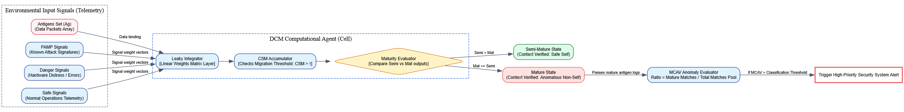Descriptive Application Example
Consider deploying the Dendritic Cell Model to monitor an online financial transaction platform for hidden fraudulent activities:
- Signal Setup Mapping:
  - Antigens ($Ag$): Individual transaction IDs combined with user identity hashes.
  - PAMP: Detection of automated script signatures or multi-location logins executed within a one-second window.
  - Danger Signals: High transaction amounts that deviate from historical user averages or multiple consecutive typing mistakes during authentication.
  - Safe Signals: Success confirmations from multi-factor biometrics or transactions initiated from verified home network addresses.
- Agent Collection: A population of automated computational dendritic cell agents starts tracking the transaction stream, recording transaction hashes and accumulating environmental metrics.
- Evaluation Threshold Breach: A user makes an unusually large purchase, triggers two typing mistakes, but successfully satisfies a fingerprint scan challenge. The combination of danger and safe signals increases the cell agent’s internal variables, causing the total CSM score to pass the migration threshold ($τ$). The cell agent stops gathering data and evaluates its state.
- Lifecycle Categorization: The linear matrix calculates the internal scores. Because the biometric pass provides a strong safe signal, the accumulated Semi-Mature value outweighs the Mature value. The cell agent transitions into the Semi-Mature State, logging the transaction ID as safe inside the main ledger.
- System-Wide Verification ($MCAV$): Conversely, if an automated attack vector processes a series of high-volume transactions that trigger PAMP and danger signals while lacking safe biometric confirmations, a large percentage of active cell agents will transition into the Mature State. The calculated $MCAV$ ratio for those transaction hashes jumps to $0.94$. Since this exceeds the alert threshold, the system flags the activity as fraudulent, blocking the transactions and freezing the compromised accounts.

5. Conclusion / Summary
The Dendritic Cell Model provides a robust, context-aware framework for anomaly detection by translating the principles of antigen presentation into a multi-signal computational architecture. By balancing structural feature collection with continuous environmental health metrics, it avoids the false alarms common in rigid, classic view models. This ability to evaluate data patterns alongside real-time system distress signals makes the model an essential tool for monitoring complex, dynamic environments, such as automated cybersecurity platforms, financial tracking networks, and industrial IoT monitoring systems.

PYQ May 2025 (Q8c - Part 1): Discuss the role of dendritic cells in the artificial immune system. [Marks combined below]

1. Definition / Introduction
In biological immunology, Dendritic Cells (DCs) are specialized antigen-presenting cells of the innate immune system that act as the primary structural links to the adaptive immune system. They continuously sample the tissue environment for foreign material, process contextual tissue signals, and migrate to lymph nodes to direct T-cell activation.
In the context of Artificial Immune Systems (AIS), dendritic cells are modeled as distributed, autonomous, multi-sensor computational agents. Formulated primarily within the Dendritic Cell Algorithm (DCA) by Julie Greensmith in 2005, the role of artificial dendritic cells is to perform context-dependent data aggregation and probabilistic anomaly detection. Rather than matching static strings, these agents pool multi-stream environmental health metrics concurrently, making them highly effective at determining whether a specific data sequence is benign or hazardous based on the overall state of the system.

2. Detailed Explanation
The functional role of dendritic cells within an Artificial Immune System is centered around data sampling, linear signal processing, and changing operational states.

I. Multi-Sensor Data Ingestion and Signal Mapping
An artificial dendritic cell agent operates as a multi-signal processing engine. It does not look at a single parameter in isolation; instead, it processes an input data token (termed an Antigen) alongside three separate environmental telemetry signals:
- PAMP (Pathogen-Associated Molecular Patterns): Direct signatures of known malicious events or absolute system failures. The presence of a PAMP signal strongly indicates an anomaly.
- Danger Signals: Telemetry metrics that indicate increased system risk or technical distress without confirming a breach (e.g., high server temperatures or non-fatal syntax errors).
- Safe Signals: Explicit indicators of normal, healthy operational states (e.g., successful user authentications or stable memory loads).

II. Internal Integration Mechanics (The Leaky Integrator)
Every dendritic cell agent maintains a collection of parsed antigens and behaves mathematically as a leaky integrator. It continuously combines the incoming environmental signal concentrations ($S$) using a standard transformation matrix with distinct structural weights ($W$) to update three internal variables:
$$\text{CSM Output}=\left(1×P_{\text{pamp}}\right)+\left(2×P_{\text{danger}}\right)+\left(3×P_{\text{safe}}\right)$$
$$\text{Semi-Mature Output}=\left(0×P_{\text{pamp}}\right)+\left(0×P_{\text{danger}}\right)+\left(1×P_{\text{safe}}\right)$$
$$\text{Mature Output}=\left(2×P_{\text{pamp}}\right)+\left(1×P_{\text{danger}}\right)+\left(-1×P_{\text{safe}}\right)$$
- Co-Stimulatory Molecules (CSM): Measures the total volume of data signals processed by the individual agent. When the cell’s accumulated CSM value exceeds a predefined Migration Threshold ($τ$), the cell stops sampling data and enters its processing phase.
- Semi-Mature Score: Driven entirely by safe inputs, this internal tracker guides the cell to classify its collected data as normal.
- Mature Score: Driven by danger and PAMP inputs, this internal tracker guides the cell to classify its collected data as anomalous.

III. Lifecycle Transitions and Contextual Classification
Once an individual agent passes its migration threshold, it compares its accumulated internal variables to determine its final maturity state:
$$\text{If Semi-Mature Output}>\text{Mature Output}⟹\text{Semi-Mature Lifecycle State (Context: Safe/Benign)}$$
$$\text{If Mature Output}≥\text{Semi-Mature Output}⟹\text{Mature Lifecycle State (Context: Anomalous/Hostile)}$$

IV. Collaborative Decision Fusion
The fundamental role of dendritic cells is to provide a distributed defense. Multiple agents sample the same data points concurrently in different parts of the network. When cells migrate and output their logs, the system calculates a collective score for each unique antigen string, known as the Anomaly Context Value ($MCAV$):
$$MCAV\left(Ag\right)=\frac{\text{Number of Mature Cells that collected Antigen }Ag}{\text{Total Cells that collected Antigen }Ag}$$
This probabilistic fusion filters out false positives. If a normal data variation causes a brief danger spike, only a few cell agents are affected, keeping the overall $MCAV$ ratio low and avoiding unnecessary alarms.

3. Key Points
- Multi-Signal Context Gating: Evaluates system anomalies by processing four distinct data streams—Antigens, Safe Signals, Danger Signals, and PAMPs—simultaneously.
- Autonomous Agent Architecture: Uses independent, distributed computational agents that monitor local parameters, eliminating single-point vulnerabilities.
- Dynamic Structural Lifecycles: Transitions through clear operational phases—unmature sampling, semi-mature (benign), or mature (anomalous)—based on accumulated signal combinations.
- Probabilistic False-Alarm Filtering: Uses the $MCAV$ metric to aggregate classifications across the full agent population, preventing isolated sensor noise from triggering system-wide alerts.
- Context-Driven Recognition: Specializes in dynamic environments where normal parameters shift naturally, distinguishing harmless variations from active threats by analyzing accompanying system distress metrics.

4. Diagram / Example

Complete Lifecycle and Verification Loop of Artificial Dendritic Cells

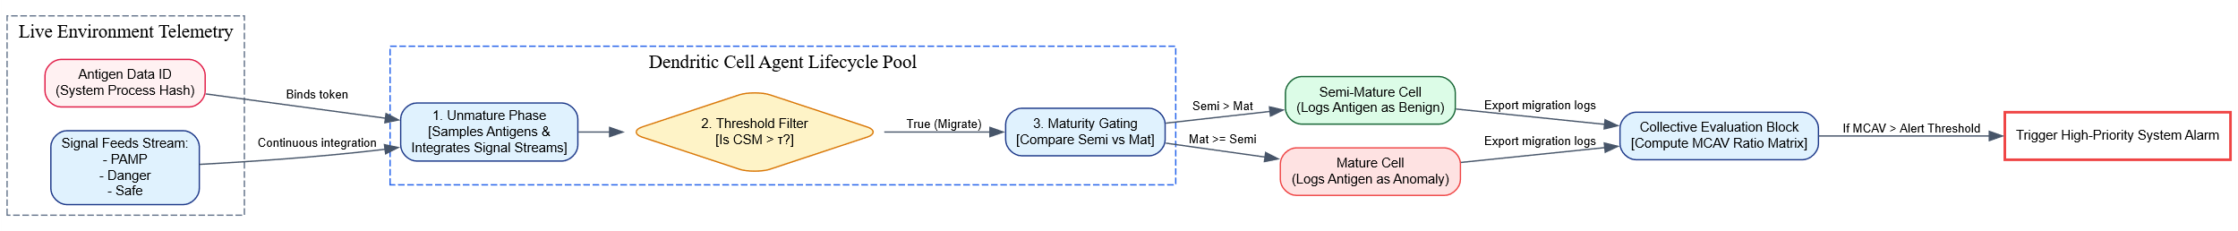Descriptive Application Example
Consider deploying artificial dendritic cells to secure a large automated warehouse infrastructure against software-driven coordinate attacks:
- The Telemetry Configuration:
  - Antigens ($Ag$): Automated robotic navigation command sequences.
  - Danger Signals: Minor communication delays or battery drain warnings.
  - Safe Signals: Success flags from localized laser distance scanners confirming a clear path.
- The Ingestion Process: Unmature dendritic cell agents monitor the warehouse network, recording robot command hashes while tracking surrounding danger and safe metrics.
- Contextual Evaluation: A robot navigates a narrow corridor, causing a slight transmission delay that triggers a minor Danger Signal. However, its laser scanners continue to return normal readings, maintaining a steady stream of Safe Signals.
- Maturity Sorting: As an active cell agent hits its migration threshold ($τ$), its transformation matrix calculates the final values. Because the safe laser metrics outweigh the transmission delay, the Semi-Mature score beats the Mature score. The cell enters the Semi-Mature State, classifying the command sequence as safe and preventing a false positive.
- Breach Resolution: Conversely, if an attacker injects rogue navigation commands that cause robots to collide, the events trigger severe hardware errors and emergency stop logs (Danger and PAMP signals). The active dendritic cell agents process these distress metrics, causing their internal Mature scores to jump. The overall $MCAV$ ratio for those command hashes climbs to $0.92$. Recognizing the threat, the system flags a confirmed anomaly, safely shutting down the affected robots to protect the facility from damage.

5. Conclusion / Summary
Dendritic cells play an essential role in Artificial Immune Systems by introducing context-aware verification to anomaly detection. By parsing the environment into separate data and telemetry channels—including PAMPs, danger signals, and safe signals—and tracking them via a distributed population of multi-sensor agents, the Dendritic Cell Model avoids the false alarms common in rigid, classic view networks. This ability to assess structural data alongside real-time system distress signals makes the framework an invaluable tool for securing complex, dynamic applications like cloud infrastructures, industrial IoT setups, and financial platforms.

PYQ May 2025 (Q8c - Part 2): How are dendritic cell-based models utilized in problem-solving and optimization tasks? [6 Marks total for Q8c]

1. Definition / Introduction
Dendritic Cell-Based Models—principally implemented through the Dendritic Cell Algorithm (DCA)—are context-aware, multi-sensor computational frameworks within Artificial Immune Systems (AIS) used to handle non-linear problem-solving and optimization tasks. This paradigm abstracts the signaling behavior of biological dendritic cells, which act as the natural immune system’s primary environmental data processors.
In computational intelligence applications, dendritic cell-based models operate as distributed, multi-signal data fusion engines. Rather than treating anomalies or optimization coordinates as static, context-isolated strings, these models continuously integrate data patterns alongside real-time environmental indicators (safe signals, danger signals, and malicious signatures). This approach is highly effective for complex, dynamic tasks such as multi-modal function optimization, real-time cyber-anomaly classification, and distributed fault localization.

2. Detailed Explanation
The application of dendritic cell-based models to problem-solving and optimization tasks relies on transforming environmental telemetry into clear classification outputs or directional search coordinates.

I. Signal Channel Architecture for Problem Solving
When utilizing a dendritic cell model to solve an engineering or optimization problem, the system monitors a continuous data stream, mapping variables into four distinct functional signal categories:
- Antigen Data Stream ($Ag$): Represents the actual problem elements or candidate solutions under review. In optimization tasks, this maps to the specific variable coordinates or parameter hashes being evaluated.
- Pathogenic PAMP Signals ($P_{\text{pamp}}$): Direct indicators of an absolute failure state, severe constraint violation, or explicit malicious action.
- Danger Signals ($P_{\text{danger}}$): Metrics that indicate an increased risk of failure or suboptimal execution (e.g., an optimization path approaching a hard structural constraint or experiencing high latency).
- Safe Signals ($P_{\text{safe}}$): Telemetry that explicitly confirms a stable, highly efficient, or valid system state.

II. Distributed Search and Data Integration Mechanics
The model initializes a population of autonomous computational agents (dendritic cells). Each agent acts as a leaky integrator, sampling the active antigen pool while calculating a linear combination of the surrounding safe, danger, and PAMP signal weights ($W$):
$$\text{CSM}=∑\left(W_{\text{csm}}×\text{Signals}\right)=\left(1×P_{\text{pamp}}\right)+\left(2×P_{\text{danger}}\right)+\left(3×P_{\text{safe}}\right)$$
$$\text{Semi-Mature}=∑\left(W_{\text{semi}}×\text{Signals}\right)=\left(0×P_{\text{pamp}}\right)+\left(0×P_{\text{danger}}\right)+\left(1×P_{\text{safe}}\right)$$
$$\text{Mature}=∑\left(W_{\text{mat}}×\text{Signals}\right)=\left(2×P_{\text{pamp}}\right)+\left(1×P_{\text{danger}}\right)+\left(-1×P_{\text{safe}}\right)$$
- The Co-Stimulatory Molecule (CSM) Gate: The CSM value tracks the total volume of data processed by an individual cell agent. When the cell’s accumulated CSM value exceeds a predefined Migration Threshold ($τ$), it stops sampling data and enters its processing phase.
- Maturity Gating: The agent evaluates its accumulated internal variables. If the Semi-Mature score is higher, the cell enters a semi-mature state, logging its collected parameters as safe. If the Mature score is higher, the cell enters a mature state, marking its collected parameters as an anomaly or constraint violation.

III. Utilization in Problem-Solving and Optimization Tasks
Dendritic cell-based models utilize this distributed signal processing framework to address complex tasks across three primary engineering domains:

1. Context-Aware Anomaly Classification in Cloud Schedulers
Traditional anomaly detection algorithms struggle with false alarms when system loads spike naturally, such as during a scheduled data backup. Dendritic cell-based models resolve this by analyzing context:
- The system reads a heavy process signature as an unfamiliar data pattern (Antigen).
- If independent hardware monitors confirm the system is running smoothly without errors (Safe Signals), the safe metrics outweigh the load spikes within the integration matrix.
- The computational agents transition into a semi-mature state, correctly identifying the activity as benign and preventing an unnecessary system freeze.

2. Multi-Modal Optimization and Constraint Gating
In complex optimization landscapes, solutions must avoid hard constraint boundaries while searching for global optima. Dendritic cell models handle this by using signal streams to guide the optimization process:
- Candidate parameter steps are treated as antigens ($Ag$).
- As a parameter coordinates trail approaches a strict penalty boundary, the system generates elevated Danger Signals.
- This causes the active cell agents to transition into a mature state, producing a high Mature Cell Antigen Value ($MCAV$) for those specific coordinates:
$$MCAV\left(Ag\right)=\frac{\text{Number of Mature Cells that collected }Ag}{\text{Total Cells that collected }Ag}$$
- The optimization engine interprets a high $MCAV$ score as a soft-constraint warning. It reshapes the fitness landscape to steer the population away from dangerous boundaries and redirect the search toward safe, optimal regions.

3. Distributed Fault Isolation in Industrial IoT
Because dendritic cell-based models rely on independent, distributed agents, they are highly effective for tracking faults across decentralized networks like robotic manufacturing lines. Autonomous agents process local sensor feeds independently, allowing the system to isolate equipment malfunctions locally. This prevents isolated hardware errors from cascading and causing a full line shutdown.

3. Key Points
- Context-Sensitive Multi-Sensor Ingestion: Evaluates data patterns alongside real-time system metrics to ensure structural variations are only flagged as anomalies if they are actively causing system distress.
- Distributed Multi-Agent Security: Uses independent computational cell agents to process data locally, eliminating reliance on a single central controller and preventing single-point system vulnerabilities.
- Soft-Constraint Optimization Tuning: Uses the continuous $MCAV$ metric to dynamically adjust the optimization landscape, guiding the search process away from hazardous parameter boundaries.
- Robust Noise Filtering: Leverages collaborative agent populations to ensure isolated sensor errors or brief performance hiccups do not trigger false alarms across production networks.
- Flexible Gradient-Free Operation: Processes data using straightforward linear combination tables, allowing the model to navigate complex optimization landscapes without requiring complex mathematical derivatives.

4. Diagram / Example

Complete Computational Loop for AIS Dendritic Cell Optimization

Descriptive Problem-Solving Application Example
Consider utilizing a Dendritic Cell Model to optimize real-time routing and fuel efficiency parameters for an automated cargo shipping vessel navigating a dynamic maritime shipping lane:
- Algorithmic Signal Mapping:
  - Antigen ($Ag$): Proposed navigation heading modifications and engine propulsion settings.
  - Safe Signals: Steady, predictable fuel consumption lines combined with smooth water hull velocities.
  - Danger Signals: Rising engine block temperatures, incoming storm alerts, or moving closer to shallow reef shoals.
  - PAMP Signals: Triggers from hard collision-warning radar sensors or shallow water alarms.
- Agent Data Ingestion: A fleet of digital dendritic cell agents runs on the vessel’s control computer, tracking proposed routing changes while monitoring surrounding sensor metrics.
- Contextual Evaluation Phase: The ship encounters a strong headwind, causing a minor drop in velocity that triggers a standard Danger Signal. However, its hull sensors and depth finders continue to report safe conditions, maintaining a steady flow of Safe Signals.
- Maturity State Sorting: As an active cell agent reaches its data-collection limit and passes its migration threshold ($τ$), its internal matrix calculates the final scores. Because the safe hull metrics outweigh the headwind delay, the cell enters a Semi-Mature State, validating the routing parameters as safe and preventing an unnecessary emergency course correction.
- Optimization Resolution: Conversely, if a routing adjustment steers the ship too close to an active storm cell, the coordinates trigger a cascade of severe wind and wave errors (Danger and PAMP signals). The cell agents process these distress metrics, causing their internal mature scores to jump. This produces a high $MCAV$ ratio of $0.95$ for that specific route. The optimization engine interprets this high score as a soft-constraint penalty, automatically reshaping its search path to steer the vessel away from the storm and find a safer, more efficient alternative route.

5. Conclusion / Summary
Dendritic cell-based models provide an effective, context-aware framework for addressing non-linear problem-solving and optimization tasks within Computational Intelligence. By breaking down environmental inputs into separate data and telemetry channels—including PAMPs, danger signals, and safe signals—and evaluating them via a distributed population of multi-sensor agents, the Dendritic Cell Algorithm avoids the false alarms common in rigid, classic view architectures. This capability allows the system to analyze data patterns alongside real-time system distress metrics, making it an invaluable tool for securing cloud scheduling networks, managing complex multi-modal optimizations, and maintaining decentralized industrial IoT systems.

Applications of AIS Models

1. Definition / Introduction
Artificial Immune Systems (AIS) are a class of adaptive, bio-inspired metaheuristics that mathematically model the decentralized defense mechanisms, pattern-recognition capabilities, and evolutionary memory profiles of the biological immune system. Within Computational Intelligence (CI), specific algorithmic sub-structures—such as Negative Selection (NSA), Clonal Selection (CSA), Artificial Immune Networks (aiNet), and the Danger Theory-driven Dendritic Cell Algorithm (DCA)—are translated into functional software architectures.
The primary significance of deploying AIS models in engineering lies in their ability to view complex data spaces through the lens of a defensive ecosystem. AIS models excel at translating real-world computing environments into a multi-dimensional coordinate network called the Shape Space. By treating input data patterns as Antigens and using distance-based calculations to define Affinity, AIS models solve complex problems by categorizing data arrays into normal baselines (Self) or anomalous variations (Non-Self). This unique methodology makes AIS models highly effective for real-world applications in network security, industrial anomaly detection, multi-modal engineering optimization, and unsupervised clustering.

2. Detailed Explanation
The engineering deployment of Artificial Immune Systems spans multiple distinct operational domains, each utilizing a specific bio-inspired model to solve practical constraints.

I. Computer Network Security and Intrusion Detection Systems (IDS)
The most direct translation of the immune paradigm is in safeguarding computer networks against malicious intrusions, zero-day exploits, and unauthorized access blocks.
- Algorithmic Model Utilized: The Negative Selection Algorithm (NSA) combined with Danger Theory.
- Operational Execution: Standard network packet profiles—comprising source/destination IPs, transmission port configurations, and payload packet sizes—are compiled during an offline safe-state baseline window to establish the system Self Set. The algorithm generates random candidate detector strings within the shape space and discards any that show affinity to this healthy self baseline. The remaining Mature Detectors are deployed to monitor live production traffic.
- Contextual Gating: To eliminate false positives from legitimate shifts (like a scheduled data backup), a Danger Theory layer requires a co-stimulatory signal (such as a sudden spike in CPU temperature or hard drive error logs) to validate an alert. If an incoming packet matches a mature non-self detector and co-occurs with an active danger signal, the system triggers an immediate security alert to isolate the compromised node.

II. Industrial Anomaly Detection and Equipment Fault Diagnosis
In complex engineering plants, such as nuclear reactors, automated manufacturing assembly lines, or aerospace avionics, components degrade over time. Detecting subtle anomalies early prevents catastrophic structural failures.
- Algorithmic Model Utilized: The Dendritic Cell Algorithm (DCA).
- Operational Execution: Industrial telemetry data from continuous physical sensors (vibration matrices, thermal arrays, and fluid pressure loops) are continuously aggregated by autonomous computational agents acting as artificial dendritic cells. The system treats telemetry trends as Antigens while simultaneously monitoring three separate environmental signal feeds: Safe Signals (nominal baseline operations), Danger Signals (minor friction spikes or temperature warnings), and PAMP Signals (hard constraint violations or structural fractures).
- Collaborative Decision Fusion: Each individual cell agent operates as a leaky integrator, combining these signals via a standardized transformation matrix. When an agent passes its integration threshold, it evaluates its accumulated scores and transitions into either a Semi-Mature State (normal operational deviation) or a Mature State (active equipment fault). By calculating the population ratio across all active agents—known as the Mature Cell Antigen Value ($MCAV$)—the system generates a probabilistic score that isolates specific component failures without disrupting healthy machinery lines.

III. Complex Multi-Modal Optimization Tasks
Many engineering design problems require finding multiple global or localized optimal solutions simultaneously across irregular fitness landscapes, such as optimizing airline logistics paths, drone fleet routing grids, or microchip layout arrays.
- Algorithmic Model Utilized: The Clonal Selection Algorithm (CSA / CLONALG).
- Operational Execution: Candidate solutions are modeled as an evolving population of Antibodies deployed across the multi-dimensional parameter search space. The system evaluates the quality of each parameter layout, assigning an Affinity Score based on target optimization constraints.
- The Proliferation Loop: Unlike standard Genetic Algorithms that replicate strings uniformly, CSA selects the top-performing candidate vectors and clones them proportionally—allowing elite solution coordinates to produce more duplicates. These clones then undergo Somatic Hypermutation, where the mutation magnitude is scaled inversely with affinity. This allows high-quality configurations to perform fine-grained local adjustments around known strong solutions, while lower-scoring variations make large spatial jumps to discover completely new regions of the optimum search grid, preventing the system from stalling in local minima.

IV. Unsupervised Data Clustering and Abstraction
In big data analytics, large unannotated datasets must be automatically sorted into distinct, meaningful clusters to profile user habits, classify medical imaging data, or compress large imagery files.
- Algorithmic Model Utilized: The Artificial Immune Network Model (aiNet).
- Operational Execution: Inspired by Jerne’s Idotypic Network Theory, this framework models data clustering as a self-organizing graph space where nodes interact dynamically with both incoming data points (Antigens) and each other.
- Pruning and Redundancy Control: Neighboring network nodes experience mutual attraction and repulsion based on distance metrics evaluated against a Suppression Threshold ($σ_{s}$). If two candidate cluster anchors drift too close to one another in the feature space, they recognize each other as redundant coordinates tracking the same data group. The network triggers a suppression event, pruning the lower-affinity node from the graph. This self-regulating interaction automatically compresses dense data distributions into a clean network graph, identifying data centroids without requiring human-engineered target labels.

3. Key Points
- Context-Driven False-Alarm Mitigation: Danger theory integration filters out harmless system updates or natural load spikes, reducing false-positive rates compared to traditional anomaly detection models.
- Gradient-Free Black-Box Optimization: Evaluates multi-dimensional parameters using distance-based affinity calculations over a continuous shape space, eliminating the need for complex mathematical gradients.
- Autonomous Distributed Surveillance: Operates through a population of independent computational agents that communicate locally, eliminating single-point vulnerabilities and ensuring high resilience.
- Dynamic Variable Architecture: Automatically scales the tracking detector population or cluster nodes up or down based on the density and variety of incoming data streams.
- Diverse Problem-Solving Spectrum: Delivers practical computational frameworks across distinct domains, including computer security, manufacturing telemetry analytics, parameter tuning, and unsupervised data compression.

4. Diagram / Example

Architectural Mapping of AIS Models to Engineering Problems

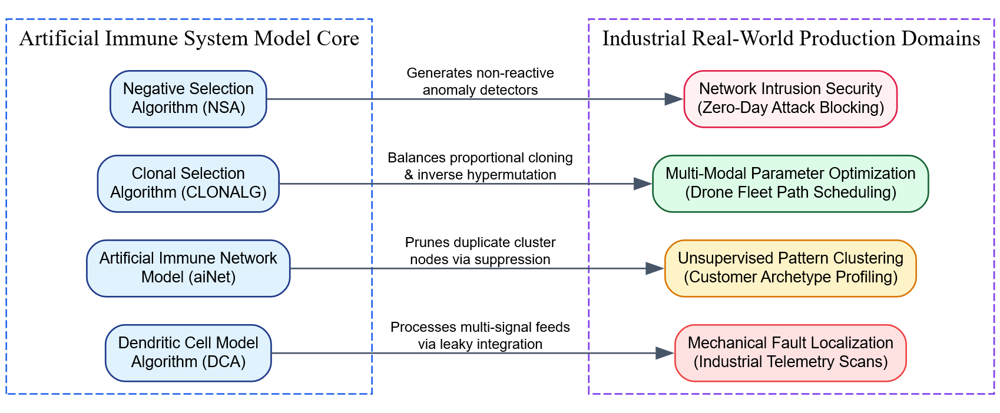Detailed Engineering Application Case Study
Consider deploying a Dendritic Cell Model-based system to safely manage and optimize real-time energy routing across an automated municipal electrical smart grid grid network infrastructure:
- The Ingestion Configuration Mapping:
  - Antigens ($Ag$): Power line configuration matrices and circuit breaker toggle combinations.
  - Safe Signals ($P_{\text{safe}}$): Steady, balanced electrical voltage frequencies matching standard transformer load limits.
  - Danger Signals ($P_{\text{danger}}$): Elevated temperatures in line transformers or brief frequency variations following a thunderstorm.
  - PAMP Signals ($P_{\text{pamp}}$): Direct hardware trip sensor alerts or sudden short-circuit ground connection spikes.
- The Agent Collection Pass: A population of independent digital dendritic cell agents runs on the control computers at localized substations, tracking active power commands while processing surrounding danger and safe metrics.
- Handling a Normal Event (The Lightning Strike): A lightning strike hits an isolated protection grounding rod near a substation, causing a brief voltage variance that triggers a Danger Signal. However, surrounding thermal sensors report stable core temperatures and baseline frequencies continue to flow, generating steady Safe Signals.
- Maturity Evaluation: As an active cell agent reaches its data-collection limit and passes its migration threshold ($τ$), its transformation matrix calculates the final values. Because the safe operational metrics outweigh the brief environmental spike, the internal Semi-Mature score beats the Mature score. The cell logs the configuration as safe, preventing an unnecessary blackout and allowing the grid to adapt to the temporary variation naturally.
- Resolving a Genuine Breach (Active Cyber-Exploit): Conversely, if an attacker gains access to a substation terminal and attempts to systematically disable safety breakers to cause a cascade failure, the action triggers immediate structural failures and emergency shutdown signatures (Danger and PAMP signals). The cell agents process these severe distress metrics, causing their internal Mature scores to jump. This produces a high collective $MCAV$ ratio of $0.96$ for those specific configuration hashes. Recognizing the active threat, the system flags a confirmed anomaly and immediately isolates the compromised substation from the rest of the grid, demonstrating the practical value of the danger theory-driven application framework.

5. Conclusion / Summary
Artificial Immune System models provide a versatile, decentralized, and context-aware framework for address engineering problems across modern industry. By translating biological protection and adaptation mechanisms into mathematical vector operations, frameworks like Negative Selection, Clonal Selection, aiNet, and the Dendritic Cell Algorithm excel at handling challenges that confuse traditional statistical approaches. Whether protecting critical network infrastructures from modern zero-day cyber-threats, isolating mechanical faults in dynamic IoT grids, organizing large unannotated datasets, or searching complex spaces for global parameters, AIS platforms deliver adaptive alternative tools for resilient computer vision and computational intelligence systems.

